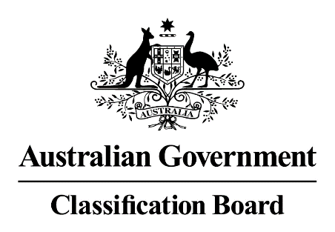

Media release—There are two versions of the theatrical release film, Bumblebee
14 December 2018
The Classification Board has considered and classified two versions of the film, Bumblebee, for Paramount Pictures Australia Pty Ltd.
The original version (114 minutes in duration) was classified on 20 November 2018 as M, Action violence; and a modified version of the film (of the same duration) was classified on 4 December 2018, also as M, Action violence.
On 11 December 2018, upon application by Paramount Pictures, the Classification Review Board, which is separate and independent from the Classification Board, reviewed the modified version of the film and classified it PG, Mild science fiction violence and mild themes. Some scenes may scare young children. Review Board media release link: www.classification.gov.au/Public/Resources/Pages/2018-media-releases.aspx.
Accordingly, there are two versions of the film which have valid classifications: the modified now classified on review as PG, and the original classified M.
The National Classification Database is currently being updated to reflect the two decisions.
It is open to Paramount Pictures to screen theatrically or to release to home entertainment, either version of the classified film.

Margaret Anderson
Director
Classification Board

