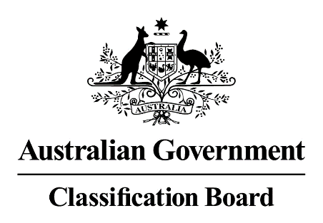

Media release—Super Mario Odyssey
There is some commentary about the classification of Super Mario Odyssey on Gamezone.
This game was submitted to the Classification Board by Nintendo under the computer games assessor scheme. Under that Scheme, industry assessors can recommend a classification and consumer advice for a game.
The Classification Board considers this recommendation to make the classification decision. Nintendo recommended the game be classified PG with consumer advice of ‘mild themes and violence, online interactivity’. The Classification Board agreed with the PG classification but decided that the more appropriate consumer advice would be ‘mild violence, online interactivity’.
When making decisions, the Board applies the Classification (Publications, Films and Computer Games) Act 1995 (the Act), the National Classification Code and the Classification Guidelines (the Guidelines). The Guidelines set out a hierarchy of impact from ‘very mild’ to ‘very high’ and that the impact of material classified G should be very mild only. The consideration of impact and context are essential principles in the use of the Guidelines. The Guidelines are available at www.classification.gov.au.
Margaret Anderson
Acting Director
Classification Board
Media Contact: Kathryn Reidy (02) 9289 7100

