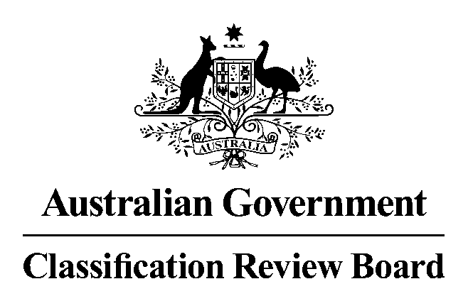
16 October 2017

MEDIA RELEASE

Classification review announced for the film Jigsaw
The Classification Review Board has received an application to review the classification of the film Jigsaw.
Jigsaw was classified R 18+ with the consumer advice ‘High impact horror violence’ by the Classification Board on 9 October 2017.
The Classification Review Board will meet on 20 October 2017 to consider the application. The decision and reasons will later be published on www.classification.gov.au.
If an individual or organisation wishes to apply for standing as an interested party to this review, please write to the Convenor of the Review Board. The names of interested parties will be disclosed in the Review Board’s final decision report, unless requested otherwise.
The closing date to lodge your application for standing as an interested party and any submissions is 19 October 2017. Please note that the Review Board can only consider submissions about Jigsaw itself and not any other matters relating to film classification policy or issues generally.
Submissions should be emailed to crb@classification.gov.au or sent to:
The Convenor
Classification Review Board
Locked Bag 3
HAYMARKET NSW 1240
The Classification Review Board is an independent merits review body. It makes a fresh classification decision upon receipt of an application for review. The Classification Review Board decision takes the place of the original decision made by the Classification Board.
Media contact
Review Board Secretariat (02) 9289 7100

