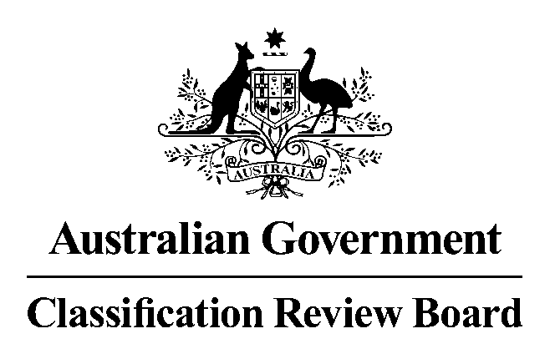

Media release

Classification review announced for the film Rocketman
17 May 2019
The Classification Review Board has received an application to review the classification of the film Rocketman.
Rocketman was classified MA15+ (Mature Accompanied) with the consumer advice ‘Strong coarse language’ by the Classification Board on 5 April 2019. A subsequent modified version was submitted and was classified MA15+ (Mature Accompanied) with the consumer advice ‘Strong coarse language’ by the Classification Board on 16 May 2019.
The Classification Review Board will meet on 21 May 2019 to consider the application. The decision and reasons will later be published on www.classification.gov.au.
If an individual or organisation wishes to apply for standing as an interested party to this review, please write to the Convenor of the Review Board. The names of interested parties will be disclosed in the Review Board’s final decision report, unless requested otherwise.
The closing date to lodge your application for standing as an interested party and any submissions is 20 May 2019. Please note that the Review Board can only consider submissions about Rocketman itself and not any other matters relating to film classification policy or issues generally.
Submissions should be emailed to crb@classification.gov.au or sent to:
The Convenor
Classification Review Board
Locked Bag 3
HAYMARKET NSW 1240
The Classification Review Board is an independent merits review body. It makes a fresh classification decision upon receipt of an application for review. The Classification Review Board decision takes the place of the original decision made by the Classification Board.
Media contact
Media Enquiries Officer 02 9289 7100
Statement authorised by Convenor, Classification Review Board

