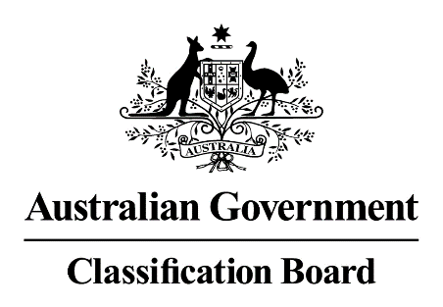

Media release—Classification of the film Tom of Finland and allegations that the Classification Board is “homophobic”
An opinion article published on the website Flicks.com.au on 17 October 2017 by Luke Buckmaster claims that the Classification Board is “homophobic” for classifying the film Tom of Finland R 18+ with consumer advice of ‘High impact sexualised imagery and nudity’.
Contrary to the claims of Luke Buckmaster and the reported opinion of Nicolas Whatson, General Manager of Palace Films (the Australian distributor of Tom of Finland), the Board did not classify the film based on a perceived level of “offence”. The Board classified the film in accordance with the Guidelines for the Classification of Films (the Film Guidelines) which are available at www.classification.gov.au/About/Pages/Legislation.aspx.
The Film Guidelines require an assessment of impact of six classifiable elements (themes, violence, sex, coarse language, drug use and nudity); not an assessment of perceived level of “offence”. The Classification Board is of the opinion that the sexualised imagery and nudity in the film is high in viewing impact.
In response to Mr. Buckmaster’s charges in the article that the Classification Board has a “hostile attitude towards homosexual-themed content” and is “homophobic, erotophobic, genophobic and archaic”, it should be noted that, on 9 June 2017, I granted Palace Cinemas’ application seeking a cultural exemption to screen unclassified films, including Tom of Finland, as part of the 2017 Scandinavian Film Festival. Their application included the following screenings of Tom of Finland: 13 screenings in Victoria; 10 screenings in NSW; and 4 screenings in Queensland. Furthermore, at the time of lodging its application for this Festival, Palace Cinemas sought to have me impose R 18+ conditions on the screening of Tom of Finland, which I did.
Mr Buckmaster also incorrectly states that the Classification Board “don’t even look at content broadcast by the streaming giant” Netflix, alleging that it classifies its own content. On 7 December 2016, Senator Mitch Fifield, Minister for Communications and the Arts, advised that the Turnbull Government had announced a 12-month pilot of a classification tool to streamline the classification of Netflix content in Australia. The Minister stated, “During the pilot, a broad range of classification decisions will be reviewed by the Classification Board to assess the integrity of the tool and ensure that ratings delivered by the tool meet Australian community standards. If needed, the Board has the power to revoke classifications made by the Netflix tool and replace them with its own decisions.” This pilot is on-going.

Margaret Anderson
Acting Director
Classification Board

