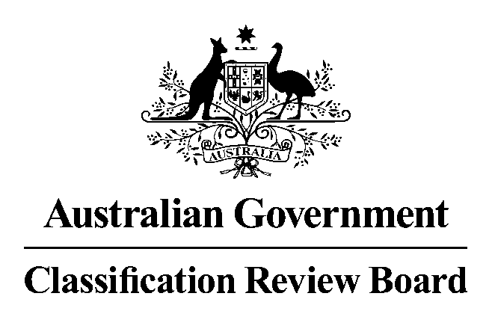

21 May 2019

Rocketman classified M
A three-member panel of the Classification Review Board has unanimously determined that the film, Rocketman, is classified M (Mature) with the consumer advice ‘Mature themes, drug use, sex scene and frequent coarse language’.
In the Classification Review Board’s opinion Rocketman warrants an M classification because the themes and the strongest use of coarse language can be accommodated within context. The other classifiable elements of drug use and sex scenes can also be accommodated at the M classification.
It is the view of the Classification Review Board that the dramatic biographical context does mitigate the impact of the language, and specifically, the one instance of the use of strong coarse language.
Films classified M are considered suitable for mature audiences.
It is for the above reasons, that the Review Board has decided that the contextual singular use of a strong coarse word can be accommodated at the M classification on this occasion. The other frequently used coarse words are routinely accommodated at the M classification level.
The Review Board convened today in response to an application from the original applicant, Paramount Pictures Australia, to review the decision made by the Classification Board on 16 May 2019 to classify Rocketman MA 15+, ‘Strong coarse language’.
In reviewing the classification, the Review Board worked within the framework of the National Classification Scheme, applying the provisions of the Classification (Publications, Films and Computer Games) Act 1995, the National Classification Code and the Guidelines for the Classification of Films 2012. This is the same framework used by the Classification Board.
The Review Board is an independent merits review body. It makes a fresh classification decision upon receipt of an application for review. This Review Board decision takes the place of the original decision made by the Classification Board.
The Review Board’s reasons for this decision will appear on the Classification website when finalised.
Media contact
02 6271 1000
Statement authorised by Convenor, Classification Review Board

