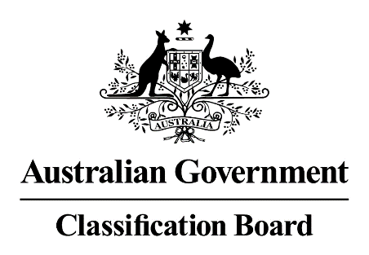
Media Statement — Rocketman classification history
24 May 2019
The Classification Board has considered and classified two versions of the film, Rocketman (2019), a dramatic bio-pic about Elton John, for Paramount Pictures Australia Pty Ltd (Paramount).
The original version (121 minutes in duration) was classified on 5 April 2019 as MA 15+, Strong coarse language. As submitted, this film appeared to be missing end credits and a few sequences appeared to be ungraded.
A modified version of the film (of the same duration) was classified on 16 May 2019, also as MA 15+, Strong coarse language. At the request of Paramount, these two decisions were embargoed until today and will be published to the National Classification Database overnight.
Having regard to the 2012 Guidelines for the Classification of Films, Board standards and precedent, and community standards, the impact of particular language in these films was, in the Board’s opinion, strong and therefore, the films warranted a legally restricted classification of MA 15+. People under the age of 15 years may be admitted to an MA 15+ classified film screening in a cinema, provided that they are accompanied by an adult who remains in the cinema for the film’s duration. The Board noted that the films contained other coarse language that could be accommodated in a lower classification level.
On 21 May 2019, upon application by Paramount, the Classification Review Board, which is separate and independent from the Classification Board, reviewed the modified version of the film and classified it M, Mature themes, drug use, sex scene and frequent coarse language.
The Classification Review Board’s decision is available at: www.classification.gov.au/About/Pages/review-board-decisions--2019.aspx
Accordingly, as of tomorrow, there will be three decisions viewable on the National Classification Database for the 2019 version of the film, Rocketman.

Margaret Anderson
Director
Classification Board

