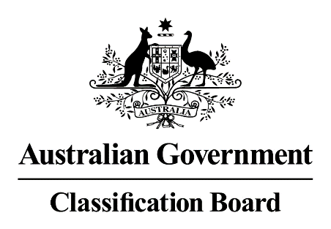

Media Release—Response to the News.com.au article ‘News.com.au forced to remove Islamic State article after Classification Board decision, sparking censorship concerns’ and Adjudication 1732 by the Australian Press Council
28 February 2018
An article published on the website News.com.au on 28 February 2018 (7:41am) by Charis Chang claims that the Classification Board has, for what appears to be the first time, ‘taken the extraordinary censorship decision to ban an Australian news site from reporting a terror threat.’
Contrary to the claims of Charis Chang, the Board did not ban an Australian news site from reporting a terror threat. On 1 June 2017, the Board received an application for classification from the Office of the eSafety Commissioner which consisted of an online webpage and related content. The webpage contained a news article titled “Islamic State terror guide encourages luring victims via Gumtree, eBay” (the original article).
The Board noted that despite the context of a news article, there was only limited author text and the overwhelming majority of the article consisted of detailed references and substantial verbatim quotations from Islamic State’s propaganda magazine, Rumiyah (published in the English language).
Section 9A of the Classification Act requires the Board to consider whether or not the “depiction or description could reasonably be considered to be done merely as part of public discussion or debate or as entertainment or satire.”
Owing to the detailed references and lengthy quotations from Rumiyah, the content of the article, pursuant to Section 9A (2)(b) of the Classification Act, indirectly provided instruction on the doing of a terrorist act. As such, the Board determined that the content should be Refused Classification pursuant to Schedule 7 of the Broadcasting Services Act 1992 and in accordance with Section 9A of the Classification (Publications, Films and Computer Games) Act 1995.
The Board agrees with News.com.au editor-in-chief, Kate de Brito, that ‘Australians have a right to know if their safety or lives are being placed at risk’, but notes the temperance of this by the Australian Press Council, which in Adjudication 1732 (Australian Press Council Adjudication 1732 document) found that the original article ‘did publish much of the source material from IS verbatim, with limited author input and accompanying analysis or context’ and that ‘republishing content from terrorist entities in this manner can perpetuate the purpose of such propaganda and give publicity to its ideas and practices’, and ‘could pose a risk to public safety, and reasonable steps should be taken to prevent such an outcome.’
Margaret Anderson
Acting Director
Classification Board

