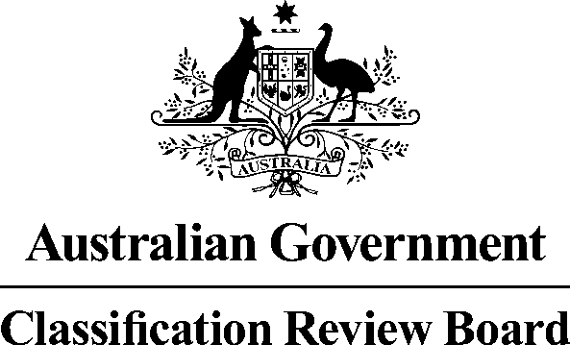

30 August 2016

MEDIA RELEASE

Classification review announced for the film Blair Witch

The Classification Review Board has received an application to review the classification of the film Blair Witch.

Blair Witch was classified MA 15+ with the consumer advice ‘Strong supernatural themes’ by the Classification Board on 17 August 2016.

The Classification Review Board will meet on 5 September 2016 to consider the application. The decision and reasons will later be published on www.classification.gov.au.

If an individual or organisation wishes to apply for standing as an interested party to this review, please write to the Convenor of the Review Board. The names of interested parties will be disclosed in the Review Board’s final decision report, unless requested otherwise.

The closing date to lodge your application for standing as an interested party and any submissions is 2 September 2016. Please note that the Review Board can only consider submissions about Blair Witch itself and not any other matters relating to film classification policy or issues generally.

Submissions should be emailed to crb@classification.gov.au or sent to:

The Convenor Classification Review Board Locked Bag 3
HAYMARKET NSW 1240

The Classification Review Board is an independent merits review body. It makes a fresh classification decision upon receipt of an application for review. The Classification Review Board decision takes the place of the original decision made by the Classification Board.

Media contact
Media Enquiries Officer 02 9289 7100

