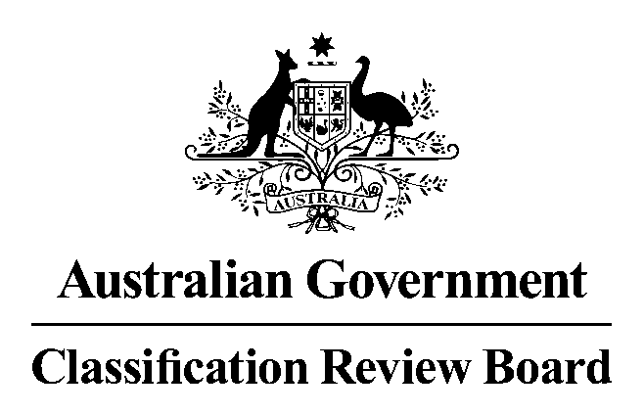

Media release

Hellboy classified R 18+
5 April 2019
A five-member panel of the Classification Review Board has unanimously determined that the film, Hellboy, is classified R 18+ (Restricted) with the consumer advice ‘High impact violence, blood and gore’.
In the Classification Review Board’s opinion Hellboy warrants an R 18+ classification because the violence has a high impact. The overall impact of the classifiable elements in the film was high.
It is the view of the Classification Review Board that the fantasy context does not mitigate the cumulative impact of the violence on a more vulnerable audience.
Films classified R 18+ are legally restricted to adults. Persons aged under 18 years cannot view these films in the cinema or purchase films classified R 18+. Some material classified R 18+ may be offensive to sections of the adult community. Consumer advice is additional information about the main content of a film which is intended to help consumers decide if they want to view this type of material.
The Review Board convened today in response to an application from the original applicant, Roadshow Films, to review the decision made by the Classification Board on 26 March 2019 to classify Hellboy R 18+, ‘High impact violence, blood and gore’.
In reviewing the classification, the Review Board worked within the framework of the National Classification Scheme, applying the provisions of the Classification (Publications, Films and Computer Games) Act 1995, the National Classification Code and the Guidelines for the Classification of Films 2012. This is the same framework used by the Classification Board.
The Review Board is an independent merits review body. It makes a fresh classification decision upon receipt of an application for review. This Review Board decision takes the place of the original decision made by the Classification Board.
The Review Board’s reasons for this decision will appear on the Classification website when finalised.
Media contact
02 6271 1000
Statement authorised by Convenor, Classification Review Board

