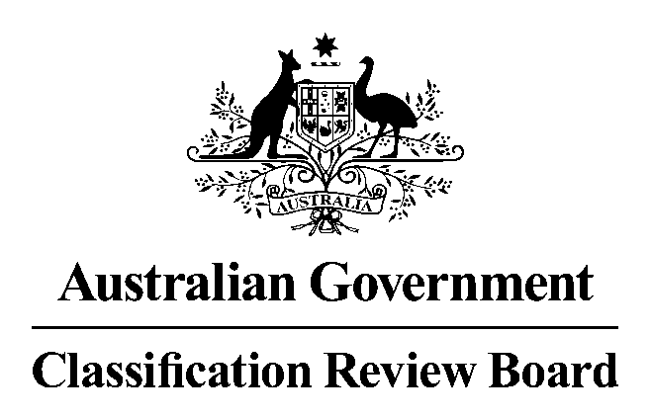

10 September 2015

23-33 MARY STREET
SURRY HILLS, NSW

MEMBERS: Fiona Jolly – Acting Convenor
Peter Attard
Richard Williams

APPLICANT Studiocanal Pty Ltd

INTERESTED
PARTIES Australian Council on Children and the Media

BUSINESS To review the Classification Board’s decision to classify the film Blinky Bill The Movie PG with the consumer advice “Mild themes and crude humour, some scenes may scare very young children”.

DECISION AND REASONS FOR DECISION

1. Decision
The Classification Review Board (the Review Board) unanimously classified the film G, with the consumer advice “Some scenes may scare very young children”.

2. Legislative provisions
The Classification (Publications, Film and Computer Games) Act 1995 (Cth) (the Classification Act) governs the classification of films and the review of classification decisions.

The Review Board
Part 5 of the Classification Act outlines the provisions relevant to the Review Board and its procedures.
Section 42 of the Classification Act sets out the persons who may apply for review of a decision:
- the Minister
- the applicant for classification of the film, or the likely classification of the film under section 33
- the publisher of the film, or
- a person aggrieved by the decision.
Section 43 sets out the conditions regarding the manner and form of applications for review, including time limits. Under section 44, the Review Board must deal with an application for review in the same way that the Board deals with an application for classification of a film.

Classification of Films under the Classification Act
Section 9, provides that films are to be classified in accordance with the National Classification Code (the Code) and the classification guidelines. Section 9A states that a computer game that advocates the doing of a terrorist act must be classified RC.
Section 11 of the Classification Act requires that the matters to be taken into account in making a decision on the classification of a film include:
- the standards of morality, decency and propriety generally accepted by reasonable adults; and
- the literary, artistic or educational merit (if any) of the film; and
- the general character of the film, including whether it is of a medical, legal or scientific character; and
- the persons or class of persons to or amongst whom it is published or is intended or likely to be published.

The National Classification Code
Relevantly, the Film Table of the Code provides that:
Films (except RC films, X 18+ films, R 18+ films, MA 15+ films and M films) that
cannot be recommended for viewing by persons who are under 15 without the guidance of their parents or guardians are to be classified ‘PG’.

Films that do not require the guidance of their parents or guardians are to be classified ‘G’.

The Code also sets out various principles to which classification decisions should give effect, as far as possible:
- adults should be able to read, hear, see and play what they want
- minors should be protected from material likely to harm or disturb them
- everyone should be protected from exposure to unsolicited material that they find offensive
- the need to take account of community concerns about:
  - depictions that condone or incite violence, particularly sexual violence and,
  - the portrayal of persons in a demeaning manner.

The Guidelines
Three essential principles underlie the use of the Guidelines for the Classification of Films (the Guidelines), determined under section 12 of the Classification Act:
- the importance of context
- the assessment of impact, and
- the six classifiable elements – themes, violence, sex, language, drug use and nudity.

3. Procedure
Three members of the Review Board met on 10 September 2015 in response to the receipt of an application from Studiocanal Pty Ltd on 27 August 2015 to conduct the review of the film, Blinky Bill The Movie, which had previously been classified PG by the Classification Board. The Review Board determined that the application was a valid application.
The Review Board was provided a written submission from the Applicant.
The Review Board was provided a written submission from the Australian Council on Children and the Media.
The Review Board viewed the film.
The Review Board heard an oral submission from the Applicant.
The Review Board then considered the matter.

4. Evidence and other material taken into account
In reaching its decision, the Review Board had regard to the following:
- Studiocanal’s application for review
- Studiocanal’s written and oral submissions
- a written submission received from the Australian Council on Children and the Media
- the film, Blinky Bill The Movie
- the relevant provisions in the Classification Act, the Code and the guidelines, and
- the Classification Board’s report.

5. Synopsis
The animated film, Blinky Bill The Movie, follows Blinky Bill leaving the town of Green Patch, making new friends, encountering various adverse conditions and adversaries, while searching for his lost father.

6. Findings on material questions of fact
The Review Board found that the film contains aspects or scenes of importance under various classifiable elements:
(a) Themes – The film contains various themes including a son – Blinky - searching for his lost father, and the theme of good triumphing over bad. These themes contain a very low threat of menace. In a number of scenes - particularly at 22 minutes, 36 minutes, and 79 minutes, Blinky, Nutso and Jacko are chased by Claude the Cat who threatens to eat Blinky and his friends, and at 57 minutes, 58 minutes, 60 minutes and 83 minutes, there are also various scenes of angry crocodiles chasing Blinky and his friends as they try to escape, and two scenes where Claude the Cat is implied to have been eaten by a crocodile. These scenes are all justified by context and have a very low sense of threat and menace.
The impact of this element is no higher than very mild and can be accommodated at the G level.

(b) Violence – contains scenes of slapstick violence, which are always diminished by cartoony animation, sound effects and humour. These scenes are of a very low sense of threat and/or menace, and are justified by context.
The impact of this element is no higher than very mild and can be accommodated at the G level.

(c) Sex – There is no sexual activity in the film.

(d) Language – there is an array of colloquial Australian slang throughout, which is justified by the Australian bush/outback context of the narrative. The word ‘stupid’ is used several times, as well as the word ‘friggin’ at 34 minutes into the film, both of which are examples of very mild coarse language, used infrequently, and justified by the context.
The impact of this element is no higher than very mild and can be accommodated at the G level.

(e) Drug Use – There is no drug use in this film.

(f) Nudity – There is no nudity in this film.

7. Reasons for the decision
The Review Board unanimously determined Blinky Bill The Movie, ‘G’ on the basis that its themes and treatment of violence are of a very mild nature. Scenes where there is a sense of threat are resolved with positive outcomes, mitigated by humour and are relevant to the context.
The occasional coarse language is very mild.
The Review Board determined the consumer advice of ‘Some scenes may scare very young children’.

8. Summary
The Review Board unanimously determined Blinky Bill The Movie, ‘G’, and should accompanied by the consumer advice of ‘Some scenes may scare very young children’.

