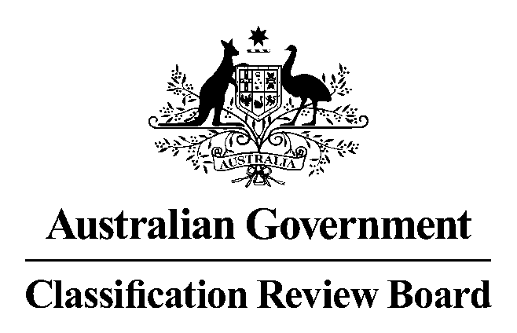

14 November 2011
23-33 MARY STREET
SURRY HILLS, NSW

MEMBERS: Ms Helena Blundell (Chair)
Ms Ann Stark
Dr Melissa de Zwart

APPLICANT Hoyts Distribution

INTERESTED
PARTIES

BUSINESS To review the Classification Board’s decision to classify the film The Twilight Saga: Breaking Dawn – Part 1 MA 15+ (Mature Accompanied) with the consumer advice ‘Strong themes’.

DECISION AND REASONS FOR DECISION

1. Decision

The Classification Review Board (the Review Board) unanimously classified the film M (Mature), with the consumer advice ‘.supernatural themes and medical procedures’.

2. Legislative provisions

The Classification (Publications, Film and Computer Games) Act 1995 (Cth) (the Classification Act) governs the classification of films and the review of classification decisions. Section 9 provides that films are to be classified in accordance with the National Classification Code (the Code) and the classification guidelines.

Relevantly, the Code in paragraph 5 of the Table under the heading ‘Films’ provides that:

Films (except RC films, X 18+ films, R 18+ films and MA 15+ films) that cannot be
recommended for viewing by persons who are under 15 are to be classified M.

The Code also sets out various principles to which classification decisions should give effect, as far as possible.

Section 11 of the Act requires that the matters to be taken into account in making a decision on the classification of a film include:

(a) the standards of morality, decency and propriety generally accepted by reasonable adults; and
(b) the literary, artistic or educational merit (if any) of the film; and
(c) the general character of the film, including whether it is of a medical, legal or scientific character; and
(d) the persons or class of persons to or amongst whom it is published or is intended or likely to be published.
Three essential principles underlie the use of the Guidelines for the Classification of Films and Computer Games 2005 (the Guidelines), determined under s 12 of the Act:
- the importance of context
- the assessment of impact, and
- the six classifiable elements – themes, violence, sex, language, drug use and nudity.
3. Procedure

The Review Board met on 14 November 2011 in response to the receipt of an application from Hoyts Distribution on 10 November 2011 to conduct the review.

Three members of the Review Board viewed the film on 14 November 2011.

The Review Board heard oral submission from Robert Slaviero, Heather MacMillan and John Dickie, representatives of the applicant. This was provided in addition to a written submission.

The Review Board then considered the matter.

4. Evidence and other material taken into account
In reaching its decision the Review Board had regard to the following:

- Hoyts Distribution application for review
- Hoyts Distribution written and oral submissions
- the film, The Twilight Saga: Breaking Dawn – Part 1
- the relevant provisions in the Classification Act, the Code and the Guidelines, and
- the Classification Board’s report
5. Synopsis

The film is the fourth film in the Twilight Saga. The film begins with Bella preparing for her wedding to Edward Cullen with the assistance of friends and family. Bella and Edward marry and travel to an island in a remote South American location for their honeymoon. Here they consummate their marriage. Bella discovers that she is pregnant and the baby grows rapidly impacting on her health. Edward and his family are concerned about the risk posed to Bella’s health by the baby. The tension between the local wolf clan and the Cullen vampires is reignited. Bella collapses in the late stages of pregnancy. A healthy girl baby is delivered by emergency caesarean. Bella dies and Jacob and Edward try frantically to revive her. While this is going on the wolf clan attacks the Cullen vampires. Bella is restored and awakes as a vampire.

6. Findings on material questions of fact
The Review Board found that the film contains aspects or scenes of importance under various classifiable elements:

- Themes – The treatment of Bella’s supernatural pregnancy and the birth of a half human half vampire baby convey a moderate sense of threat or menace which is justified by context.

A number of scenes create a sense of danger to Bella and foreboding about the outcome of the birth of the child she is carrying. At about 54.20 minutes the South American housekeeper prophesises death. At about 102.57 minutes Jacob tells Bella “It’s a killer”. At about 113 minutes Carlisle tells Edward that Bella’s rib is cracked and “it’s crushing her from inside out”. However the impact of this sense of menace and danger is mitigated by scenes such as the one at about 1.23 minutes where Edward and Bella are shown listening to the baby and Edward tells Bella “he’s like you – good, pure and happy”.

The scenes directly relating to the performance of an emergency caesarean section are of relatively short duration lasting approximately 2 and a half minutes. Cinematic techniques such as blurring, long shots and fragmented scene shots are used which have the effect of minimising the overall impact so that this element can be accommodated in the M classification.

(b) Violence – The violence depicted in the film is moderate and justified by context.
(c) Language – There was no course language.

(d) Sex – There was sexual activity which was discretely implied and was justified by context.

(e) Drug Use – There was limited drug use in a medical context which was justified by context.

(f) Nudity – There was no nudity.

7. Reasons for the decision

The applicant submitted that the film should be considered in the context of the previous three films in the series. The Board determined that it was required to consider this film on a standalone basis. The Board determined that the film falls generally within the vampire/supernatural genre.

The Board determined that the highest classifiable element was themes. All other elements could comfortably be accommodated within an M or lower classification.

In relation to themes, the Board determined that although a number of scenes dealt with the fact of Bella’s supernatural pregnancy and the resultant dangers to her life and health, the impact of these scenes was mitigated both by storytelling elements such as interspersed scenes and cinematic techniques such as blurring, long shots and fragmented scene shots. These had the effect of reducing the overall impact of the sense of threat or menace and the film does not exceed moderate in viewing impact and scan be accommodated within an M classification,
8. Summary
The Board determined that the film should be classified with consumer advice “supernatural themes and medical procedures”.

