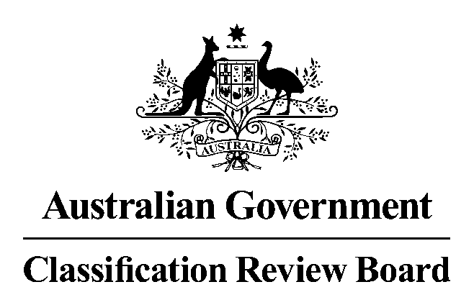
Date: 7 May 2021
Members: Sue Knowles (Convenor)
Peter Price AM (Deputy Convenor)
Susan Bush
Applicant: Studiocanal
Interested parties: Studiocanal
Elizabeth Trotman (CEO)
Greg Denning (Head of Sales)
Andrew Rolfe (Manager, Operations)
John Dickie (former Chief Censor, Classification Branch)
Chester S
Olga Anderson
Nobody Movie
Kyle Krischker

Business: To review the Classification Board’s decision to classify the film Spiral: From the Book of Saw, R 18+ (Restricted) with the consumer advice ‘High impact violence’.

Decision and reasons for decision

1. Decision
The Classification Review Board (the Review Board) unanimously classified the film R18+, with the consumer advice ‘High impact violence, blood and gore’.

2. Legislative provisions
The Classification (Publications, Film and Computer Games) Act 1995 (Cth) (the Classification Act) governs the classification of films and the review of classification decisions.

The Review Board
Part 5 of the Classification Act outlines the provisions relevant to the Review Board and its procedures.
Section 42 of the Classification Act sets out the persons who may apply for review of a decision:
- the Minister
- the applicant for classification of the film, or the likely classification of the film under section 33
- the publisher of the film, or
- a person aggrieved by the decision.
Section 43 sets out the conditions regarding the manner and form of applications for review, including time limits. Under section 44, the Review Board must deal with an application for review in the same way that the Classification Board deals with an application for classification of a film.

Classification of films under the Classification Act
Section 9, subject to section 9A, provides that films are to be classified in accordance with the National Classification Code (the Code) and the classification guidelines. Section 9A states that a film that advocates the doing of a terrorist act must be classified RC.
Section 11 of the Classification Act requires that the matters to be taken into account in making a decision on the classification of a film include the:
- standards of morality, decency and propriety generally accepted by reasonable adults, and
- literary, artistic or educational merit (if any) of the film, and
- general character of the film, including whether it is of a medical, legal or scientific character, and
- persons or class of persons to or amongst whom it is published or is intended or likely to be published.

The National Classification Code
Relevantly, the Films Table of the National Classification Code (the Code) provides that:
Films (except RC films and X 18+ films) that are unsuitable for viewing or playing by a minor are to be classified R 18+, and
The Code also sets out various principles to which classification decisions should give effect, as far as possible:
- adults should be able to read, hear, see and play what they want
- minors should be protected from material likely to harm or disturb them
- everyone should be protected from exposure to unsolicited material that they find offensive
- the need to take account of community concerns about:
- depictions that condone or incite violence, particularly sexual violence and,
- the portrayal of persons in a demeaning manner.

The Guidelines
Three essential principles underlie the use of the Guidelines for the Classification of Films 2012 (the Guidelines), determined under section 12 of the Classification Act, the:
- importance of context
- assessment of impact, and
- the six classifiable elements—themes, violence, sex, language, drug use and nudity.

3. Procedure
Three members of the Review Board met on 7 May 2021, in response to the receipt of an application from Studiocanal on 27 April 2021, to conduct the review of the film, Spiral: From the Book of Saw, which had previously been classified R18+ (Restricted) with consumer advice of ‘High impact violence’ by the Classification Board. The Review Board determined that the application was a valid application.
The Review Board was provided a written submission from the Applicant.
The Review Board viewed the film.
The Review Board was provided a written submission(s) from:
Studiocanal
Chester S
Olga Anderson
Nobody Movie
Kyle Krischker.
The Review Board heard an oral submission from the Applicant.
The Review Board then considered the matter.

4. Evidence and other material taken into account
In reaching its decision, the Review Board had regard to the following:
- Studiocanal application for review
- Studiocanal written and oral submissions
- a written submission received from the four other interested parties listed above
- the film, Spiral: From the Book of Saw
- the relevant provisions in the Classification Act, the Code and the Guidelines, and
- the Classification Board’s report.

5. Synopsis
Spiral: From The Book of Saw is an American-Canadian co-production in which Detective Zeke Banks pursues a killer who is hunting police offers and killing them using elaborate torturing machines - similar to the behaviour of the serial killer Jigsaw which is from the Saw franchise.

6. Findings on material questions of fact
The Review Board found that the film contains aspects or scenes of importance under various classifiable elements:
(a) Themes—Within the R18+ classification there are virtually no restrictions on the treatment of themes
The impact of this element is no higher than high and can be accommodated at the R18+ classification level. This classifiable element includes not only acts of violence, but also the threat, effect of or result of violence.
(b) Violence—Within the R18+ classification, violence is permitted
The impact of this element is no higher than high and can be accommodated at the R18+ classification level.
(c) Sex—
Not applicable
(d) Language—Within the M or MA 15+ classification
The impact of this element is no higher than strong.
(e) Drug Use—Within the M classification
The impact of this element was infrequent and justified by context
(f) Nudity—
Not applicable

7. Reasons for the decision
In making the decision, the Review Board has applied the Classification (publication, Films and Computer Games) Act 1995 (the Classification Act), the National Classification Code (the Code) and the Guidelines for the Classification of Films 2012 (the Guidelines).
In the Review Board’s opinion, this film warrants an R18+ classification as, in accordance with item 3 of the films table of the Code, the impact of the classifiable elements are high and unsuitable for a minor to see.
The classifiable elements of themes at this classification have virtually no restrictions. Violence at this classification is permitted.
The Review Board’s view was that immediately from the introduction in the film there was extreme violence which was followed by regular displays of dismemberment, torture, blood detail, human mutilation, threat and taunting.

8. Summary
The examples described below are in addition to the Classification Board’s examples and do not represent an exhaustive list of the content that caused the film to be classified R18+. The times given are approximate.
At 3 minutes, the opening scenes depict a person in complex mechanical traps. This leads to blood detail, torture, menace and threat. The aftermath of these scenes are closely examined, such as a tongue of the victim seen hanging in a vice.
At 33 minutes, there are fingers attached to a device that are seen to be dismembered.
At 56 minutes there is a scene of a human hand hanging in a butcher’s shop followed by a skinned human body also hanging in the same shop.
At 62 minutes, Angie, while being restrained, has hot wax poured over her face which, when peeled off, shows her to be severely burned.
At 73 minutes there is a close up of a badly mutilated body having been showered with shards of glass.
At 75 minutes, Banks is shown pulling shards of glass from himself.
In the Review Board’s opinion, a classification of R18+ is therefore warranted with a consumer advice of ‘high impact violence, blood and gore’.

