Australian Government
Department of Infrastructure, Transport, Regional Development and Communications

Report on classification usage and attitudes research
27 May 2022

Quality and Compliance Statement
This project was conducted in accordance with the international quality standard ISO 20252, the international information security standard ISO 27001, as well as the Australian Privacy Principles contained in the Privacy Act 1988 (Cth). ORIMA Research also adheres to the Privacy (Market and Social Research) Code 2021 administered by the Australian Data and Insights Association (ADIA).

Acknowledgments
ORIMA pays respect to Aboriginal and Torres Strait Islander Peoples past and present, their cultures and traditions and acknowledges their continuing connection to land, sea and community.

We would also like to acknowledge and thank all the participants who were involved in our research for their valuable contribution.

Contents
Executive Summary 3
1. Introduction 1
1.1. Background 1
1.2. Research objectives 1
1.3. Research methodology 2
1.4. Presentation of findings 4
2. Contextual background: media consumption and decision making 7
2.1. Platform and media consumption: adults 7
2.2. Platform and media consumption: children 10
2.3. Content decisions and perceptions of suitability 12
2.4. Engagement with classification 13
3. Usage and value of classification 14
3.1. Usage of classification information 14
3.2. Usage of consumer advice 17
3.3. Overall usefulness and importance 20
3.4. Importance for parents / carers 21
4. Awareness and understanding of classification 23
4.1. Awareness of classification and consumer advice 23
4.2. Understanding of classification ratings and consumer advice 26
5. Classification system expectations 28
5.1. Key expectations 28
5.2. Overall comfort and fulfilment of expectations 30
5.3. Consistency 31
6. Potential improvements to the classification system 34
6.1. Overview of potential improvements 34
6.2. Potential changes to classification information 34
7. Agreement with recent classification decisions 38
7.1. Overall satisfaction with classifications 38
7.2. Areas of less agreement 41
8. Usage and perceptions of parental controls and other media 43
8.1. Usage of parental controls 43
8.2. Perceptions of parental controls 45
8.3. Usage and perceptions of children’s access to online content 46
9. Conclusions 48
APPENDIX A: Demographic profile of participants in the qualitative research 50
APPENDIX B: Quantitative Sample Demographics 53

Executive Summary
Background and methodology
ORIMA Research was commissioned by the Classification Branch of the Department of Infrastructure, Transport, Regional Development and Communications to conduct the 2022 Classification Usage and Attitudes Research to inform the work of the Classification Board (the Board) as well as additional areas of policy development.

The key objectives of the research were to identify the Australian public’s:
- Understanding of classification categories and related consumer advice;
- Behaviours and usage of classification information to inform media consumption decisions as well as its perceived importance;
- Agreement with recent classification decisions;
- Perceptions and expectations of the classification system; and
- Views on the effectiveness of parental controls in streaming video on demand (SVoD) and online game platforms.

The research comprised of:
- Qualitative research – via 9 face-to-face focus groups and 4 online focus groups with a total of n=105 participants across Australia; and
- Quantitative research – involving n=2,054 online surveys with the general public.
Usage and value of classification
Overall, classification played a much greater role in deciding content suitability for children among parents / carers than for adults themselves. Classification was the highest ranked source of information in helping parents make decisions about what is suitable for their children, and four in five (81%) used consumer advice at least sometimes to ensure that there was no content that would be unsuitable for their children.

While rarely the top ranked source for determining content suitability among adults, classification information was found to have an important role for a minority – around one in four to one in five respondents ranked it as the most important source across the various media types. In addition, many have used consumer advice to avoid certain types of content, including:
- Content that is disturbing (63% at least sometimes used consumer advice for this reason); and
- Triggering or traumatic content (58%).

Overall, the importance, usefulness and social value of classification was widely recognised by participants, even if it was not as personally useful or relevant to their current situation. 88% of respondents felt classification was personally useful and almost all felt it was useful to people responsible for children (97%) and to the Australian community (96%).
Awareness and understanding of classification
The research found high awareness and understanding of the key classification ratings and definitions – this ranged from 85-93% for the different classification categories (excluding the niche X18+ category). There was also strong agreement that classification ratings and consumer advice were easy to use (75% and 74% respectively). Only a small minority of respondents disagreed (7% and 6% respectively).

Overall expectations
Eight key expectations in relation to the classification system were identified in the research, as outlined below.

Satisfaction with the classification system and potential improvements
The classification system was largely found to be meeting the expectations of consumers – 79% of respondents agreed that the system met their expectations and only 5% disagreed.

More specifically, key expectations were generally being met for most in relation to:
- The classification categories – the majority of respondents (74%) felt that they did not need to change and only 5% disagreed;
- The classification of content and consistency across different media:
- Three in four (74%) respondents reported that there was consistency between the classification of movies and streaming content and only 5% disagreed;
- 70-86% of respondents were comfortable with classification for the different media types tested and only a minority disagreed (less than 10% for any type); and
- The protection of children – seven in ten parents / carers agreed classification and consumer advice worked well to help them ensure their children were accessing appropriate content and only 9% disagreed.

The expansion and specificity of consumer advice was identified as the main area for improvement in relation to current classification arrangements. Many felt that this should be “modernised” to reflect a wider range of community sensitivities, including greater recognition of mental / emotional harm of some content. Consistent with this, the majority of respondents agreed (and only a small minority disagreed) that:
- Consumer advice should be given about content that could be distressing to some people (e.g. suicide, rape, abuse of women or children) – 84% agreed;
- Specific warnings should be included about content that could be offensive to some people (e.g. racism, homophobia) – 75%; and
- Discriminatory language (e.g. racism and homophobic slurs) should be included in the definition of course language – 72%.

While lack of consistency in the display of classification content did not emerge as a key concern, perceived clarity of display was somewhat lower on streaming services and online gaming platforms compared to other media types. Some participants felt that improving display clarity could support consumers to more easily find and utilise this information.
Agreement with classification decisions
The research found general satisfaction and agreement with recent classification decisions. Most respondents (77%) could not recall disagreeing with the classification of a movie, show or video game in the last 3 years. Disagreement was highest with the classification of movies (17% vs 7% for video games and shows) and most commonly for movies seen on streaming services (40% vs 25% for movies in the cinema). Among the minority that did report disagreement with a classification, many could not recall what the content was and / or noted examples that were not recent.

This suggests that most recent classification decisions made by the Board are aligned to community expectations. Where the content is not matching expectations, it is often due to content that had been classified some time ago and / or had not left a lasting impression.
Usage and perceptions of parental controls and other media
The main concern identified in relation to content suitability for children was access and exposure to unsuitable content via free online platforms (e.g. YouTube and TikTok) – which was a key and top-of-mind concern for parent / carer participants. While greater regulation of this content was desirable, classification of content on free online sharing platforms was not expected by the majority of parents / carers. This was recognised as difficult and unfeasible by many, especially by those with higher familiarity with the platforms. In addition, many also acknowledged that it was ultimately a parental responsibility to oversee what content their children were exposed to.

While some challenges in applying parental controls were identified, the majority of parent / carer respondents reported that parental controls worked well in helping make sure their children accessed appropriate online content. However, 10% disagreed and almost half (45%) did not use parental controls. In addition, it was evident that not all parent / carer participants were aware of the full range of parental controls available. This indicates that online safety education and support for parents is a broader, ongoing need.
Overall conclusions
The research indicates that the classification system and recent classification decisions by the Board are largely meeting community expectations. The familiarity and perceived usability of the current classification categories suggests that they should be maintained in their current form.

A key area to consider focusing on in relation to the classification system improvements was the expansion and specificity of consumer advice – specific statements / areas for inclusion tested outlined in Chapter 6.

Given the increased prevalence of streaming services and online gaming, clarity of classification display on these services could be an area for further exploration in future research and policy development.

- Introduction
  - Background
The National Classification Scheme (the Scheme) provides a framework by which films, video games and certain publications made available in Australia must be classified and receive a rating and consumer advice. Classification ratings aim to help consumers make informed choices about what they watch, play or read. The Scheme, established in 1995, applies to online and physical video games, films and episodic series on various platforms including in cinemas, on DVD and online (such as streaming services and subscription video on demand). Films and computer games are classified either G (General), PG (Parental guidance recommended for persons under 15), M (for Mature audiences – not recommended for persons under 15), MA 15+ (Mature Accompanied – restricted to persons 15 years or over unless accompanied by a parent or guardian), R 18+ (restricted to adults 18 or over) or X 18+ (for sexually explicit films) (see image below). In addition to the classification category, consumer advice is given which notes the strongest content in a film or computer game.

Image: Classification ratings


It is important for classification decisions to reflect current community standards as much as possible. As such, periodical social and market research into the Australian public’s usage of, and agreement with, recent classification decisions is conducted to inform the work of the Board.

The Department of Infrastructure, Transport, Regional Development and Communications (the Department) provides administrative support to the Board. The Department commissioned ORIMA Research to conduct the 2022 Classification Usage and Attitudes Research to inform the work of the Board as well as additional areas of policy development, as outlined in section 1.2 below. This report presents the findings of the research.
  - Research objectives
The key objective of the research was to inform the work of the Board and related policy development and communications activities.

More specifically, the research sought to understand the Australian public’s:
- Understanding of classification categories and related consumer advice;
- Behaviours and usage of classification information to inform media consumption decisions as well as its perceived importance;
- Agreement with recent classification decisions;
- Perceptions and expectations of the classification system; and
- Views on the effectiveness of parental controls in streaming video on demand (SVoD) and online game platforms.

  - Research methodology
The research comprised of:
- Qualitative research – via 9 face-to-face focus groups and 4 online focus groups with a total of n=105 participants across Australia; and
- Quantitative research – involving n=2,054 online surveys with the general public.
Qualitative Research
The qualitative research was conducted between 10 – 23 February 2022.

As shown in Table 1 overleaf, focus group participants included people from metropolitan and regional locations of Australia.

Participants in the focus groups included:
- Members of the general public – split by age and gender;
- Parents / carers of children / young people aged 3-17 years;
- Non-parent key influencers of children aged 3-17 years;
- First Nations parents and community members; and
- Culturally and linguistically diverse (CALD) parents and community members.

Research participants were recruited via:
- ORIMA’s First Nations community interviewers – for Aboriginal and Torres Strait Islander participants; and
- Local specialist external qualitative recruiters for all other participants.

Participants received a reimbursement payment to cover their expenses to attend focus groups of up to 1.5 hours in duration.

The demographic profile of research participants (refer to Appendix A) shows that people from a range of demographic backgrounds participated in the research.

Table 1: Qualitative research design
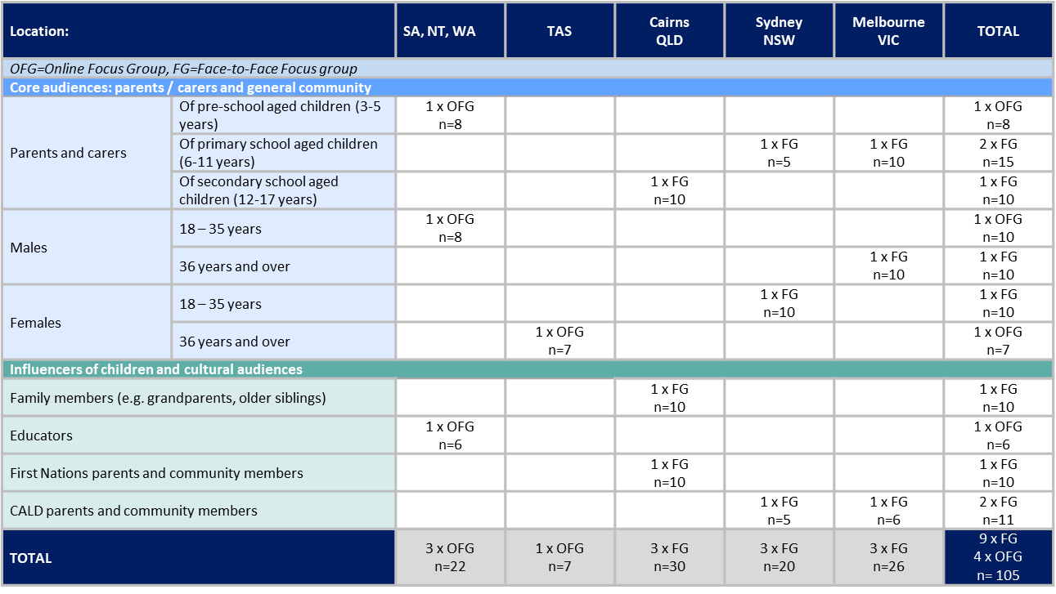

quantitative Research
The quantitative fieldwork was conducted from 15 – 22 March 2022.

It comprised an online survey with n=2,054 Australians aged 18 and over. Respondents were excluded from the research if they did not consume any form of media. The demographic profile of respondents shows that people from a range of demographic backgrounds participated in the research (refer to Appendix B).

Table 2: Sample design
Target audiences | Target | Sample achieved
General community (aged 18 years and older, nationally representative by state/territory, age, and gender) | n=2,000 | n=2,054

The sample was sourced from a high-quality online access panel – the Online Research Unit (ORU) Panel.

The survey data was weighted to align the sample distribution across gender, age, State / Territory and location (metropolitan versus non-metropolitan) with that of the Australian population aged 18 years or older, based on ABS Census 2016 data.
  - Presentation of findings
TErminology
Throughout the report, the following references have been used to differentiate between the quantitative and qualitative research findings:
- The term ‘participant(s)’ refers to participant(s) in the qualitative research whilst ‘respondent(s)’ refers to respondent(s) from the quantitative survey; and
- Numbers and percentages used only refer to the quantitative research findings.
Understanding the qualitaTive resarch findings
Qualitative research findings have been used to provide depth of understanding on particular issues. In some cases qualitative data has been presented without quantitative data. In these instances it should be noted that the exact number of participants holding a particular view on individual issues cannot be measured.

The following terms used in the report provide a qualitative indication and approximation of the size of the target audience who held particular views:

Most – refers to findings that relate to more than three quarters of the research participants;


Many – refers to findings that relate to more than half of the research participants;


Some – refers to findings that relate to around a third of the research participants; and


A few – refers to findings that relate to less than a quarter of research participants.

The most common qualitative findings are reported except in certain situations where only a minority has raised particular issues, but these are nevertheless considered to be important and to have potentially wide-ranging implications / applications.

Participant quotes have been provided throughout the report to support the main results or findings under discussion.
Understanding the quantitatIve research findings
Percentages from the quantitative research presented in the report are based on the total number of valid responses made to the question being reported on. In most cases, results reflect those respondents who had a view and for whom the questions were applicable. ‘Don’t know’ / ‘Not sure’ responses have only been presented where this aids in the interpretation of the results.

Base sizes may vary for questions asked of the same respondents due to respondents being able to select ‘Don’t know’ / ‘Not applicable’ or ‘Prefer not to say’ for a number of questions in the survey (these responses were treated as missing in the analysis – i.e. were removed from the valid response base).

For stacked bar charts, numeric labels for categories that are less than four percent of the total proportion may be removed from a chart for ease of reading and clarity.

Percentage results throughout the report may not sum to 100% due to rounding.

Table 3 provides indicative confidence intervals (at the 95% level of statistical confidence) for different response sizes. Percentage results for questions answered by all respondents to the survey have a degree of sampling error at the 95% level of statistical confidence of +/- 2 percentage points (pp). That is, there is a 95% probability (abstracting from non-sampling error and subject to the caveat set out below in relation to online panel respondents) that the percentage results will be within +/- 2pp of the results that would have been obtained if all Australians aged 18 years or older had responded. Higher degrees of sampling error apply to questions answered by fewer respondents and for specific target audience groups.

Table 3: Statistical precision
Number of respondents | Statistical precision
2,054 | +/- 2pp
1,000 | +/- 3pp
500 | +/- 4pp
200 | +/- 7pp
100 | +/- 10pp
Note: These confidence intervals are upper bound levels based on percentage results of 50%. For higher or lower percentage results, the confidence intervals will be narrower.

The ORU panel’s rigorous recruitment approach (offline as well as online) and large size means that the panel is broadly representative of the underlying Australian population. However, the panel members were not selected via probability-based sampling methods and hence the use of statistical sampling theory to extrapolate the online panel survey findings to the general population is based on the assumption that a stratified random sample of panel members provides a good approximation of an equivalent sample of the general population.
COMPArisons with the 2014 research
Where relevant, data is compared with the 2014 research. This is not done for all questions as not all were directly comparable.
distinctions between Audiences
To aid interpretation of the results, the following symbols have been used to identify the two key target audiences of the research:

Findings that pertain to adult participants / respondents.

Findings that pertain to children (based on responses of their parents / carers).

- Contextual background: media consumption and decision making
This chapter presents background contextual information that is useful to understanding the research findings. It covers reported media consumption and platform usage, factors influencing decision making about content and its perceived appropriateness, as well as engagement with the topic of classification.

Key findings and implications
Media consumption patterns reported by respondents have several potential implications in relation to exposure to classification and survey responses. Specifically:
- Respondents were commonly consuming multiple types of media, as well as multiple streaming services. Therefore they are likely to be exposed to classification information across a variety of channels.
- Frequency of television and streaming service use was higher in comparison to other media (and lowest for cinema – it should be noted that cinema attendance has reduced due to the impacts of COVID-19 restrictions over the past two years). This suggests that respondents are likely to be exposed to classification via these channels more regularly, which may impact their recall and survey responses.
- The proportion of older Australians streaming content, playing video games and using free video sharing platforms (e.g. YouTube) was lower than other age groups. Therefore responses to questions related to these services among older respondents are likely to be based on lower knowledge and exposure.
The research found that perceptions of content appropriateness and suitability were highly subjective and influenced by a broad range of individualised factors. Variation in the expectations of appropriate content at each classification level across the community should therefore be expected. Furthermore, it is unlikely that all members of the Australian community will agree with every classification decision.
  - Platform and media consumption: adults
Figures 1 – 4 (overleaf) show types and frequency of media consumption among adult respondents.

Overall, consumption of films in the cinema was high among respondents (76%). A similar proportion of respondents consumed streaming content, watched by 75% of respondents. Almost three in five respondents played video games (58%). There were large overlaps in the type of media consumed, with almost half of respondents consuming all three forms of content – cinema, streaming, and video games (44%). Usage of multiple streaming services was also very common, with 73% of respondents having access to multiple streaming services.

The consumption of media varied by the age of respondents. In particular, streaming (of both free and paid) content and use of video games gradually decreased in frequency among older age groups.

Frequency of usage varied by media type. Respondents were more likely to be watching / playing TV shows, free online video content (e.g. YouTube, TikTok), video games and streaming content more frequently (around half to three quarters of respondent doing so on a weekly or daily basis) in comparison to watching movies at the cinema (only 7% of respondents reported doing so weekly).

Video games also have a distinct usage frequency pattern. Though over half (58%) of respondents ever played video games (48% mobile devices, 49% consoles and handhelds), those that did were playing them on a frequent basis.

Figure 1: Types of media consumption among adults
Q9: How often do you personally watch / play the following…? More frequently than ‘never’.
Base: All (n=2,054).
Note: Not shown: Watch free to air or online video sharing services only (8%)

Figure 2: Types of media consumption among adults by age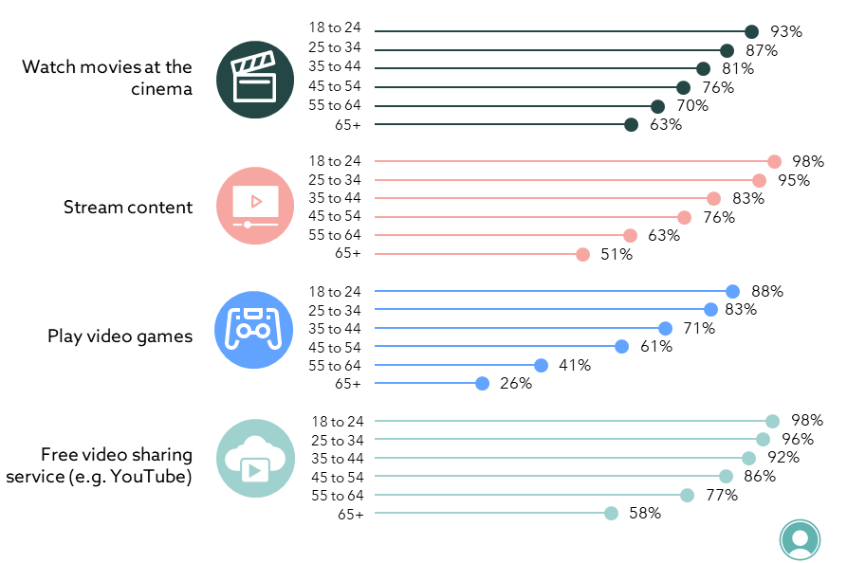
Q9: How often do you personally watch / play the following…?
Base: All (n=2,054 overall). Age bases range from n=227 to 456. Note: Not shown: Watch free to air (93% overall)
Figure 3: Frequency of media consumption among adults using each platform
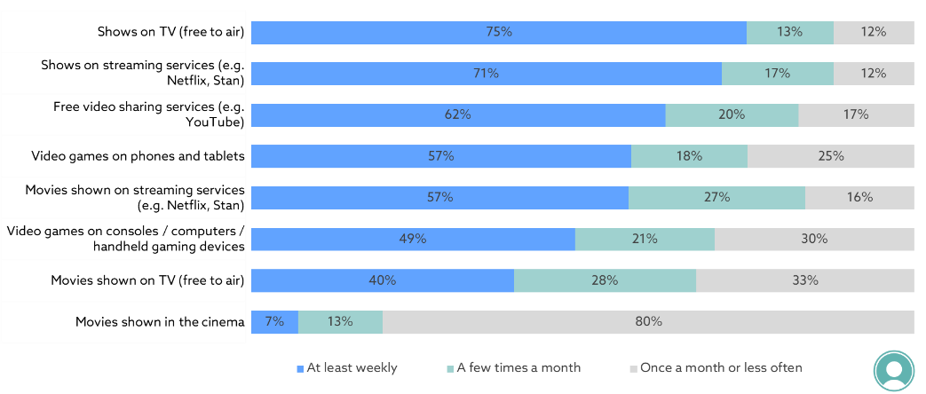
Q9: How often do you personally watch / play the following…?
Base: All (n=986 to 1,877)
Note: Excludes ‘Don’t know’ and ‘Never’ responses

Figure 4: Streaming service usage
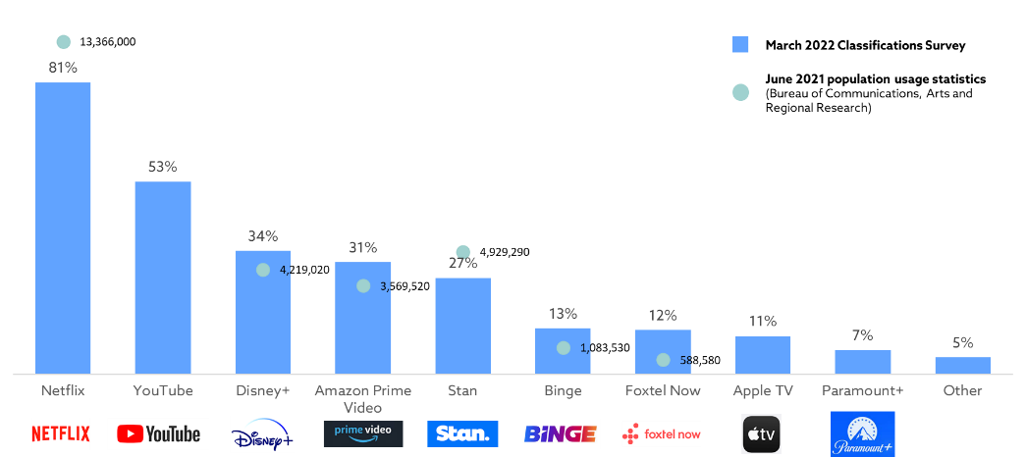

Q11. What streaming services do you use?
Base: Use streaming services (n=1,552). Note: Don’t know (1%) not shown
Subscription Video on Demand (SVoD) in Australia dashboard, Bureau of Communications, Arts and Regional Research (results based on the proportion of Australians aged 14 or older accessing the service)

  - Platform and media consumption: children
29% of survey respondents were parents / carers of children under the age of 18. These respondents were asked to provide the media consumption habits of their children, presented in Figures 5 – 7 overleaf.

Almost all parents reported that their children consumed one of the three media types of interest (93%) and 63% reported that their children used all three. Almost all parents / carers indicated that their child used free online video sharing services (86%) – see Figure 41 for the breakdown of usage by child age. Children were also commonly watching streaming services (84%) and playing video games (81%). Movie watching at cinemas was the least common form of media consumption among children, with three in four parents reporting that their children watched movies at the cinema (76%).

Differences in child media consumption were also apparent by age. Children aged 0 to 3 were less likely to watch movies at the cinema, watch streaming content or play video games.

Similarly to adults, children were less likely to be watching movies at the cinema on a regular basis, compared to other forms of media.

Figure 5: Media consumption among children  Q10: How often do your children aged 17 or younger watch / play the following…?  Base: Parents and carers (n=598)  Note: Not shown: Watch free to air or online video sharing services only (2%) | Figure 6: Media consumption among children by age of child  Q10: How often do your children aged 17 or younger watch / play the following…?  Base: Parents and carers with children of each age group (n=107-269)  Note: Not shown: Watch free to air (82%), online video sharing services (86%)
Figure 7: Frequency of media consumption among children using each platform
Q10: How often do your children aged 17 or younger watch / play the following…? Base: Parents and carers (n=437 to 515) Note: Excludes ‘Don’t know’ and ‘Never’ responses

  - Content decisions and perceptions of suitability
The qualitative research identified two key factors that drove participants’ media consumption decisions:
- Entertainment value (i.e. alignment with viewing interests and tastes, and expected enjoyment); and
- Appropriateness (i.e. perceived suitability of the content).


“I watch what’s going to be interesting and enjoyable”—CALD parent and community member, Melbourne

The primary factor considered was found to vary depending on whether the content was being selected for personal viewing or with or by others, especially children. More specifically:
- Entertainment value was the primary factor considered when making personal consumption decisions; and
- Appropriateness was the primary factor when selecting content for younger children. Appropriateness also tended to play a greater role when participants were selecting content to watch in a communal environment with other adults (in comparison to alone) as the suitability / comfort of other viewers became a greater consideration. In addition, a few participants noted that they felt less comfortable viewing some types of content with others in certain situations (e.g. viewing sex scenes with parents).

It was evident from the research that participants’ assessment of the “appropriateness” of content was highly subjective and influenced by a range of individualised factors. Most participants recognised there was wide variation in community views in relation to appropriate content. Many also felt that meeting such a broad range of expectations and norms was challenging and acknowledged that classification could not always satisfy all consumers.

Specific factors that were found to influence perceptions of content appropriateness included:
- In relation to children:
- Maturity of the viewer / child – parent / carer participants felt that children matured at different rates, and while some content may be appropriate for more mature viewers of a particular age, it may not be suitable for others of the same age;
- Parenting style / approach – assessments of suitability were found to differ based on parent / carer participant’s capacity and capability to supervise or monitor their child while watching / playing content, as well as their relationship with their child. For example, some participants with a more relaxed parenting approach and / or who were more comfortable discussing particular themes with their child were more likely to allow them to consume higher rated content;
“Every parent is different; one might think it’s suitable another might not”—Parent / carer of a child aged 6-11 years, Sydney

- Personal values and attitudes – such as level of conservatism / liberalism, religion or willingness to be exposed / allow their children to be exposed to different types of content;
- Social and community norms – including perceived suitability and comfort with different types of content (e.g. nudity, drug use and alcohol consumption) as well as the types of content viewed by a child’s peer group;
- Expected impact of content – i.e. whether the content was expected to have a negative impact on the viewer. Participants assessed the likely impact based on which classifiable elements were included in the consumer advice, whether they (or the viewer) had past experiences with, or particular sensitivities to, these types of content, and how realistically the content was portrayed (as more realistic content was felt to have a greater impact on the viewer); and
- Demographic factors – including age, gender and cultural background.

The role of the individual in making decisions about the content that they consumed (or parent / carer for children) was also widely acknowledged. 80% of respondents agreed that ultimately it was up to people to decide what was suitable for them to watch or play and 81% agreed that ultimately it was up to parents / carers to decide what was suitable for children. Only 5-6% disagreed respectively.

“I think it would be a very hard decision to make on behalf of other people, everyone has their own moral compass”—Female, 36+ years, Tasmania
  - Engagement with classification
Around 20% of respondents consistently neither agreed nor disagreed to a range of attitudinal questions towards classification. This indicates that there is a group of respondents who were either less engaged or did not consider the topic of classification to be personally relevant. In addition, the proportion of respondents who indicated strong agreement to attitudinal questions was consistently lower than those who agreed, which is another indicator of lower engagement.

The qualitative research found that engagement was lower among some participants who felt that classification had less personal relevance as they:
- Did not have any children; and / or
- Were open to viewing a large range of content as they were not easily offended.
“[In regard to using classification] No, I’m pretty hard to offend and I don’t have kids”—Male, 36+years, Melbourne
- Usage and value of classification
This chapter presents research findings about the reported usage of classification information (i.e. classification ratings and consumer advice), as well as its perceived value and importance for individuals and the community.

Key findings and implications
Similar to previous research , classification played a much greater role among parents in deciding content suitability for children. Classification was the highest ranked source of information in helping parents make decisions for what is suitable for their children. In addition, four in five (81%) parents / carers used consumer advice at least sometimes to ensure that there is no content that would be unsuitable for their children.
While classification information was rarely the top ranked information source for determining media suitability among adults, the research suggests it has an important role for a minority – between 21-24% of respondents ranked it as the most important source to determine suitability across the various media types. In addition, many have used consumer advice to avoid triggering (58%), offensive and disturbing (63%) content, supporting the value of, and need for, consumer advice.
Overall, the importance, usefulness and social value of classification was widely recognised, even among research participants who did not personally use it. 88 per cent of respondents felt classification was personally useful and over 95% felt it was useful to people responsible for children and to the Australian community.

  - Usage of classification information
Participants in the qualitative research reported using a variety of information sources when making decisions about what content they (or their children) would consume – including classification and consumer advice.

The importance of key information sources in helping make choices about media suitability was tested in the survey to determine the role of classification information. As shown in Figure 8, classification ratings and consumer advice were rarely the top ranked determinant for making decisions about content suitability for adults.

However, classification was still the top ranked source for a minority when nominating their most important source of information when determining the suitability of:
- Movies at the cinema or free to air (24%);
- Video games (21%); and
- Streaming content (21%).

“I do pay attention to the ratings because if its horror I know it will give me nightmares”—CALD parent and community member, Melbourne

The qualitative research suggests that slightly higher importance of classification for movies in comparison to other media could in part be due to the lower levels of flexibility in the viewing environment (and therefore greater importance placed on confirming suitability before use). Some participants reported that they were more concerned about the rating of a movie in the cinema as, unlike when they were watching or playing content at home, it was more difficult to “change the channel” or “walk away” if they became uncomfortable, as they had already outlaid cost, time and effort.

“If you go to the movies and have certain people with you and it’s not appropriate, there’s going to be a lot of people wanting to refute [the classification]”—Male, 18-35 years, NT, SA, WA

Figure 8: Ranking of preferred sources of information when choosing what media is suitable among adults
Q29: Please rank the following from 1 (most important) to 6 (least important) in helping you decide if a movie at the cinema is suitable for you to watch.
Q33: Please rank the following from 1 (most important) to 7 (least important) in helping you decide if a movie or show on a streaming service is suitable for you to watch.
Q31: Please rank the following from 1 (most important) to 6 (least important) in helping you decide if a video game is suitable for you to play.
Base: Movie watchers (n=1,927) , stream content (n=1,545), play video games (n=1,189)

Overall, classification information played a much greater role among parents / carers than among their counterparts. Classification was the highest ranked source of information in helping parents make decisions about what is suitable for their children (see Figure 9).
“I don’t use classification or consumer advice for my husband and I, but we use it for our children”—Educator, SA / WA / NT

Figure 9: Ranking of preferred sources of information among parents / carers when choosing what media is suitable for their children
Q30: Please rank the following from 1 (most important) to 6 (least important) in helping you decide if a movie at the cinema is suitable for your children to watch.
Q34: Please rank the following from 1 (most important) to 8 (least important) in helping you decide if a movie or show on a streaming service is suitable for your children to watch.
Q32: Please rank the following from 1 (most important) to 6 (least important) in helping you decide if a video game is suitable for your children to play.
Base: Parents and carers: has child who watched movies (n=522) / child streams content (n=503) / child plays video games (n=480)

Classification was the source of information most commonly seen as highly important among parents. The largest proportion of parents / carers, around two in five, ranked classification as the most important source of information when deciding the suitability of movies at the cinema, streaming services and video games, as shown below.

Figure 10: Preferred sources of information among parents / carers when choosing what media is suitable for their children – Ranked classification as the most important source
Q30: Please rank the following from 1 (most important) to 6 (least important) in helping you decide if a movie at the cinema is suitable for your children to watch.
Q34: Please rank the following from 1 (most important) to 8 (least important) in helping you decide if a movie or show on a streaming service is suitable for your children to watch.
Q32: Please rank the following from 1 (most important) to 6 (least important) in helping you decide if a video game is suitable for your children to play.
Base: Parents and carers: has child who watched movies (n=522) / child streams content (n=503) / child plays video games (n=480)

The qualitative research found that many parent / carer participants used classification as an initial “filter” of content suitability (especially for preschool, primary and middle school age levels). These participants would only allow their child/ren to watch content of particular ratings (depending on their age) and / or seek additional information about the content for higher ratings, before allowing their children to consume it.

“It’s a first step to filter what kids can watch”—Parent / carer of a child 6-11 years, Sydney
  - Usage of consumer advice
As shown in Figures 8 and 9 above, consumer advice was generally ranked lower as a helpful source of determining content suitability than classification ratings.

The research found that participants used consumer advice to provide further information about the expected type of content to help guide viewing decisions – but only in some situations, which could explain its lower ranking. In particular, participants tended to use consumer advice for:
- Higher rated content (generally MA15+ and above among adults) as they were more likely to feel uncomfortable with certain types of content at this level; and
- PG or M rated media, to decide if the content was suitable for their child.

“PG covers such a broad range of things the [consumer advice helps] to give you an idea of what they will be seeing”—Parent / carer of a child aged 3-5 years, SA / WA / NT

The majority of respondents reported using consumer advice at least sometimes to avoid certain types of content (see Figure 11). Specifically:
- Content that is disturbing (63% at least sometimes used consumer advice for this reason) – the type of content participants found disturbing and / or made them feel uncomfortable was found to vary by the individual. Examples raised by some participants included violence, gore, horror, sexual content or language; and
- Triggering or traumatic content (58%) – this was also found to depend on the individual and their past experiences and exposure to past trauma, as well as how recently the traumatic event had occurred. Examples of such content raised in the qualitative research included suicide and abuse themes.

“I have a friend with severe PTSD, she checks the warnings to see if there’s something that might trigger her”—Female, 18-35 years, Sydney

The research found that there was a portion of respondents who never used consumer advice for the above reasons and they were:
- Males – who were less likely than females to use consumer advice to avoid content that is disturbing or offensive (60% vs 67%). In the qualitative research male participants were more likely to be “open to all content”, including higher rated classifications; and
- Regionally based and older respondents – who were less likely to use consumer advice for both the above reasons. A few older participants in the qualitative research reported that they avoided higher rated content (e.g. only watched PG and below), which may explain why usage was lower among some of these respondents.

Figure 11: Reasons for using consumer advice among adults
Q36. How frequently do you use consumer advice for the following reasons?
Base: All (n=1,905, 1,908)
Note: Excludes ‘Don’t know’ and ‘Unsure’

Parents / carers were asked if they used consumer advice specifically to manage the content that their child was consuming. Roughly four in five used consumer advice to:
- Ensure there was no unsuitable content for their children (81%);
- Consider the suitability of M rated content (80%); and
- Consider the suitability of PG rated content (77%).

Figure 12: Parent / carer specific reasons to use consumer advice
Q36. How frequently do you use consumer advice for the following reasons?
Base: Parents and carers (n=565 to 569)
Note: Excludes ‘Don’t know’ and ‘Unsure’

The pattern of consumer advice usage by parents / carers varied by age of child, peaking between the ages of 4 to 12, and declining as children approached adulthood.

Figure 13: Specific reasons for using consumer advice by age of child
Q36. How frequently do you use consumer advice for the following reasons?
Base: Parents and carers with children in each age group (n=70-223)
Note: Excludes ‘Don’t know’ and ‘Unsure’

Parent / carer participants indicated that this was because:
- Children were generally only watching G-rated content when they were very young and directly supervised (hence consumer advice was less relevant); and
- They had less involvement in supervising their children’s media consumption once they entered their mid-teens, and / or felt more comfortable with their children watching a wider range of content at this age.

  - Overall usefulness and importance
Overall, the research found that the community and social value of classification was widely recognised by respondents, even if it was not as personally useful or relevant to their current situation.

As shown in Figure 14, almost all respondents reported that classification information was useful in some regard. The majority (88%) reported personal usefulness of classification information and almost all regarded classification information as useful to:
- People who are responsible for children (97%); and
- The Australian community (96%).

Figure 14: Usefulness of classification information
Q45. To what extent would you say that classification information is..?
Base: All (n=1,958 – 2,003)
Note: Excludes ‘Don’t know’ and ‘Unsure’

The perceived usefulness of classification information was highest among people who were responsible for children – 30% of respondents thought that classification information was extremely useful in this context, with a further 44% seeing it as very useful.

Only around one in ten respondents reported that classification information was not useful to them (12%). These respondents were commonly males (15% found classification information not useful), non-parents / carers (15%), and those with incomes over $150k (18%).

In addition, a few CALD participants in the qualitative research perceived classification as less useful as:
- They were less familiar with Australian classification, which reduced their trust and usage of the information; and / or
- Among those with lower English proficiency, application of classification information was more difficult for them (or others in their cultural community), as the information was presented in English.

The research found that classification was perceived as important and valuable to:
- Ensure individuals could make informed decisions on the appropriateness and suitability of content, particularly prior to exposure to content that was sensitive or had the potential to cause discomfort to the viewer; and

“It’s so everyone can make a well-informed decision about what to watch”—CALD parent and community member, Melbourne

- Support families and the community by providing psychological and emotional protection – this was considered particularly important to protect children, who were felt to be more vulnerable to harm from certain content, as well as those in the community who may have been exposed to previous trauma that certain content could trigger.
- Many parent and educator participants also valued the “reassurance” provided by classification which acted as a safety net to guide content decisions for their children / students, and ensure children were less likely to be exposed to unsuitable content when not in their care.

“I think the classifications are really good. I’m a teacher and it’s really handy for me because it’s a set standard I can fall back on if someone complains [about what I’ve shown]”—Male, 18-35 years, SA / WA / NT

Some participants also felt that the classification system was important to the media industry as it:
- Provided a framework and accountability to content creators in relation to what was considered appropriate / suitable by the community; and
- Assisted the industry in marketing / targeting their content to a particular target audience.

While classification was perceived as important and necessary, a few participants questioned the value of legally restricted classification categories (e.g. MA15+; R18+) as they felt that such content was widely accessible online and restricted access generally not enforced.
“[The age restrictions] are relevant when you hire a DVD, but how could they check the age if someone is watching on Netflix?”—CALD parent and community member, Melbourne
  - Importance for parents / carers
The research further explored the importance of classification among parent and carer respondents. It found that four in five agreed that accurate classification information was important when choosing movies, TV series or games for their children (81%).

Figure 15: Importance of accurate classification information among parents / carers
Q46: To what extent do you agree or disagree with the following statements?
Base: Parents and carers (n=582)
Note: Excludes ‘Don’t know / unsure’ (3%)
Parent / carer participants reported that classification information was important to help prevent:
- Nightmares / disturbed sleep among young children;

“My son has seen things on TV before that have given him nightmares”—Parent / carer of a child aged 6-11 years, Sydney

- Exposure to poor behaviour / language that could be mimicked by children;
- Exposure to unknown concepts that they were not ready to discuss with their children (e.g. relationships, death, sex); and / or
- Fear, concern or emotional disturbance among their children.

Respondents who were parents / carers also commonly agreed that classification and consumer advice worked well to help them ensure their children were accessing appropriate content (see Figure 16). Seven in ten parents agreed classification information was helpful for their children (71%) and only 15% strongly agreed with this statement. The qualitative research suggests that the lack of strong agreement could potentially be due to an acknowledgment that parental monitoring and discretion, based on the individual needs of the child, was also required.

“I use it alongside the ratings. My kids are grossed out by anything sex wise, so if it is fantastical violence like dragons, it’s okay”—Parent / carer of a child aged 6-11 years, Melbourne

Figure 16: Helpfulness of classification and consumer among parents / carers
Q37: To what extent do you agree or disagree with the following statements?
Base: Parents and carers (n=579)
Note: Excludes ‘Don’t know / unsure’ (3%)
- Awareness and understanding of classification
This chapter reports on respondents’ awareness and understanding of classification. Where relevant it also compares survey results to previous research conducted in 2014.

Key findings and implications
Overall, the research found high prompted awareness and understanding of the key classification ratings and definitions – this ranged from 85-93% for the different classification categories (excluding the niche X18+ category). There was also strong agreement that classification ratings and consumer advice were easy to use (75% and 74% respectively), and only a small minority of respondents disagreed.
This familiarity and perceived usability suggest that the current classification categories should be maintained.
Where comparable, results between the 2014 and 2022 research indicate that awareness and understanding of classification and consumer advice has remained generally steady over the past 5 years.
  - Awareness of classification and consumer advice
Overall, prompted awareness of classification was significantly higher than the levels of unprompted recall among respondents. This is unsurprising given the applied and contextual nature in which consumers are exposed to, and use, the information. As shown in Figure 17, 18% of respondents were able to recall all 5 major classification ratings, however 72% were familiar with all 5 when shown the classification symbols.

Figure 17: Recall and prompted awaress of all major classification categories
Q12. Can you name all of the ratings for films and computer games that you are currently aware of?
Base: All (n=1,938)
Note: Excludes responses that misinterpreted the question
Q13: Before today were you familiar with the definition of this classification symbol?
Base: All (n=2,054)

Unprompted recall of classification was similar, but slightly lower, than the 2014 research across most ratings (see Figure 18). Consistent with the 2014 research, recall was highest of the PG rating (59%) and lowest for the X18+ rating (9%), reflecting the niche status of this classification.
“I’ve never seen [the X] category before… I wouldn’t know the difference between R and X”—Male, 18-35 years, SA / WA / NT

The following factors may have contributed to the apparent decline in unprompted recall of classification:
- The proliferation of online platforms for films, episodic series and games, which use varied approaches to classification and / or the display of classification information;
- Greater exposure to online information about movies that use international ratings, rather than Australian ratings (e.g. IMDb, movie trailers on YouTube) that do not use the Australian classification system; and / or
- Lower exposure to classification information in cinemas due to the impacts of COVID-19 restrictions on movie theatre visitation in the last 2 years.

Figure 18: Unprompted awareness of classification ratings
Q12. Can you name all of the ratings for films and computer games that you are currently aware of?
Base: All (n=1,938)
Note: Excludes responses that misinterpreted the question
2014 Question: Can you name all of the ratings for films and computer games that you are currently aware of?
Base: All (n=1,030)

Some of the other common responses respondents gave when asked to name ratings they were aware of were not a part of the Australian film and video game classification scheme. These included:
- 13+ / 15+ / 18+;
- A and AO;
- C and P; and
- E.

In addition, a few participants in the qualitative research had incorrect or outdated recall of Australian classification categories. Specifically that there was a PG13 rating in Australia, or that there was still an AO (Adults Only).

As shown below, roughly nine in ten respondents were familiar with each of the 5 major classification ratings (Figure 19) and 67% were aware that classification ratings were paired with consumer advice that described the content that may impact viewers.

Figure 19: Familiarity with classification symbol definitions
Q13: Before today were you familiar with the definition of this classification symbol?
Base: All (n=2,054)

Figure 20: Awareness of consumer advice
Q14. Before today were you aware of the following...?
Base: All (n=2,054)
In addition, the qualitative research found that most participants had good awareness of the:
- Types of media classified (although a few parent participants were uncertain if classification was provided for games);
- Types of content that were considered in classification decisions (i.e. classifiable elements such as violence, sex, etc); and
- Localised nature of classification.

However, most participants had limited awareness of the process for determining ratings (i.e. what determined each threshold). This is reflected in the survey results which indicated some confusion about the rating distinctions (discussed below).
  - Understanding of classification ratings and consumer advice
Overall, the research found that classification information was considered easy to use by the majority of respondents – around three in four agreed that:
- Classification ratings are easy to understand (75%); and
- Consumer advice was easy to understand (74%).
“Classifications are pretty easy to use, particularly when you have the rating and those little explanations about the reason for it”—Male, 18-35 years, SA / WA / NT

CALD respondents and those aged over 65 were less likely to agree that classification ratings are easy to understand (71%, 68% agree respectively).

Figure 21: Ease of understanding classification ratings
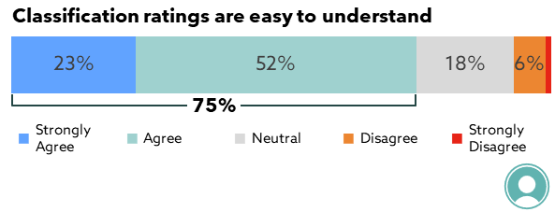
Q41: To what extent do you agree or disagree with the following statements?
Base: All (n=1,996)
Note: Excludes ‘Don’t know / Unsure’ (3%)

Figure 22: Ease of understanding consumer advice
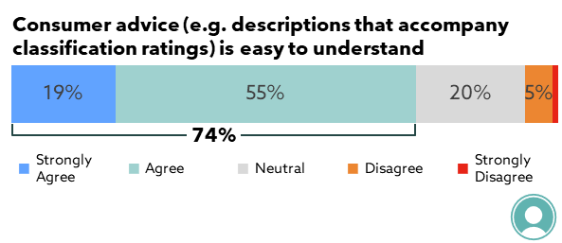
Q41: To what extent do you agree or disagree with the following statements?
Base: All (n=1,970)
Note: Excludes ‘Don’t know / Unsure’ (4%)

Research conducted in 2014 identified that the delineations between G to PG and M to MA were a source of confusion among some respondents. As shown in Figure 23, similar confusion about the difference between ratings was identified in the 2022 research. Specifically:
- 36% of respondents indicated that they were confused about the difference between M and MA 15+ across both survey periods; and
- Around a fifth of respondents were confused about the differentiation of G and PG classifications – there was a significant but minor increase in reported confusion between 2014 (18%) and 2022 (22%).

Figure 23: Areas of classification rating confusion
Q15: To what extent do you agree or disagree with the following statements?
Base: All (n=1,991 – 2,016)
Note: Excludes ‘Don’t know/Unsure’ responses (2%-3%)

Other areas of some confusion included:
- The distinction between the PG and M ratings during classification – one in four respondents reported being confused about this (25%); and
“I feel like the difference between M and PG is really blurry. There’s not a clear distinction”—Male, 36+years, Melbourne

- What parental guidance meant in the context of PG rated movies and video games – one in six respondents (17%) reported that they were confused about this. The qualitative research found that some parents / carers were uncertain about what sort of guidance was recommended (e.g. direct supervision at all times, or a “general check” before watching), as well as the age group for whom parental guidance was recommended.

While there was some confusion between some of the rating distinctions, the general agreement that classification was easy to use, and high overall agreement that the classification system was meeting expectations (see Chapter 5), indicates that this confusion is not a key area of concern as it is not necessarily impacting on usage and application of classification.
- Classification system expectations
This chapter identifies participants’ key expectations of the classification system and the extent that these are being met, including the perceived consistency in classifications and their display across platforms.

Key findings and implications
Overall, the research found that the classification system was largely meeting the expectations of consumers (79% of respondents agreed or strongly agreed that the system met their expectations).
In particular, the classification system was effectively meeting the needs and expectations of consumers in the following areas: the classification of content across different platforms; the role of classification information in informing decisions about the appropriateness of content for children; the consistency of classification between films shown in the cinema and content on streaming services.
While lack of consistency in the display of classification content did not emerge as a key concern, the qualitative research indicates that there is scope for this to be improved on streaming services and online gaming platforms to support consumers, particularly parents / carers, to more easily find and utilise this information.

  - Key expectations
The qualitative research identified eight key expectations in relation to the classification system. These are summarised in Figure 24 and discussed in more detail below.

Figure 24: Expectations of the classification system

In particular, participants expected that the classification system would:
- Provide guidance and recommendations – classification was widely recognised as a guidance tool. While classification was expected to provide information to assist in content decisions, the large majority of respondents felt that responsibility for selecting appropriate content lay with the viewer. Specifically:
- 80% of respondents agreed that ultimately it was up to people to decide what was suitable for them to watch or play, and only 5% disagreed; and
- 81% agreed that ultimately it was up to parents / carers to decide what was suitable for children to watch or play, and only 6% disagreed;
“I think it’s important to remember that it’s a recommendation. At the end of the day it’s the parent or teacher that has the responsibility”—Educator, SA / WA / NT

- Ensure children were protected – as previously discussed, classification was found to be particularly important for informing decisions about children’s viewing / gaming. Participants expected classification to provide reliable and adequate guidance to ensure children were protected from potential harms caused by exposure to inappropriate content;

“I don’t want to expose my four-year-olds to anything like violence, language or nudity. It’s absolutely not appropriate and I think there could be long term impacts. I remember things I watched as a child that I absolutely shouldn’t have”—Educator, SA / WA / NT

- Provide government oversight and accountability for classification – this was considered important to ensure trust, consistency and reliability in ratings;
- Be consistent and clear across platforms – to ensure easy identification and understanding of classification information. Consistency was also noted as important to ensure that trust in the overall classification system was maintained. A few participants noted that inconsistent or inappropriate classifications on some platforms (e.g. streaming platforms) could erode the perceived reliability and trust in classification more broadly;
“As soon as things are not classified properly then people won’t trust it anymore”—Parent / carer of a child aged 6-11 years, Sydney

- Provide a complaints process for consumers – most participants felt it was important that a complaints process was in place to provide a means for consumers to raise concerns about classification decisions;
- Remain modern and up-to-date – participants felt that it was important for classification to reflect current community standards, including as they changed over time;
- Take appropriate caution when rating content – most participants felt that it was appropriate for caution to be prioritised when classifying content (i.e. over a lower rating) to ensure sufficient warning and protection about potentially inappropriate content for consumers; and
“I think they err on the side of caution…that’s a good thing”—Parent / carer of a child aged 6-11 years, Melbourne

Provide timely access to new media / releases – participants expected to be able to access content / new releases in a timely manner. It was therefore considered important for classification decisions to be made as efficiently as possible.

  - Overall comfort and fulfilment of expectations
Overall, the research found that the current classification system was largely meeting expectations. 79% of respondents agreed or strongly agreed that the current classification system met their expectations and only 5% disagreed.
“Most of the content I’ve seen is what I’d expect”—Parent / carer of a child 3-5 years, SA / WA / NT

In addition, the majority of:
- Parents / carers agreed that classification and consumer advice worked well in helping them make sure their child/ren access appropriate content (71% of parents / carers agreed and only 9% disagreed); and
- Respondents were comfortable with classification across different types of media – 70%-86% of respondents were comfortable with classifications for different media and only a minority disagreed (less than 10% for all media types). In addition, at least three in four respondents agreed that they were comfortable for all mediums tested.

As shown in Figure 25, comfort was highest for films in the cinema, with 86% of respondents agreeing that they were comfortable with these classifications.

Comfort was slightly lower for video games bought online (70%) and for the ratings on the Apple App store (71%) – with disagreement and neutral responses both slightly higher. This was consistent with the qualitative research in which disagreement with classification was more common in relation to games. A few younger male participants felt that PC and console game classification was often “too conservative” in Australia – particularly as they recalled that some games had been “banned” or refused classification in Australia (but available for sale / purchase overseas). Although examples of games felt to be classified “too low” were also identified by other participants.
“In games I feel like our rating system is a lot stricter than it is in the US”—Male, 18-35 years, NT, SA, WA

In addition, the quantitative research found that males were slightly more likely to disagree that they were comfortable with classification on the Apple App store (7% males vs 4% females), classification on TV (5% vs 2%) and classification of films at the cinema (4% vs 2%).

Figure 25: Comfort with classification on different medium
Q46: To what extent do you agree or disagree with the following statements?
Base: All (n=1,413 to 1,974)
Note: Excludes ‘Don’t know / Unsure’
Note: *Question only asked of those who played games (n=1,115, 1,099)

The 5% of respondents who disagreed that the classification system met their expectations were asked the reason for this. No dominant reason for disagreement was identified – which is in line with the high level of subjectivity associated with perceptions of appropriate classification evident in the qualitative research. The most common reasons for disagreement related to the following (however these were identified by less than 1% of respondents overall):

- Classification was not strict enough;
“I have found that the standards in the classifications have slipped so that more adult content is being viewed in lower classifications”—Survey respondent

- The classification system was too strict;
- Ratings and classification information was inaccurate, insufficient and / or vague;
- Classification was not consistent across mediums;
- Classification information was too confusing; and
- Classification did not align with personal or communal perceptions.
  - Consistency
As shown in Figure 26, three in four respondents (74%) reported that there was consistency between the classification of movies in the cinema and streaming content and only 5% of respondents disagreed.
Figure 26: Consistency of classification between films and streaming services
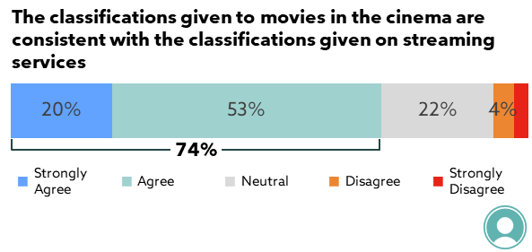
Q41: To what extent do you agree or disagree with the following statements?
Base: All (n=1,670)
Note: Excludes ‘Don’t know/ Unsure’ (19%)

Respondent groups that were notably more likely to report that there was a difference in classification between movies and streaming services were:
- Secondary school teachers (15%);
- Aboriginal and / or Torres Strait Islander respondents (14%); and
- Those aged 18 to 24 (11%).

The majority of respondents also agreed that classification ratings and consumer advice were clearly displayed across all the media asked about (Figure 27), and only a minority disagreed (no more than 11% for any media type).

However, there were some differences in perceived clarity of classification display between media types. In particular:
- Respondents were most likely to agree that this information was clearly displayed for films at the cinema (81%) and on DVDs / Blu-Rays (79%);
- Physical games (also classified by the Board) were also commonly seen as having clearly displayed information (71%); and
- The perceived clarity was lowest for streaming services (66%) and online gaming platforms (60%). These services also had the highest levels of disagreement (8% and 11%, respectively).

The qualitative research found that some participants had trouble recalling the specific format / location that classification information was displayed on different streaming platforms. A few participants felt that inconsistency in the consumer advice displays across different streaming platforms made it more difficult to find the information. Some participants felt that improving the clarity and consistency in display across platforms could improve the usability of this information.

“I know the Australian classifications but if I’m watching Netflix it looks different… it would be better if the displays were consistent, if it’s simple and always the same you can recognise it quickly”—Educator, SA / WA / NT

Figure 27: Agreement that classification information is clearly displayed for different platforms
Q38: To what extent do you agree or disagree with the following statements?
Base: All (n=1,436 to 1,930)
Note: Excludes ‘Don’t know / Unsure’ (6% to 30%)
- Potential improvements to the classification system
This chapter discusses opportunities for improvements to classification information to better meet community expectations as well as some other suggested areas of improvement identified by participants in the qualitative research.

Key findings and implications
Overall, the research found that there was limited appetite or perceived need to change the current rating system used in Australia, which was found to be a trusted and familiar source of information about the suitability of content.
However, a few areas for potential improvement were identified in the research – most notably the “modernisation” of consumer advice. The research suggests that there is support from the public for consumer advice to include additional and more specific content descriptions to better reflect current societal concerns and sensitivities and provide warning of potential emotional / mental health triggers.
  - Overview of potential improvements
While the classification system was largely meeting expectations, some areas for potential improvement were identified by some qualitative research participants. These were related to:
- Consumer advice – specifically:
- The “modernisation” and expansion of consumer advice – this was the main area for improvement identified by the research. It is discussed further in section 6.2 below;
- The specificity of some consumer advice – some participants felt that consumer advice was sometimes “too vague”, which made it difficult to interpret and apply. Specific examples identified by participants included terminology such as ‘mild sense of peril’; ‘adult themes’ and ‘may cause offense’; and
“‘Themes’ can be a bit vague, it’s just a broad brushstroke”—Parent / carer of a child aged 6-11 years, Sydney

- The provision of translated consumer advice – while not a strong or top-of-mind concern, when prompted, some CALD participants felt that this could help ensure that all community members could understand classification information; and
- Increasing accuracy of ratings on streaming services – while the majority of respondents were comfortable with ratings provided on streaming services, some qualitative participants felt that some content on streaming services was sometimes not accurately described or “underrated”.
“With streaming services it’s a bit of a hit and miss. I don’t trust the descriptions. I think they are a bit of a cut and paste”—Parent / carer of a child aged 6-11 years, Sydney
  - Potential changes to classification information
Overall, the research found that the current classification categories (i.e. G, PG, M, MA15+, R18+) are considered appropriate and were meeting participant’s needs in their current form.

As shown in Figure 28, about three in four respondents (74%) agreed that the classification categories did not need to change and only 5% disagreed. Many participants in the qualitative research also noted that the classification was well-known, familiar and trusted by the community and therefore should not change.

“If it’s not broken don’t change it [the classification process] —Parent / carer of a child aged 6-11 years, Sydney

Figure 28: Agreement that classification categories do not need to change
Q41: To what extent do you agree or disagree with the following statements?
Base: All (n=1,881)
Note: Excludes ‘Don’t know / Unsure’ (8%)
Note: Labels less than 4% not shown

However, the expansion and specificity of consumer advice was identified as an area for potential improvement in current classification information. In particular, many participants felt that current consumer advice should be “modernised” to:
- Better reflect current societal concerns and sensitivities; and
- Provide more specific warnings on potential emotional / mental health triggers (e.g. abuse, suicide and family violence) – some participants felt that viewers were currently not appropriately warned about potential content that could be triggering or cause emotional harm to people based on their past experiences.

“A lot of people nowadays are quite sensitive with what they want to be exposed to… if something says racial themes, I already know I don’t want to see that”—Parent / carer of a child aged 6-11 years, Melbourne

Figures 29 - 31 show that the majority of survey respondents agreed that the scope of classification and consumer advice should be expanded to include more information and warnings in relation to offensive and distressing content and discriminatory language.

Figure 29: Attitudes towards warnings for offensive content
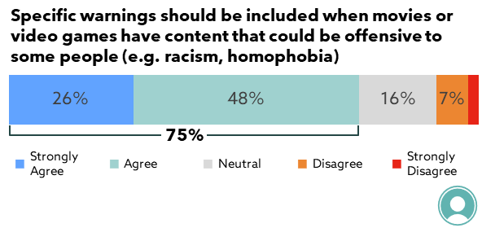
Q41: To what extent do you agree or disagree with the following statements?
Base: All (n=1,974)
Note: Excludes ‘Don’t know / Unsure’ (4%)

Figure 30: Attitudes towards discriminatory language being included in definition of coarse language
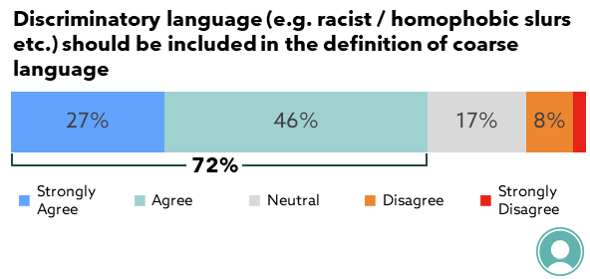
Q41: To what extent do you agree or disagree with the following statements?
Base: All (n=1,971)
Note: Excludes ‘Don’t know / Unsure’ (4%)

Figure 31: Attitudes towards providing consumer advice for distressing content
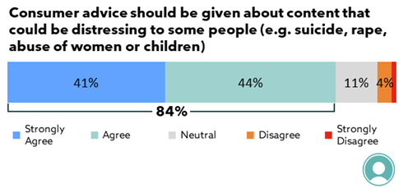
Q41: To what extent do you agree or disagree with the following statements?
Base: All (n=1,997)
Note: Excludes ‘Don’t know / Unsure’ (3%)

The survey tested a range of potential new consumer advice warnings suggested in the qualitative research and by the Department. As shown in Figure 32 and Figure 33, all suggested new content descriptions had high levels of support for inclusion. Support for inclusion was highest for child abuse, depictions of suicide and dangerous behaviours.

Respondents were also able to include additional content descriptions outside of this list via an open-ended response, with the most common being for the inclusion of animal abuse (1%).

Figure 32: Inclusion of additional content descriptions in consumer advice for movies and shows
Q39: For movies and shows, should the following types of content be described in the consumer advice?
Base: All (n=1,860 to 1,920)
Note: Excludes ‘Don’t know/ Unsure’

Figure 33: Inclusion of additional content descriptions in consumer advice for video games
Q40: For video games, should the following types of content be described in the consumer advice?
Base: All (n=1,222 to 1,870)
Note: Excludes ‘Don’t know / Unsure’
- Agreement with recent classification decisions
This chapter reports on respondents’ overall satisfaction with classification, as well as specific areas of disagreement with classification, where raised.

Key findings and implications
Overall, the research found high levels of satisfaction with the classification of movies (88% of respondents were satisfied) as well as video games (79%). Most respondents did not recall any classifications in the last 3 years that they disagreed with. Among the minority that did report disagreement, many could not recall what the content was and / or noted examples that were not recent.
These results suggest that most recent classification decisions made by the Board are likely to be aligned with community expectations.
  - Overall satisfaction with classifications
Overall, the majority of respondents were satisfied with the classification of movies and video games. The average rating out of 10 for satisfaction was 7.6 for movies and 7.1 for video games.

Although less than three in ten respondents were very satisfied (ratings of 9 or 10), this is to be expected given it is not a service / topic of high engagement for most participants. A few participants in the qualitative research also reported that they “wouldn’t give full marks” for overall satisfaction (i.e. a 9 or 10 rating out of 10), despite not being able to identify any specific concerns or disagreements. This was because they felt that there would always be some issues, particularly given the large volume of content.

As shown in
Figure 34 and Figure 35, there was slightly higher levels of dissatisfaction (ratings of 0 to 5) among respondents for the classification of video games. Some participants in the qualitative research also reported being less satisfied with the classification of video games. As previously discussed, some younger males felt that game classification was “too conservative” in Australia. A few participants also perceived that the content included in some games that were played by children was having a negative impact.

“I think games are getting away with a bit too much, there are a lot more graphically violent and sexually explicit things in them [than there should be]… but people are letting their kids play it because they think its PG!”—Female, 36+ years, Tasmania

There was also a very high proportion of respondents who provided a ‘don’t know / unsure’ response when rating the classification of video games (39%), reflecting the lower levels of video game usage in the population.
Figure 34: Satisfaction with the classification of movies
Q43: Overall how satisfied are you with the classification of movies (including at cinemas, on DVDs, on streaming services and free-to-air TV)?
Base: All (n=1,906)
Note: Excludes ‘Don’t know / Unsure’ (7%)

Figure 35: Satisfaction with the classification of video games
Q43: Overall how satisfied are you with the classification of video games?
Base: All (n=1,257)
Note: Excludes ‘Don’t know / Unsure’ (39%)

Other reasons for lower levels of overall satisfaction with classification (in addition to those related to video games already discussed) reported by a few participants in the qualitative research included:
- Perceived inconsistency and / or disagreement across platforms – particularly in relation to streaming services;
“My daughter has been watching this awful show called ‘Shameless’, and on streaming services its R and on SBS its MA, so its inconsistent. It’s frustrating”—Educator, SA / WA / NT

- Slight “mismatches” between expected and actual classification level for some content;
“I googled Sing 2 and it said PG and I couldn’t work it out- I think it should have been G”—Parent / carer of a child 6-11 years, Melbourne

- The perceived large variability within some ratings (i.e. PG and M), which made it hard to predict the suitability of content;
- Some topics perceived to be missing / not appropriately considered in classification (across all media) – e.g. same sex relationships and racist content; and
- Perceptions that film and SVoD classification was “too high” – this was among a few CALD participants from European backgrounds, who reported that their culture was more relaxed and open about certain content.

  - Areas of less agreement
Respondents were asked if they had seen any content in the last 3 years where the classification had not met their expectation. The majority did not have any disagreement with classification decisions, however 23% reported watching a movie or show, or playing a video game, where they disagreed with the classification. As shown in Figure 36, respondents were more likely to report that they disagreed with the classification of a movie they had seen than other forms of media. This was most commonly in relation to movies seen on streaming services (40% vs 26% for movies seen on free-to-air and 25% for movies in the cinema).
“I think the classifications I’ve seen have been pretty good, I don’t find any issues with the movies I’ve seen rated”—Female, 36+ years, Tasmania

Despite being prompted to only include media that they had encountered recently (i.e. in the last 3 years), much of the content respondents identified as being incorrectly classified was older. Similarly, many respondents were unaware, or had forgotten, the details of the content that they nominated.

These results suggest that most recent classification decisions made by the Board are aligned to community expectations. Where the content is not matching expectations, it is often due to content that had been classified some time ago and / or had not left a lasting impression.

Figure 36: Disagreement with recent classifications
Q16: Have you recently (in the last 3 years) watched a movie or show or played a video game where you disagreed with the classification?
Base: All (n=2,054)

A summary of the content that respondents perceived to be incorrectly classified is included in Figure 37.

Very few top-of-mind examples of media that participants felt was incorrectly classified were identified in the qualitative research. However, participants searched for the classification of recent media that they had watched during focus groups and asked to consider if the content was appropriately rated, and a few examples of content that participants felt was incorrectly classified were identified during this task.

“I looked up Zelda and that was rated M for fantasy violence and I thought that was ridiculous… Mario Kart is G and there is violence in that, you can electrocute people and stomp on people!”—Male, 18-35 years, SA / WA / NT
Figure 37: Summary of reported content that had been classified incorrectly

Q18/Q22/Q26. Was the classification of this (movie/video game / show) too high or too low?
Q19/Q23/Q27. Where did you watch this (movie/video game / show)?
Q17/Q21/Q25. What was the name of the (movie/video game / show) that you felt was incorrectly classified?
- Usage and perceptions of parental controls and other media
This chapter presents research findings related to usage and perceived effectiveness of parental controls among parent / carer participants. It also discusses children’s access to broader online content, which emerged as a key concern among parent / carer participants in the qualitative research.

Key findings and implications
Making sure all the content their children accessed was appropriate was a challenge for the majority of parents / carers. Children’s access and exposure to unsuitable content via free online platforms (e.g. YouTube and TikTok) was identified as a key concern for parent / carer participants in relation to media / content suitability.
While some challenges in applying parental controls were identified, the majority of parent / carer respondents reported that parental controls worked well in helping make sure their children accessed appropriate online content. However, 10% of parent / carer respondents disagreed and almost half (45%) did not use parental controls. In addition, the qualitative research found that not all parent / carer participants were aware of the full range of parental controls available. This indicates that online safety education and support for parents is an ongoing need.
  - Usage of parental controls
The research found that 55% of parents / carers were using parental controls on at least some of their streaming video services or gaming platforms. One in four parents / carers used parental controls on all of the services that they used (26%). Figure 38 (below) shows the proportion using parental controls for different platforms.
Figure 38: Usage of parental controls by streaming platform and on gaming storefronts, ordered by frequency of platform usage
Q35. Do you use parental controls on the following services?
Base: Use specific platform, Children play video games (n=as shown)
Note: Excludes ‘Don’t know’ responses

As shown in Figure 39, usage of parental controls was found to differ based on the age of the child. Respondents with children aged 4 to 12 years (i.e. around primary school age) were most likely to use these controls.

Figure 39: Use of parental controls by age of child
Q35. Do you use parental controls on the following services?
Base: Parents and carers with children of each age group (n=106-259)
Note: Excludes ‘Don’t know’

The qualitative research found that parents of primary school-aged children were more likely to use parental controls because children in this age range were generally able to access media on their own, however their content choices were still felt to require close supervision.
In contrast:
- Younger pre-school aged children were often not accessing content unsupervised and / or able to select their own content; and
“I don’t find parental controls useful or relevant because my son doesn’t have access to devices on his own”—Parent / carer of a child aged 3-5 years, SA / WA / NT

- Parent / carer participants tended to be more comfortable with high school-students being exposed to a wider range of content, especially once they were over 15 years.

Specific parental control types and functions parent and carer participants reported using included:
- Separate user accounts for children – many parent / carer participants reported that their children had separate accounts which enabled them to restrict the content their children, could choose from. Typically, children were restricted to viewing content with certain ratings only (e.g. G and PG);
“On Netflix there’s kid’s profiles so I’d trust anything they see will be appropriate”—First Nations parents and community members, Cairns

- Use of passcodes – some parent / carer participants reported that a passcode was required for their children to access a platform or device;
- Approval for game purchases – a few participants with children who regularly gamed reported that their children required parental approval for game purchases via online game stores; and
- Email reports on gaming behaviour – a few participants reported that they received emails from online gaming services about their children’s gaming activity. These were used to monitor the suitability of games their children played, as well as amount of time spent gaming.
  - Perceptions of parental controls
Ensuring that all the content their children accessed was appropriate was found to be challenging for parents / carers – 67% agreed that it was hard to make sure all the content that their child/ren accessed was appropriate for them.
“I blocked YouTube because they were constantly on it and I know there were some things they shouldn’t be watching”—Parent / carer of a child 6-11 years, Melbourne

The qualitative research found that parents were using a variety of mechanisms and strategies to prevent exposure to inappropriate content, including parental controls. Overall, parental controls were considered useful by most parent / carer participants in helping to ensure their children accessed appropriate content. As shown in Figure 40, the majority of parent / carer respondents (66%) felt that parental controls worked well in helping their child/ren access appropriate content. However, 10% of respondents disagreed – those who disagreed were more likely to be single parents / carers (19%) and those earning under $50k (19%).
Figure 40: Perceived helpfulness of parental controls in preventing access to inappropriate content
Q37: To what extent do you agree or disagree with the following statements?
Base: Parents and carers (n=560)
Note: Excludes ‘Don’t know / Unsure’

While a lack of effectiveness of parental controls was not a top-of-mind concern for most parent / carer participants, some challenges and concerns were raised. Specifically:
- The ability for children to circumvent parental controls, including by:
  - Accessing their parents accounts (where content was not restricted) if passcodes were not used to prevent this;
  - Disabling the controls / restrictions – which was particularly a concern for parent / carer participants with older, more technologically savvy children;
“I did that [create a kid’s profile] and my son created a new profile”—Parent / carer of a child 6-11 years, Melbourne

  - Being provided access to inappropriate content by older siblings or friends, who were not subject to the same parental controls;
- Variability within ratings – the range of content levels and types within a rating category was a concern for a few parents who restricted content by ratings in their children’s account settings. These parents noted that while some content within a rating may be appropriate for their children, other content may not be;
- Limited availability on some services – a few participants noted that parental controls were not available on some streaming services (e.g. Binge); and
- Digital literacy barriers – a few participants, particularly older participants looking after grandchildren, reported that they were not able or confident to use parental controls.
“As a grandparent I’m a bit old fashioned”—Close family member of a child, Cairns

In addition, it was evident in the qualitative research that some parent / carer participants were not familiar with or not aware of the full range of parental controls available, which posed another barrier to effective content control.
  - Usage and perceptions of children’s access to online content
The majority of children were found to be accessing free video sharing services, with 86% of parents / carers reporting that their children watched free online video content, and 61% reporting that their children did so at least a few times a week. Usage of these services varied by age, as shown in Figure 41 below.

Figure 41: Child use of free video sharing services by age of child
Q10: How often do your children aged 17 or younger watch / play the following…?
Base: Parents and carers with children of each age group (n=107-269)

The research found that children’s access to unsuitable content via free online platforms was a key concern for many parent / carer participants. 27% strongly agreed and 45% agreed that they were concerned about the free video content that their children are exposed to online (e.g. YouTube and TikTok).

“My daughter was watching Peppa Pig [on YouTube], and then it changed to something else and the content started getting really crude. It’s become a really big problem, so I removed the YouTube app off the phone”—Parent / carer of a child aged 3-5 years, SA / WA / NT

The qualitative research found that the unregulated and unclassified nature of free online video content made it difficult for parents to determine appropriateness of content. In addition, the widespread accessibility of this content (e.g. mobile devices, tablets and in-built into smart televisions) was reported to make monitoring access challenging for some parents.

Some specific concerns were raised in relation to YouTube by many parent / carer participants, including:
- The ‘auto-play’ feature – parents felt they needed to be “constantly” monitoring what their children were watching as they “never knew” what would play next, which was challenging; and
“You can’t control what they get fed on YouTube”—Close family member of a child, Cairns

- Unsuitable content on YouTube kids – a few participants reported that their child had been exposed to content they perceived to be inappropriate for children on YouTube Kids (e.g. violent cartoons).

However, the research found that classification of this content was not a key expectation for most parents due to the challenges of doing so for free user generated online content – but rather, online safety knowledge and strategies were perceived to be required.
- Conclusions
Overall, the importance, usefulness and social value of classification was widely recognised in the research, even among those who did not personally use classification.

Consistent with previous research, usage of classification information was much higher among parents / carers. Classification was the highest ranked source of information in helping parents make decisions about content suitability for their children, and over three quarters of parents / carers used consumer advice at least sometimes to determine suitability in various contexts.
While classification information was rarely the top ranked information source for determining content suitability among adults’ own media choices, it still had a key role for a minority – just under a quarter of respondents ranked it as the most important source across the various media types. In addition, many respondents used consumer advice to avoid triggering (58%), offensive and disturbing (63%) content, indicating the value and need for consumer advice.

The research found widespread awareness, familiarity and trust of the key classification ratings and definitions (excluding the niche X18+ category). There was also strong agreement that classification ratings and consumer advice were easy to use, and that the classification categories did not need to change. The research strongly supports the maintenance of the current classification categories.

Overall, the classification system was largely found to be meeting the expectations of consumers. This included in relation to consistency in the classification of content across different platforms; the usefulness of classification information in informing decisions about the appropriateness of content for children; the consistency of classification between films shown in the cinema and content on streaming services.

The research also identified a general satisfaction and agreement with recent classification decisions (i.e. over the last 3 years) made by the Board. While a minority reported disagreement, the majority could not recall what the content was and / or noted examples that were not recent. It was also evident in the research that perceptions of content appropriateness and suitability were highly individualised and subjective, suggesting that some disagreement in relation to classification decisions should be expected.

The expansion and specificity of consumer advice was identified as the main area for improvement in relation to current classification information. The majority of survey respondents agreed that the scope of classification and consumer advice should be expanded to include more information and warnings in relation to offensive and distressing content (e.g. child abuse, suicide and rape) and discriminatory language (e.g. racism and homophobic slurs). There was strong support for the inclusion of all additional content descriptions tested – specific statements are presented in
Chapter 6.

In addition, while lack of consistency in the display of classification content did not emerge as a key concern, perceived clarity of display was somewhat lower on streaming services and online gaming platforms compared to other media types. The qualitative research found that improving display clarity could support consumers to more easily find and utilise this information. Given the increased prevalence of streaming services and online gaming this could be an area for further exploration in future research and policy development.

The main concern identified in relation to content suitability for children was access and exposure to unsuitable content via free online platforms (e.g. YouTube and TikTok) – which was a key and top-of-mind concern for parent / carer participants. While greater regulation of this content was desirable, the majority of parents / carers did not expect it to be classified. This was recognised as difficult and unfeasible by many, especially by those with higher understanding and familiarity of the platforms. In addition, many also acknowledged that it was ultimately a parental responsibility to ensure children accessed appropriate content.

While some challenges in application were identified, parental controls were perceived to work well in helping make sure their children accessed appropriate online content by the majority of parents / carers. However, a significant proportion did not use parental controls and a minority (10%) disagreed that they worked effectively. It was also evident that not all parent / carer participants were aware of the full range of parental controls available. Overall, the research indicates that there is a broader and ongoing need for online safety education and support for parents.

APPENDIX A: Demographic profile of participants in the qualitative research

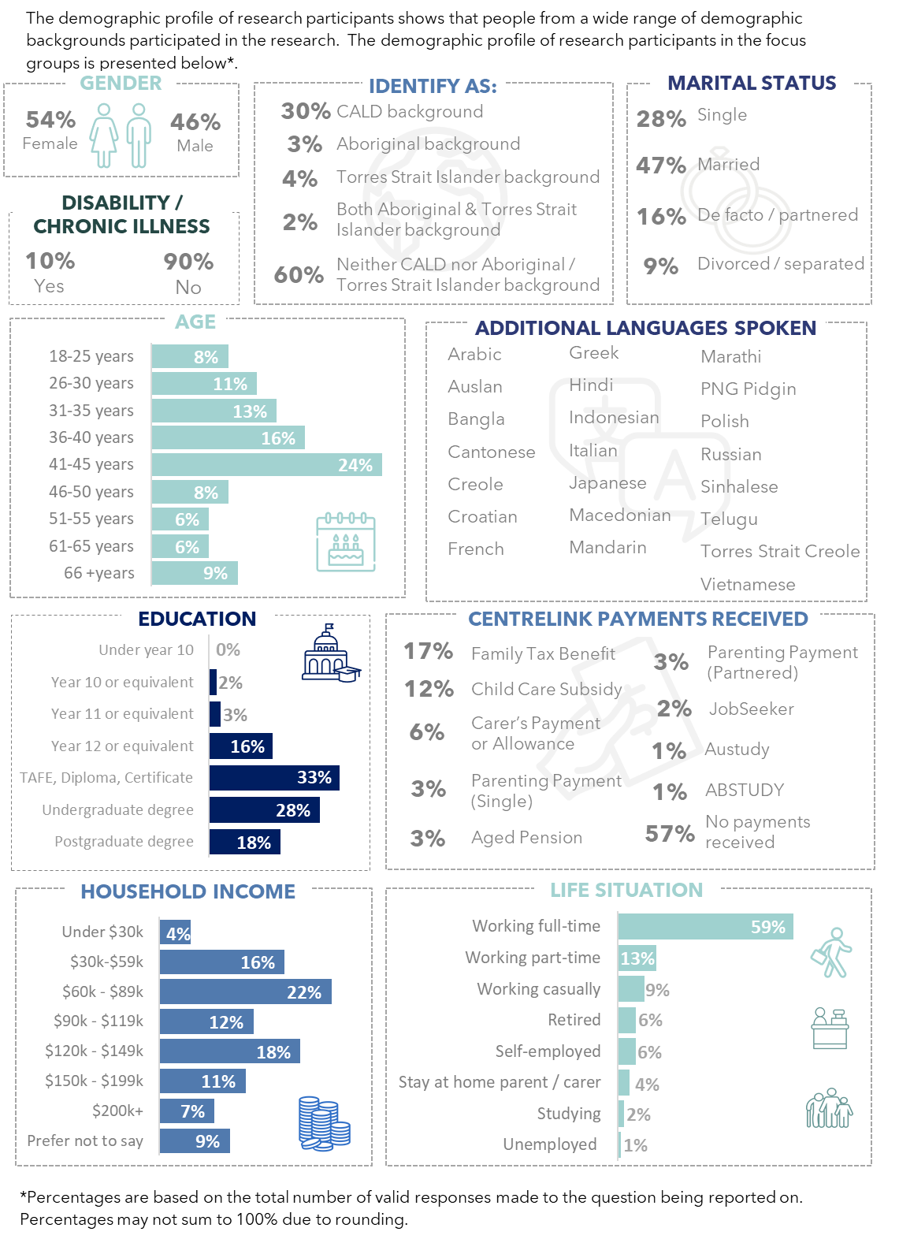

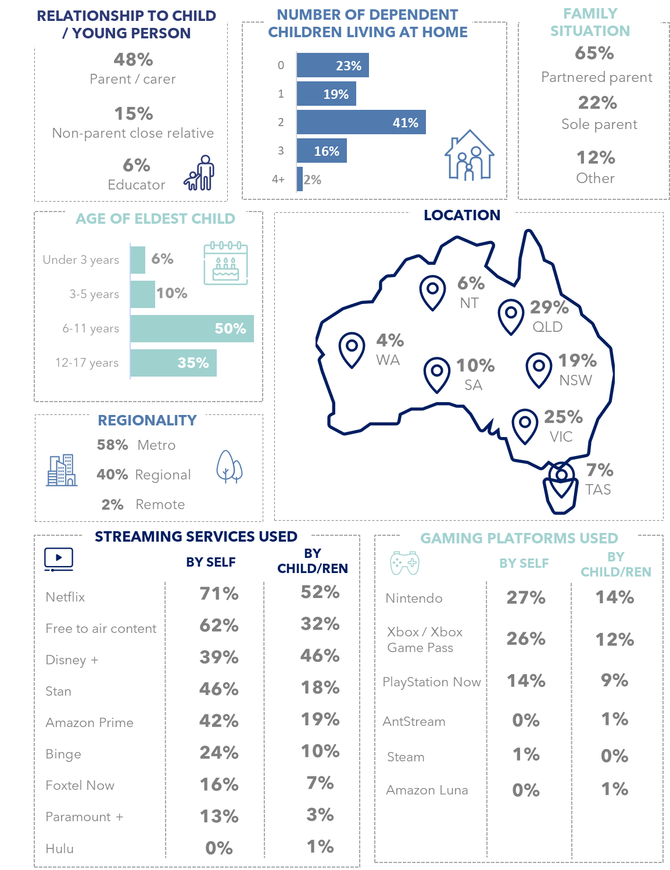

APPENDIX B: Quantitative Sample Demographics

Table 2: Quantitative sample demographics
 |  | n | Unweighted (%) | Weighted (%)
 | Overall | 2054 | 100% | 100%
Age | 18 to 24 | 227 | 11% | 11%
Age | 25 to 34 | 348 | 17% | 17%
Age | 35 to 44 | 345 | 17% | 17%
Age | 45 to 54 | 318 | 15% | 15%
Age | 55 to 64 | 360 | 18% | 16%
Age | 65+ | 456 | 22% | 23%
Geolocation | Metro | 1589 | 77% | 75%
Geolocation | Other | 465 | 23% | 25%
Gender | Male | 1010 | 49% | 51%
Gender | Female | 1037 | 50% | 49%
Parent / carer | Parent/carer | 598 | 29% | 29%
Parent / carer | Not a parent/carer | 1456 | 71% | 71%
Parent / carer, child age | 0 to 3 | 166 | 8% | 8%
Parent / carer, child age | 4 to 6 | 152 | 7% | 7%
Parent / carer, child age | 7 to 12 | 269 | 13% | 13%
Parent / carer, child age | 13 to 15 | 162 | 8% | 8%
Parent / carer, child age | 16 to 17 | 107 | 5% | 5%
Media usage | Movies | 1927 | 94% | 94%
Media usage | Streaming | 1545 | 75% | 75%
Media usage | Video games | 1189 | 58% | 58%
Parent / carer child media usage | Movies | 480 | 23% | 23%
Parent / carer child media usage | Streaming | 503 | 24% | 24%
Parent / carer child media usage | Video games | 522 | 25% | 25%
Work in education | Early years teacher | 31 | 2% | 2%
Work in education | Primary school teacher | 49 | 4% | 4%
Work in education | Secondary school teacher | 76 | 6% | 6%
Employment | A student | 80 | 4% | 4%
Employment | Retired / Pensioner / not looking for work | 518 | 53% | 55%
Employment | Carer / parental leave | 124 | 6% | 6%
Employment | Working / looking for work | 1335 | 65% | 65%
Household | Single parent with dependent child / children | 67 | 3% | 3%
Household | Living with a partner only | 607 | 30% | 29%
Household | Living with a partner and dependent child / children | 526 | 26% | 26%
Household | Living alone | 388 | 19% | 20%
Household | Living with other adults | 415 | 20% | 20%
Reported disability |  | 272 | 13% | 14%
Aboriginal and/or Torres Strait Islander |  | 42 | 2% | 2%
CALD |  | 521 | 25% | 25%
Income | Under $50k | 544 | 26% | 27%
Income | $50k to $90k | 471 | 23% | 23%
Income | $90k to $150k | 518 | 25% | 25%
Income | $150k or over | 276 | 13% | 13%

ORIMA has a team of over 35 First Nations community interviewers that conduct face-to-face surveys as well as assist with recruiting participants for qualitative research groups.
Those who did not use media were initially included for the weighting schema and then removed from the sample for analysis purposes.
Australian Government Attorney-General’s Department: Classification Branch, ‘Classification ratings: Research with the general public’, 2014.
Although this is only a small proportion of the total sample, a higher result may have occurred if it was asked in a similar way to the other content described in the survey.

