
l

Classification Portal – Reference Guide for Applications
November 2022 (V1.0)
Introduction 1
Applications – Starting Point 2
Public Exhibition (Cinema) 3
DVD, Blu-ray, online Streaming services and On demand (includes ACAs and ATSAs) 8
No assessor report (FO Application) 11
ATSA Application 16
Assessor Report – but not a TV Series (FO Application) 28
Additional Film Content Application (ACA) 29
Publications 33
Title Changes – Film, Games, Publications 37
Event Application 38
Reviews – Film, Games, Publications 42
Advertising – Film and Games 44
Film 44
Games 46

Introduction
The Portal gathers all relevant information for each application type and the pathway through the system will depend on answers provided along the way. This reference guide provides screenshots of each pathway and will be useful for those who want to anticipate the questions being asked.
Key data entry fields are listed for each form so that they can be found when searching through the document.
Many pathways contain common components and these are not repeated each time.
This reference guide is not a full user manual for the Portal, it is designed to document the key application pathways only.

Applications – Starting Point
Starting from the main dashboard, choose “Application Management”.
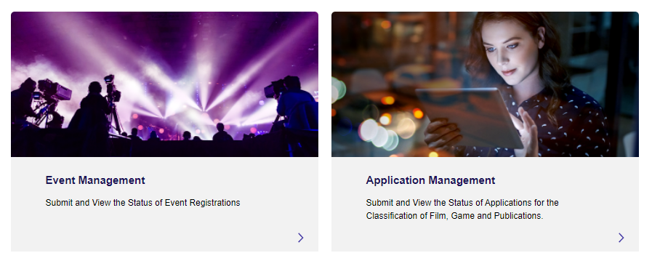
Next, choose “Create New Application”:
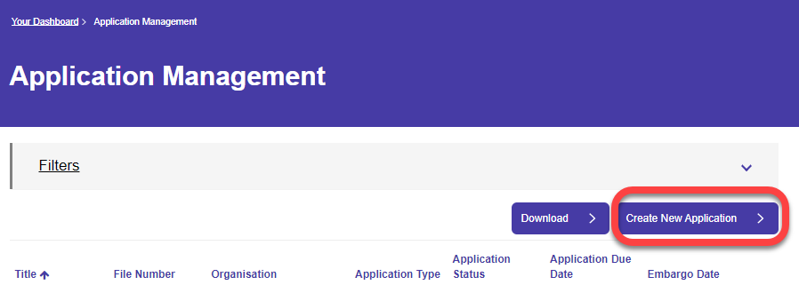
From here, we can now choose between:
- Films for cinema, home entertainment and on demand;
- Computer Games;
- Publications.
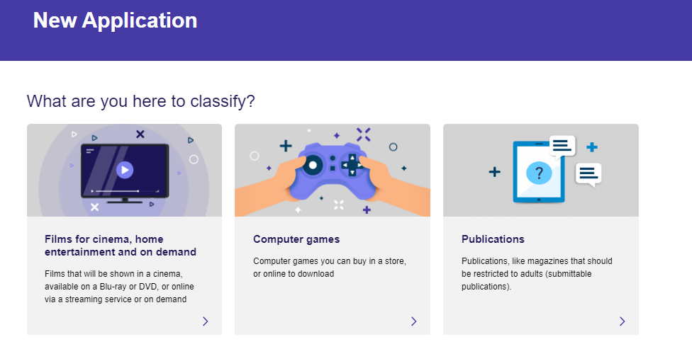

Public Exhibition (Cinema)
Choosing “Films for cinema, home entertainment and on demand” takes you to the menu shown below. To progress a PE application - choose “Get a classification”:
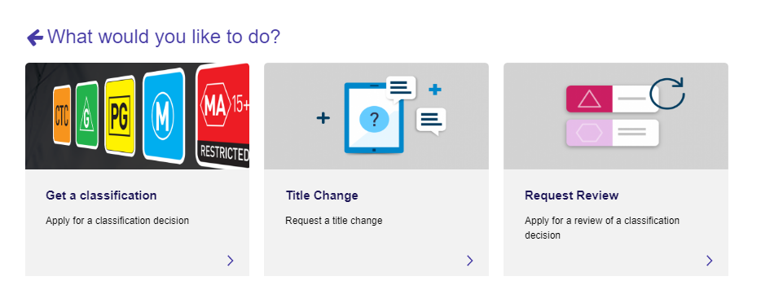
Choose “Cinema”:
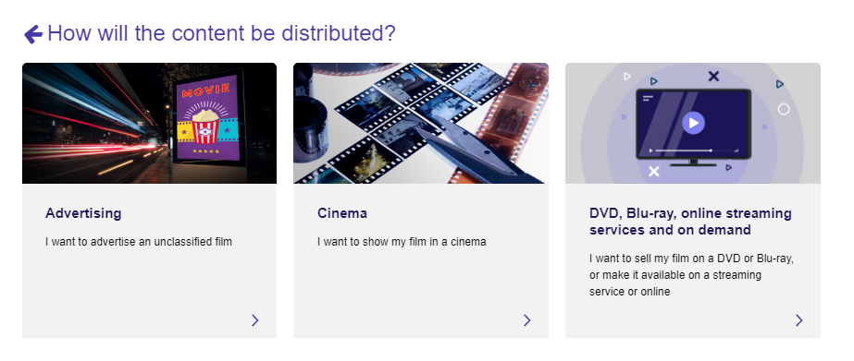

Select Organisation:
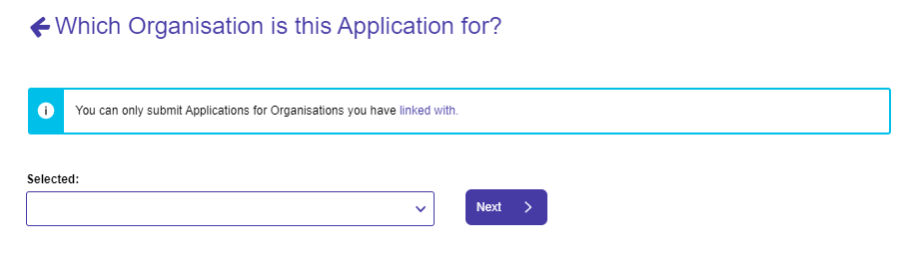
If you can’t find your Organisation, please refer to the FAQ guide questions on “How do I connect to an Organisation?” and possibly “I have selected an existing Organisation but nothing has happened – what do I do next?”
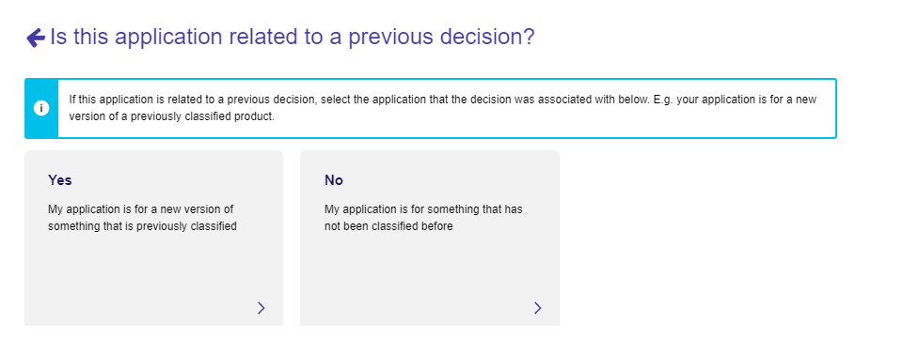
If this application is related to a previous decision, select the application that the decision was associated with below. E.g. your application is for a new version of a previously classified product.
If you select “No” – “My application is for something that has not been classified before”. If you have selected this option jump to the Basic Details form.
If you select “Yes” – “My application is for a new version of something that is previously classified” – you will be asked these additional questions:
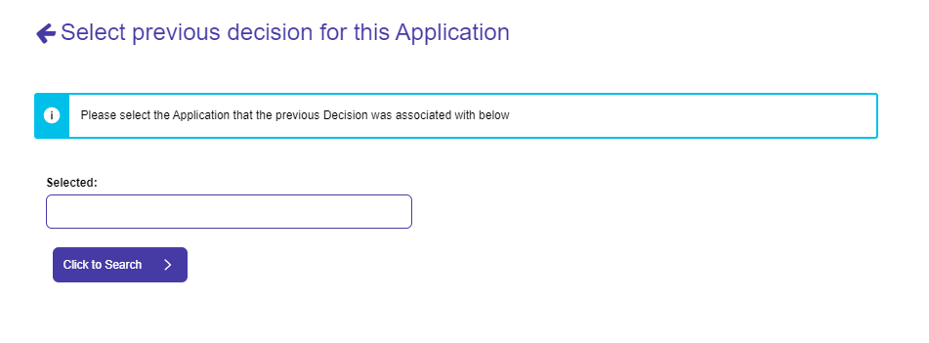
Select previous decision details – click the “Click to Search” button” to search for the relevant application.
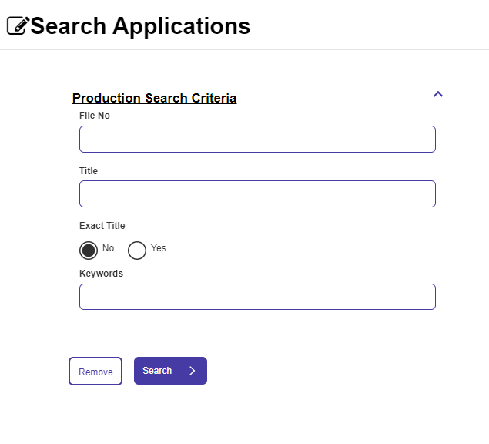
Search by: File number, Title (exact title yes/no) or keywords.
Note that I’ve clicked and selected “Smurf’s Easter Special” below but the only button apparently available is the “Close” button:
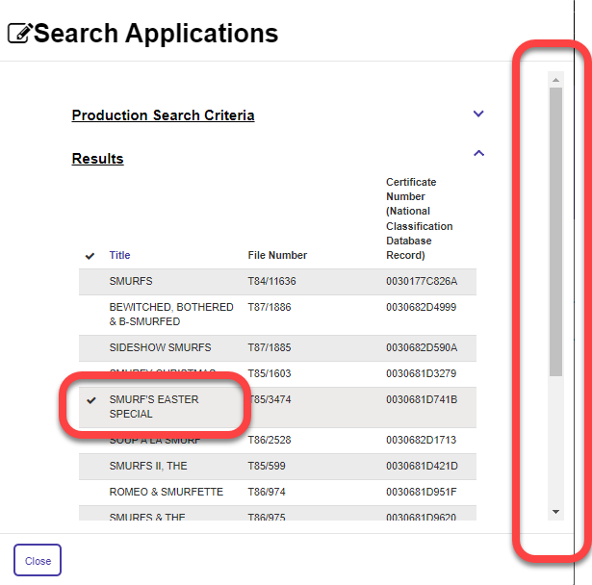
To get to the “Select” button in this case – you need to use the scroll bar on the right hand side and drag it down:
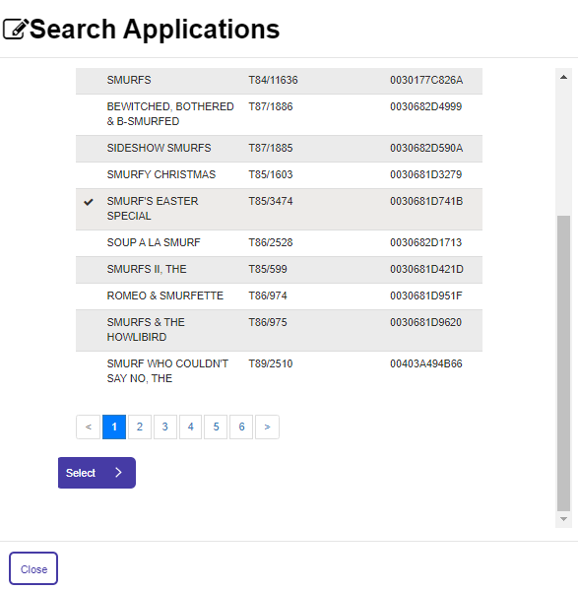

Basic Details form (jump to here if you selected “My application is for something that has not been classified before” earlier)
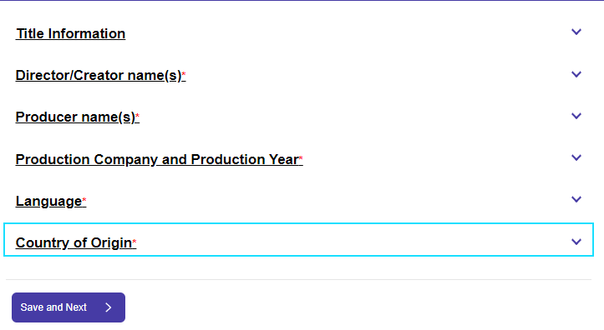
Title, Director/Creator names, Producer names, Production company and production year, language(s), country(ies) of origin.

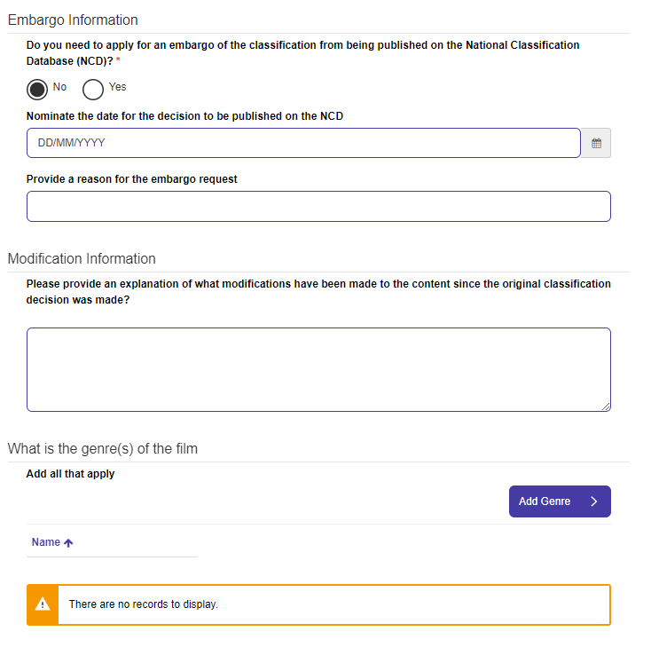
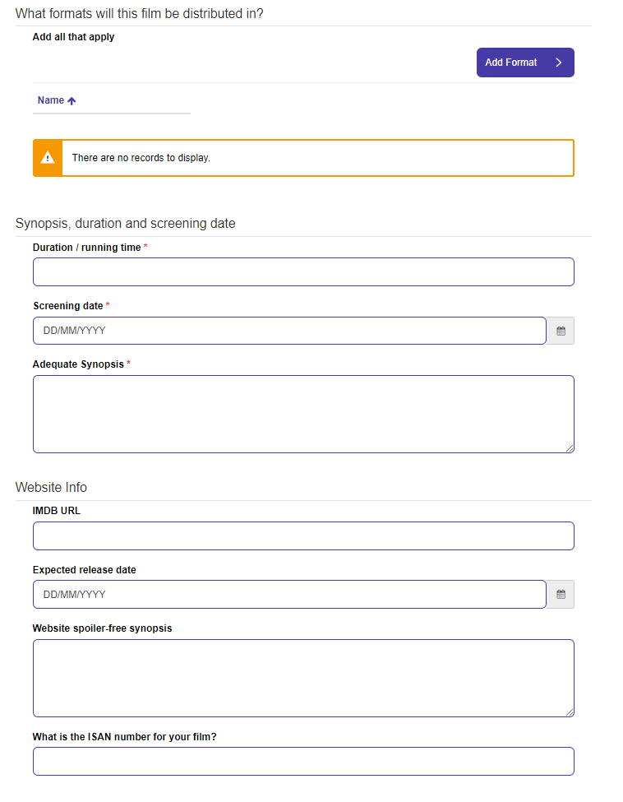
Additional Information for PE’s form:
Key questions:
- Do you need to apply for an embargo of the classification from being published on the National Classification Database (NCD)
If Embargo Chosen:
- Nominate the date for the decision to be published on the NCD
- Provide a reason for the embargo request
Modification Information
- Please provide an explanation of what modifications have been made to the content since the original classification decision was made?
Genres, Distribution formats – note that at least one genre and distribution type must be selected.
- Synopsis, duration and screening date:
  - Duration / running time, Screening date, Adequate Synopsis
Website Info
- IMDB URL, Expected release date, Website spoiler-free synopsis, ISAN number

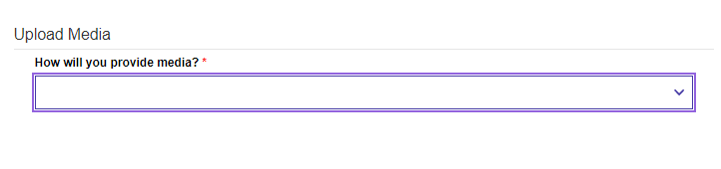
Upload Media – online via Box, online via other method, a physical copy of the content.
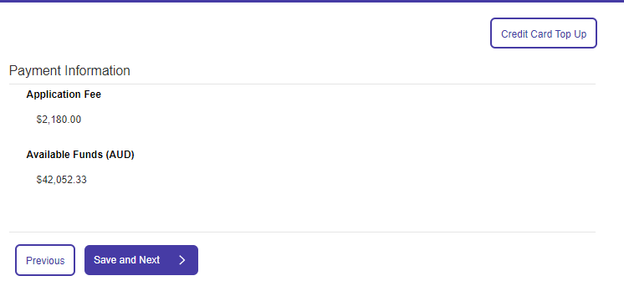
Payment information – application fee, available funds. No ability to request a priority application in this case.

Noting that this text is being updated – declaration.

DVD, Blu-ray, online Streaming services and On demand (includes ACAs and ATSAs)
This pathway is followed when you choose “DVD, Blue-ray, online streaming services and on-demand”.
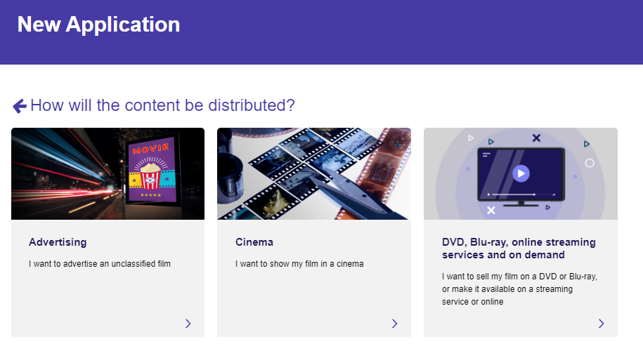

Select your organisation.
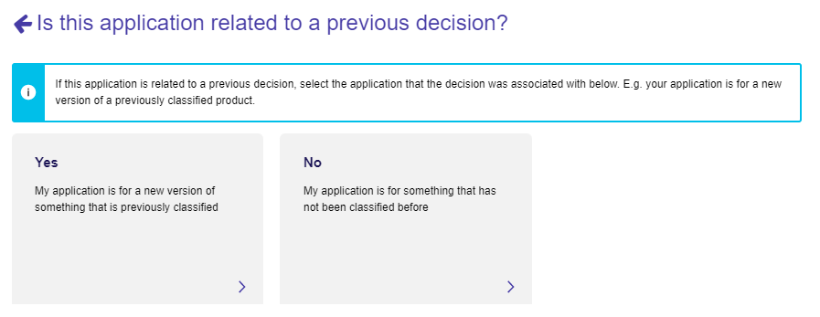

If you select “Yes – My application is for a new version of something that is previously classified”:
To select previous decision details – click the “Click to Search” button” to search for the relevant application.
Search by: File number, Title (exact title yes/no) or keywords.
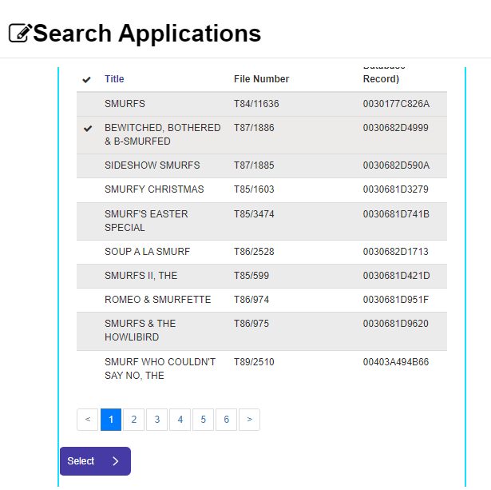
In the resulting Search results pane, scroll down the right hand side scroll bar in order to see the “Select” Button.

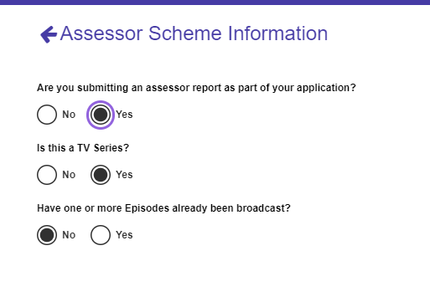
Assessor Scheme Information
“Are you submitting an assessor report as part of your application”
If NO – no further items.
If YES:
“Is this a TV series”: YES
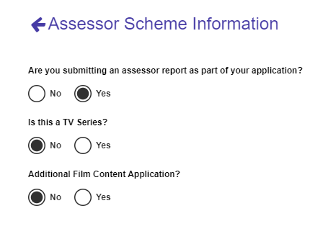
If YES – “Additional Film Content Application”: YES/NO

If NO – “Have one or more episodes already been broadcast”: YES/NO

No assessor report (FO Application)
The Following pathway is the result of selecting “NO” to the question Are you submitting an assessor report as part of your application
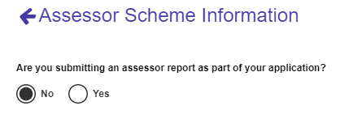
By choosing “No” - this application now becomes a “Film Other” Application.
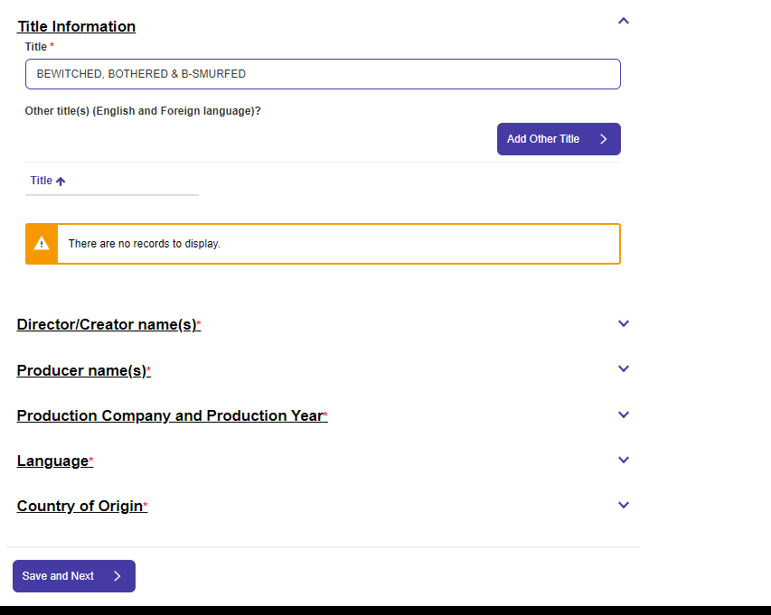
Basic information – as per other Public Exhibition details - Title, Director/Creator names, Producer names, Production company and production year, language(s), country(ies) of origin.
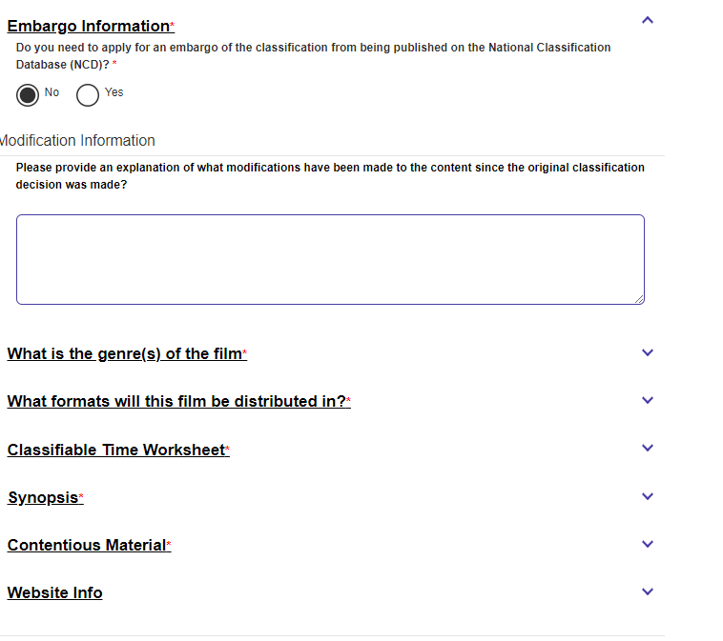
Additional Information (FO) Form:
Includes: Embargo information, Modification information, Genre(s), Formats for distribution, Classifiable Time worksheet (CTW), Synopsis, Contentious Material, Website Info.
The elements not previously described are as follows:
CTW:
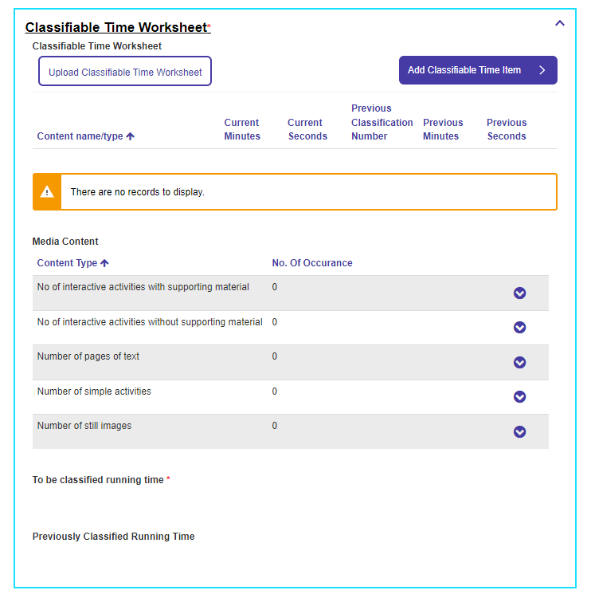
Individual Classifiable Time Items:
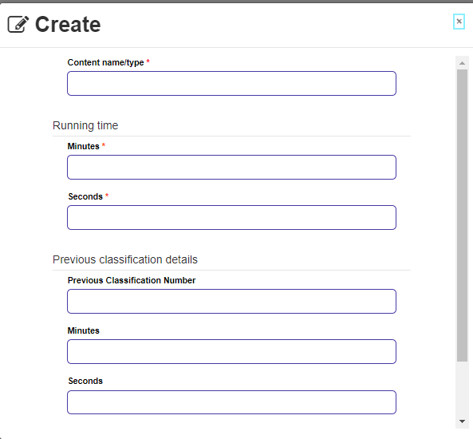
Items include: Content name/type, Running time (Minutes, Seconds), Previous Classification details (Previous Classification Number, Minutes, Seconds
Content types, where you enter the number of occurrences for each include:
- No of interactive activities with supporting material
- No of interactive activities without supporting material
- Number of pages of text
- Number of simple activities
- Number of still images
For each of these items, choose “Edit” to the right of the text and enter “No of Occurrences”
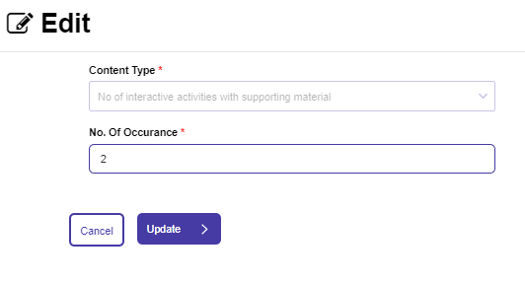
Note that fees are increased according to the number of content types and occurrences are to be assessed.

Other items to fill in are:
- To be classified running time
- Previously classified running
For Synopsis – form asks for an “Adequate Synopsis”.
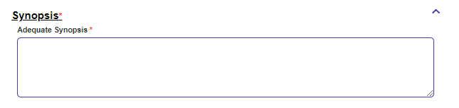
For Contentious material – forms asks for a YES/NO answer to: “Contentious Material”.
If the answer is “Yes”:
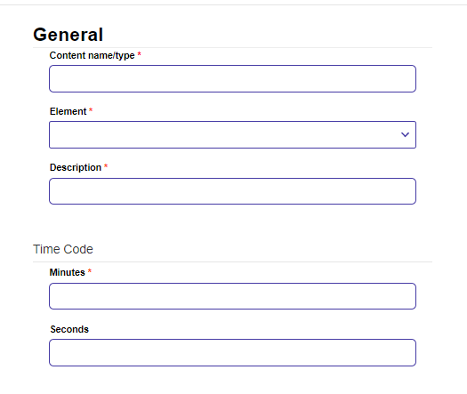
Enter: Content name/type, Element (One of Themes, Violence, Sex, Language, Drug Use, Nudity), Description, Time Code (Minutes, Seconds).
Only one element needs to be provided but more can be added if you have them.
Change to Priority Application is available in this pathway.
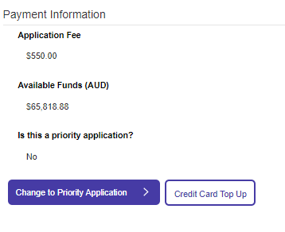
Declaration is next (not shown as these can change).

Next, we’ll follow the pathway for:
Are you submitting an assessor report as part of your application? = YES
Is this a TV Series? = YES
Have one or more Episodes already been broadcast? = NO
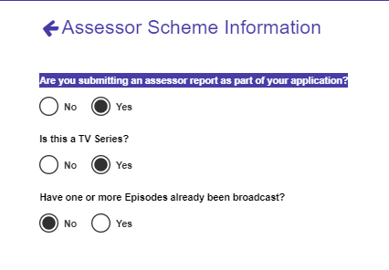
This is now a Film Other (FO) application.
Basic Details form comes next:
Title, Director/Creator names, Producer names, Production company and production year, language(s), country(ies) of origin.
Note that some fields will be available from the previous application chosen but older applications are often missing information and you’ll need to supply any mandatory missing details.
Additional Details form:
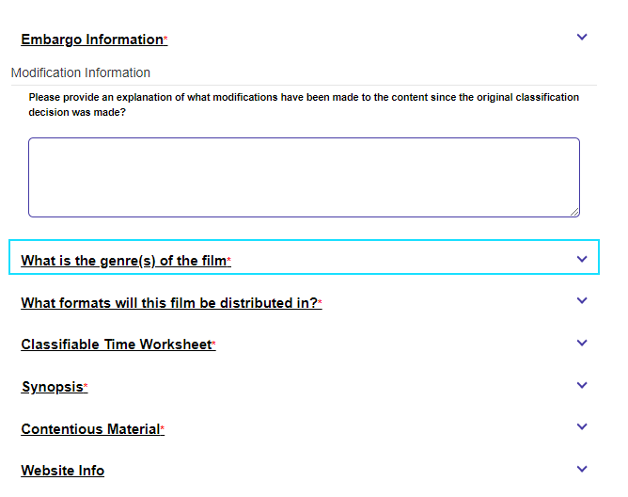
This form includes:
Embargo (previously described);
Modification Information;
Genres;
Distribution formats (note that at least one genre and distribution type must be selected);
Synopsis (adequate synopsis);
Contentious Material (previously described – if “Yes” – only one item is required);
Classifiable Time Worksheet (CTW – previously described - at least one CTW is required);
Website Info (IMDB URL, Expected release date, Website spoiler-free synopsis, ISAN number).
Change to priority application is available in this pathway.
Declaration next (to be added once updated).

ATSA Application
Next, we’ll follow the pathway for:
Are you submitting an assessor report as part of your application? = YES
Is this a TV Series? = YES
Have one or more Episodes already been broadcast? = YES
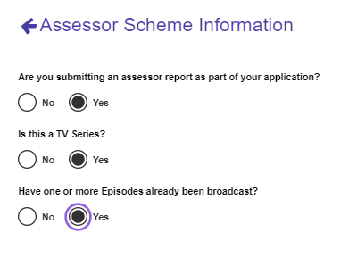
This is now an ATSA Application.
The Basic Details form is next (previously described) and includes:
Title, Director/Creator names, Producer names, Production company and production year, language(s), country(ies) of origin.
Additional Information form is next (Previously described) and includes:
Embargo information, Modification information, Genre(s), Formats for distribution, Classifiable Time worksheet (CTW – only one classifiable time item is required but note a recommendation is required for each Classification Element – see further below), Website Info.
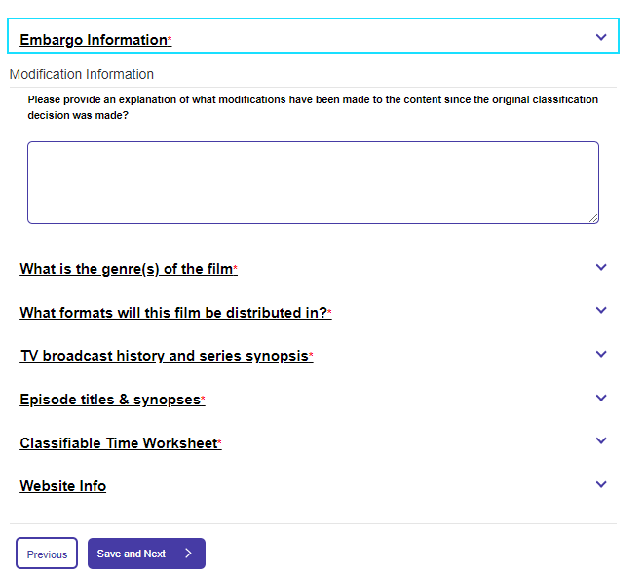

New items on this form include:
TV Broadcast history and series synopsis:
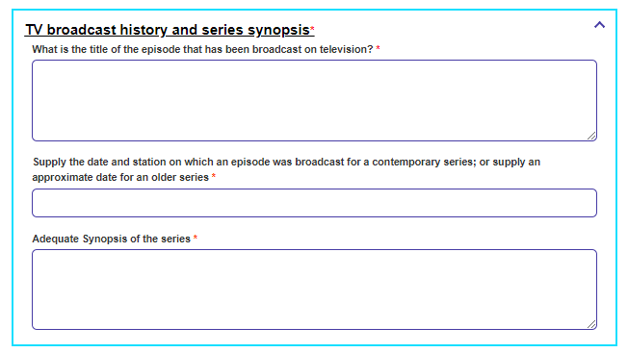
What is the title of the episode that has been broadcast on television?
Supply the date and station on which an episode was broadcast for a contemporary series; or supply an approximate date for an older series;
Adequate Synopsis of the series
Episode titles and Synopsis:
For each episode title and synopses:
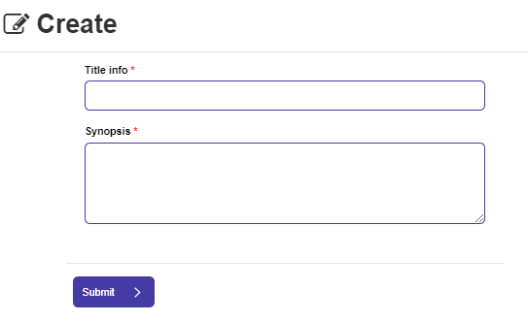
Title info;
Synopsis.

Recommendation form:
In this pathway, a recommendation must be provided for each Classification Element (Themes, Violence, Sex, Language, Drug Use, Nudity)
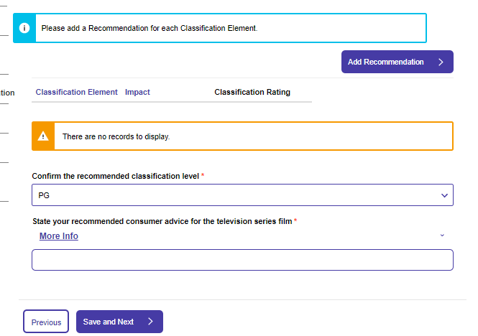
Confirm the recommended classification level
State your recommended consumer advice for the television series film
For each Classification Element:
Select the element, fill in details on Impact by clicking on the magnifying glass icon to the right of the Impact field.
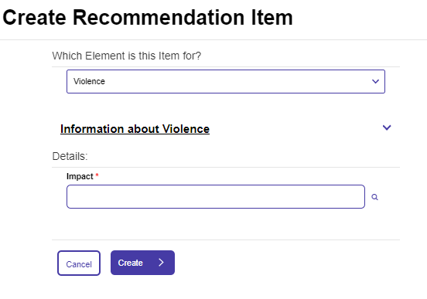
Impact will be one of:
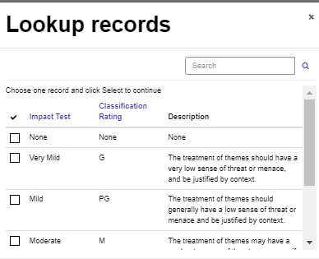
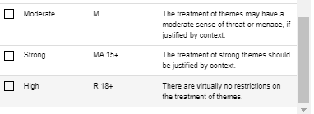
Themes:
Impact Test | Classification Rating | Description
None | None | None
Very Mild | G | The treatment of themes should have a very low sense of threat or menace, and be justified by context.
Mild | PG | The treatment of themes should generally have a low sense of threat or menace and be justified by context.
Moderate | M | The treatment of themes may have a moderate sense of threat or menace, if justified by context.
Strong | MA 15+ | The treatment of strong themes should be justified by context.
High | R 18+ | There are virtually no restrictions on the treatment of themes.
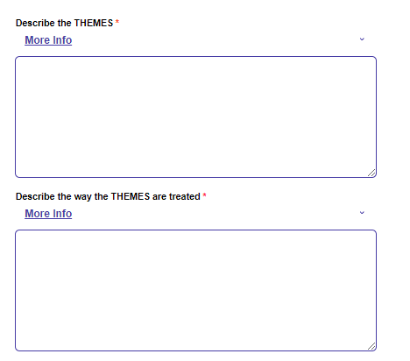
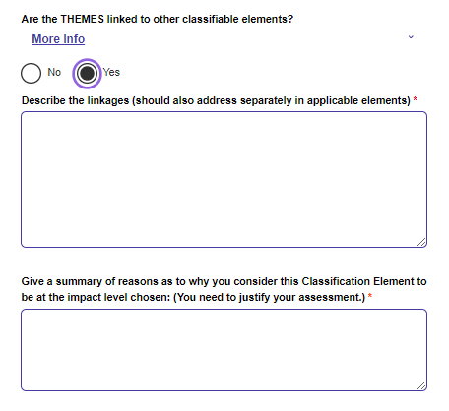
Additional questions if impact is more than “None”:
Describe the THEMES;
Describe the way the THEMES are treated;
Are the THEMES linked to other classifiable elements?
Describe the linkages (should also address separately in applicable elements);
Give a summary of reasons as to why you consider this Classification Element to be at the impact level chosen: (You need to justify your assessment.)
Violence:
Impact Test | Classification Rating | Description
None | None | None
Very Mild | G | Violence should have only a low sense of threat or menace, and be justified by context. Sexual violence, implied or otherwise, is not permitted.
Mild | PG | Violence should be mild and infrequent, and be justified by context. Sexual violence, implied or otherwise, is not permitted.
Moderate | M | Moderate violence is permitted, if justified by context. Sexual violence, implied or otherwise, is not permitted.
Strong | MA 15+ | Violence should be justified by context. Strong and realistic violence should not be frequent or unduly repetitive. Sexual violence, implied or otherwise, is not permitted.
High | R 18+ | Violence is permitted. High impact violence that is, in context, frequently gratuitous, exploitative and offensive to a reasonable adult will not be permitted. Actual sexual violence is not permitted. Implied sexual violence that is visually depicted, interactive, not justified by context or related to incentives or rewards is not permitted.
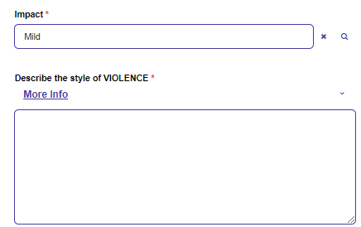
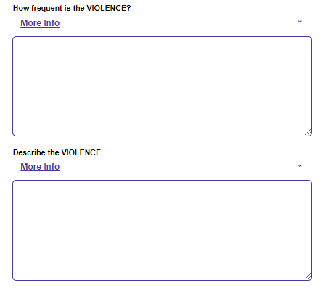
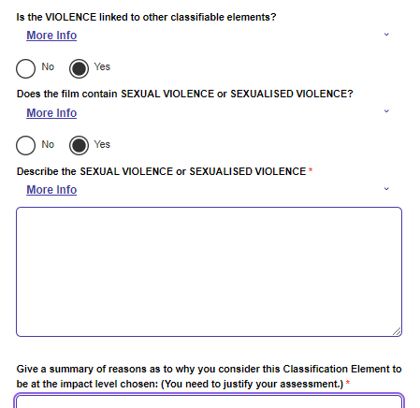
Impact
Describe the style of VIOLENCE
How frequent is the VIOLENCE?
Describe the VIOLENCE
Is the VIOLENCE linked to other classifiable elements?
Is the VIOLENCE linked to other classifiable elements?
Does the film contain SEXUAL VIOLENCE or SEXUALISED VIOLENCE?
Describe the SEXUAL VIOLENCE or SEXUALISED VIOLENCE
Give a summary of reasons as to why you consider this Classification Element to be at the impact level chosen: (You need to justify your assessment.)

Sex
Impact Test | Classification Rating | Description
None | None | None
Very Mild | G | Sexual activity should be very mild and very discreetly implied, and be justified by context. Sexuality activity must not be related to incentives or rewards.
Mild | PG | Sexual activity should be mild and discreetly implied, and be justified by context. Sexual activity must not be related to incentives or rewards.
Moderate | M | Sexual activity should be discreetly implied, if justified by context. Sexual activity must not be related to incentives or rewards.
Strong | MA 15+ | Sexual activity may be implied. Sexual activity must not be related to incentives or rewards.
High | R 18+ | Depictions of actual sexual activity are not permitted. Depictions of simulated sexual activity may be permitted. Depictions of simulated sexual activity that are explicit and realistic are not permitted.

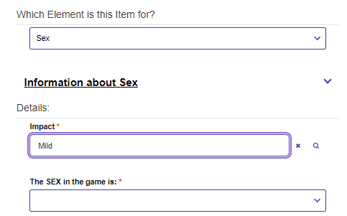
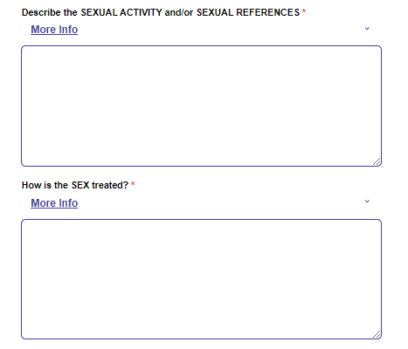

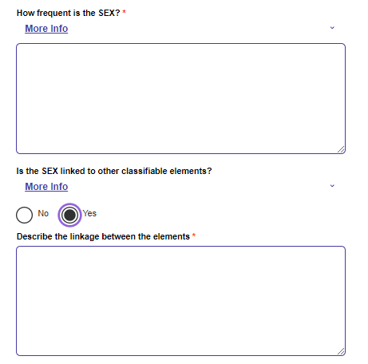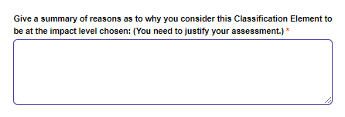
If a game, the question will be – “The SEX in the game is:”
If a film, the question will be – “The SEX in the additional content is:”
How is the SEX treated?
How frequent is the SEX?
Is the SEX linked to other classifiable elements?
Describe the linkage between the elements

Give a summary of reasons as to why you consider this Classification Element to be at the impact level chosen: (You need to justify your assessment.)
Language
Impact Test | Classification Rating | Description
None | None | None
Very Mild | G | Coarse language should be very mild and infrequent, and be justified by context.
Mild | PG | Coarse language should be mild and infrequent, and be justified by context.
Moderate | M | Coarse language may be used. Aggressive or strong coarse language should be infrequent, justified by context, and not gratuitous, exploitative or offensive.
Strong | MA 15+ | Strong coarse language may be used. Aggressive or very strong coarse language should be infrequent, and not exploitative or offensive.
High | R 18+ | There are virtually no restrictions on language.
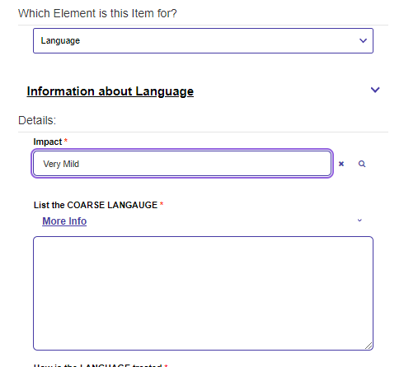
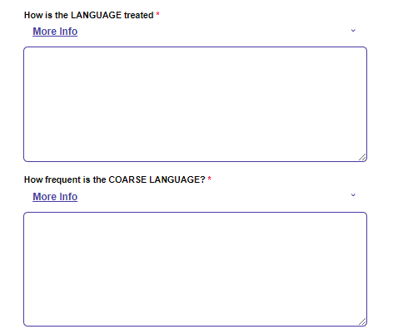
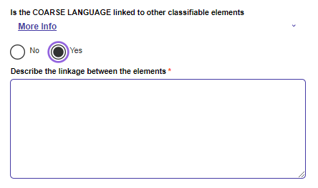
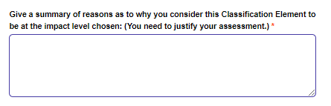
List the Course Language;
How is the LANGUAGE treated
How frequent is the COARSE LANGUAGE?
Is the COARSE LANGUAGE linked to other classifiable elements
Is the COARSE LANGUAGE linked to other classifiable elements?
Describe the linkage between the elements
Give a summary of reasons as to why you consider this Classification Element to be at the impact level chosen: (You need to justify your assessment.)

Drug Use
Impact Test | Classification Rating | Description
None | None | None
Very Mild | G | Drug use should be implied only very discreetly, and be justified by context. Drug use related to incentives or rewards is not permitted. Interactive illicit or proscribed drug use is not permitted.
Mild | PG | Drug use should be infrequent and justified by context. Drug use related to incentives or rewards is not permitted. Interactive illicit or proscribed drug use is not permitted.
Moderate | M | Drug use should be justified by context. Drug use related to incentives or rewards is not permitted. Interactive illicit or proscribed drug use is not permitted.
Strong | MA 15+ | Drug use should be justified by context. Drug use related to incentives or rewards is not permitted. Interactive illicit or proscribed drug use is not permitted.
High | R 18+ | Drug use is permitted. Drug use related to incentives or rewards is not permitted. Interactive illicit or proscribed drug use that is detailed and realistic is not permitted.
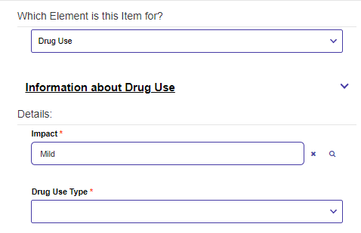
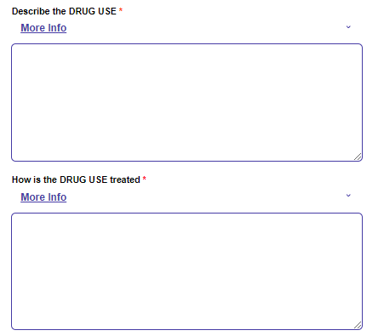
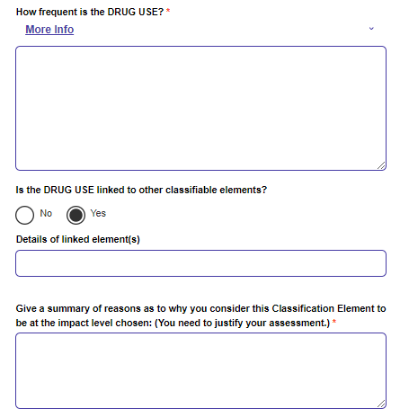

Drug Use Type
Describe the DRUG USE
How is the DRUG USE treated
How frequent is the DRUG USE?
Is the DRUG USE linked to other classifiable elements?
Details of linked element(s)
Give a summary of reasons as to why you consider this Classification Element to be at the impact level chosen: (You need to justify your assessment.)
Nudity
Impact Test | Classification Rating | Description
None | None | None
Very Mild | G | Nudity should be infrequent and justified by context. Nudity must not be related to incentives or rewards.
Mild | PG | Nudity should be infrequent and justified by context. Nudity must not be related to incentives or rewards.
Moderate | M | Nudity should be justified by context. Nudity must not be related to incentives or rewards.
Strong | MA 15+ | Nudity should be justified by context. Nudity must not be related to incentives or rewards.
High | R 18+ | Nudity is permitted.
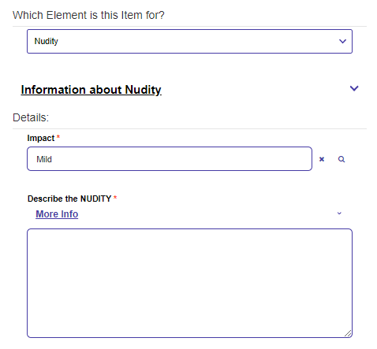
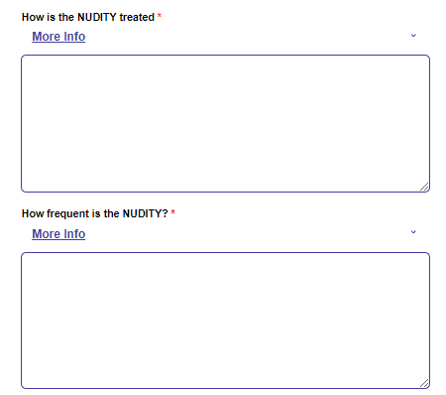
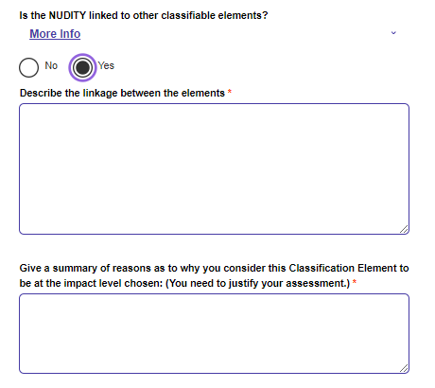

Impact
Describe the NUDITY
How is the NUDITY treated
How frequent is the NUDITY?
Is the NUDITY linked to other classifiable elements?
Is the NUDITY linked to other classifiable elements?
Describe the linkage between the elements
Give a summary of reasons as to why you consider this Classification Element to be at the impact level chosen: (You need to justify your assessment.)

Provide media.
Change to priority application is available for ATSA’s.
Declare and submit (to be provided once updated).

Assessor Report – but not a TV Series (FO Application)

Next, we’ll follow the pathway for:
Are you submitting an assessor report as part of your application? = YES
Is this a TV Series? = NO
Additional Film Content Application? = NO
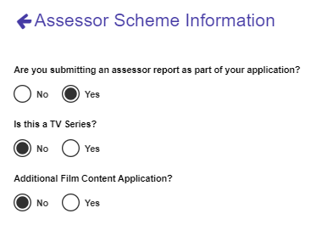
This is now an Film Other (FO) application and the same content as previously required for FO applies:
Basic Details:
Title, Director/Creator names, Producer names, Production company and production year, language(s), country(ies) of origin.
Additional Information:
Embargo information, Modification information, Genre(s), Formats for distribution, Classifiable Time worksheet (CTW - at least one CTW is required), Synopsis (Adequate Synopsis), Contentious Material, Website Info.
Change to priority application is available in this pathway.
Declaration next (to be added once updated).

Additional Film Content Application (ACA)

Next, we’ll follow the pathway for:
Are you submitting an assessor report as part of your application? = YES
Is this a TV Series? = NO
Additional Film Content Application? = YES
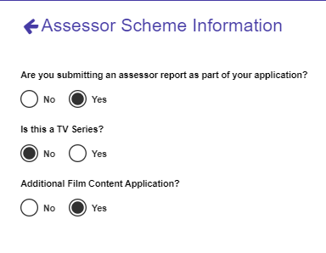
This is now an ACA application.
c
Basic details form:
Title, Director/Creator names, Producer names, Production company and production year, language(s), country(ies) of origin.
Note that some fields will be available from the previous application chosen but older applications are often missing information and you’ll need to supply any mandatory missing details.
Additional Details form:
Embargo,
Modification Information,
Genres.
Distribution formats (note that at least one genre and distribution type must be selected),
Classifiable Time Worksheet (CTW – previously described - at least one CTW is required);
Website Info (IMDB URL, Expected release date, Website spoiler-free synopsis, ISAN number).
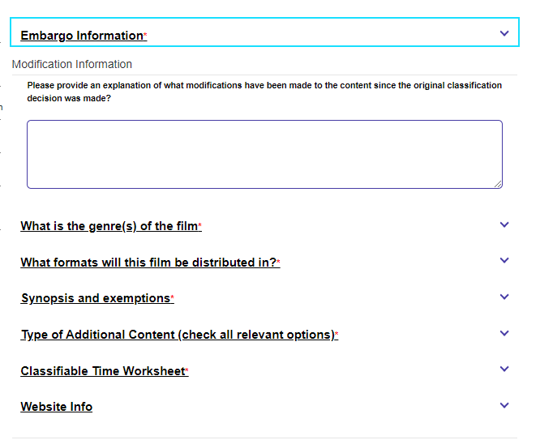

New items include:
Synopsis and exemptions
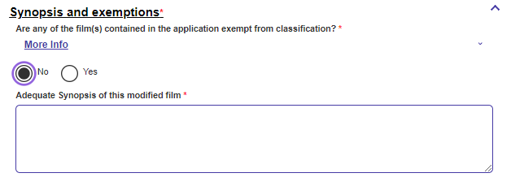
Are any of the film(s) contained in the application exempt from classification?
Type of Additional Content.
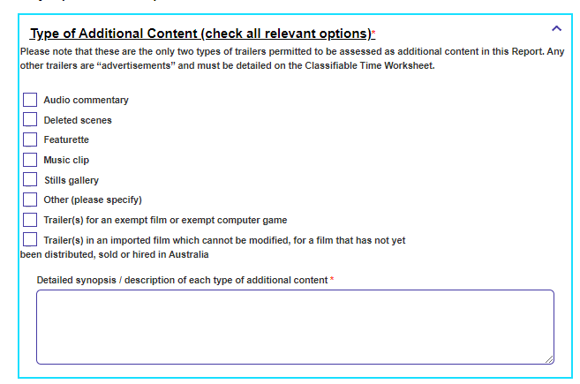
Please note that these are the only two types of trailers permitted to be assessed as additional content in this Report. Any other trailers are “advertisements” and must be detailed on the Classifiable Time Worksheet.
Audio commentary
Deleted scenes
Featurette
Music clip
Stills gallery
Other (please specify)
Trailer(s) for an exempt film or exempt computer game
Trailer(s) in an imported film which cannot be modified, for a film that has not yet been distributed, sold or hired in Australia
Detailed synopsis / description of each type of additional content
Recommendation from – previously described – a Recommendation Item is required for each Classification element.
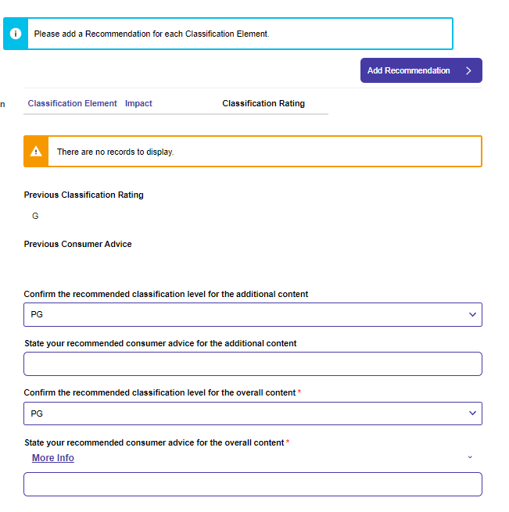

Confirm the recommended classification level for the additional content
State your recommended consumer advice for the additional content
Confirm the recommended classification level for the overall content
State your recommended consumer advice for the overall content

For each Recommendation item:
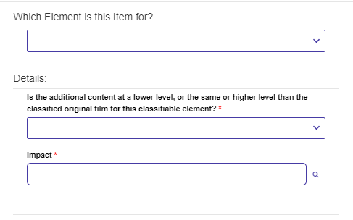
Is the additional content at a lower level, or the same or higher level than the classified original film for this classifiable element?
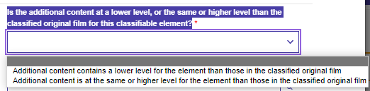
Options are:
Additional content contains a lower level for the element than those in the classified original film.
Additional content is at the same or higher level for the element than those in the classified original film.
Each recommendation item now asks for impact and details as per fully described previously.
A new question applies for Sex and Drug Use:
The <theme> in the additional content is:
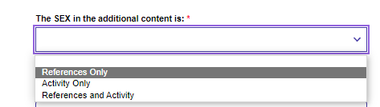
Options for this question are:
References only
Activity only
References and Activity
Provide Media
Change to priority application is available for this ACA pathway.

Publications

If this application is related to a previous decision, select the application that the decision was associated with below. E.g. your application is for a new version of a previously classified product.
If you select “No” – “My application is for something that has not been classified before” – this application becomes a “New Publication Application”.
If you select “Yes” – “My application is for a new version of something that is previously classified” – This application becomes a “Serial Declaration Application”.
In both cases, the following information is gathered:
Publications Basic Details form:
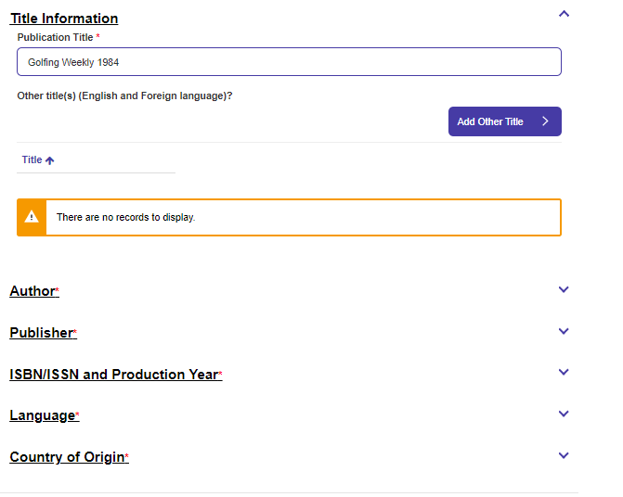
This form asks for: Author, Publisher, IBN/ISSN and Production year, Language, Country(ies) of Origin.

For a New Publication Application, the Additional Information form has:
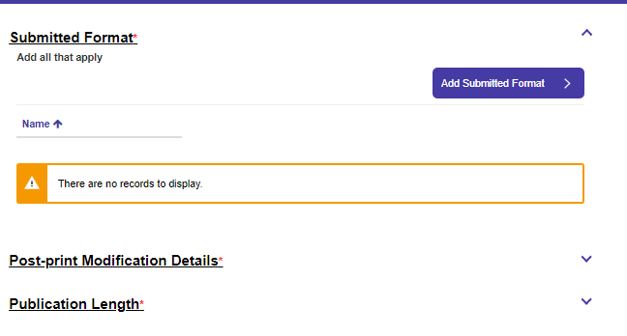
Submitted Format – one or more of:
Calendar
Hardcover
Magazine
Paperback
Poster
Post Print Modification Details:
Have any post-print modifications or alterations been made to this publication?
For each publication modification:
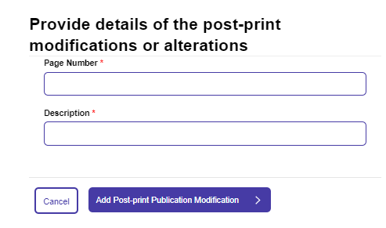
Page Number, Description

Publication Length -How many pages long is the publication?
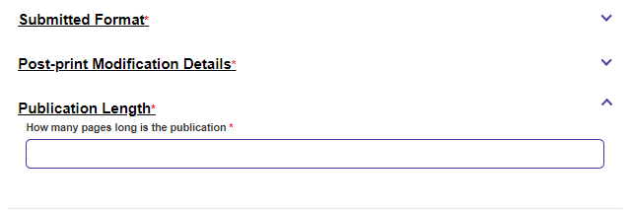
For a Serial Declaration Application – the Additional Information form has:
Publishing Frequency

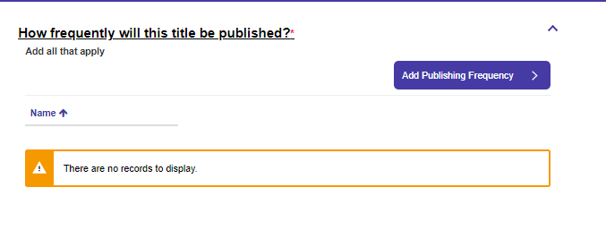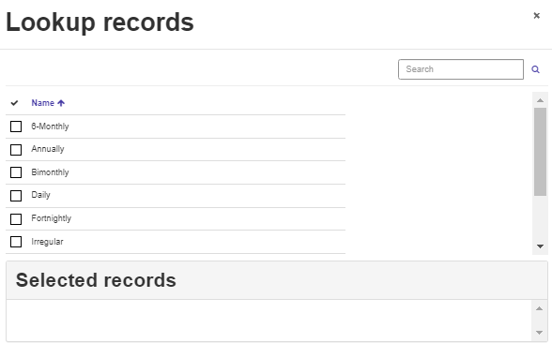
Options are (multiple can be selected):
6-Monthly
Annually
Bimonthly
Daily
Fortnightly
Irregular
Monthly
Quarterly
Weekly
Declaration text (to be added).
Priority processing is not available in this pathway.

Title Changes – Film, Games, Publications
For title changes (Film and Games) – select the previous application as per shown in PE and provide the following:
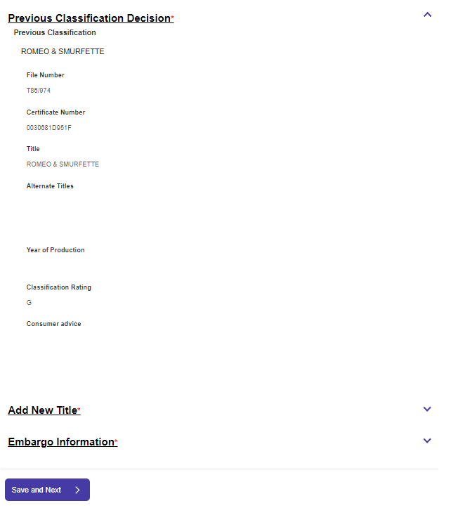
Previous Classification Decision – information only.
Add new title:
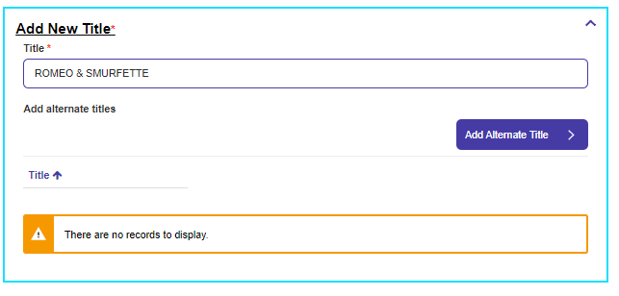
Embargo information (previously described).
Change to Priority Application is available in this pathway for Films and Games but not for Publications.

Event Application
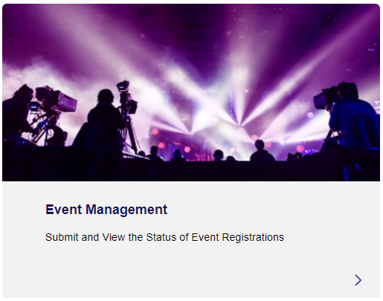
Acknowledge event guidelines, select if event is being registered by yourself or for an Organisation:
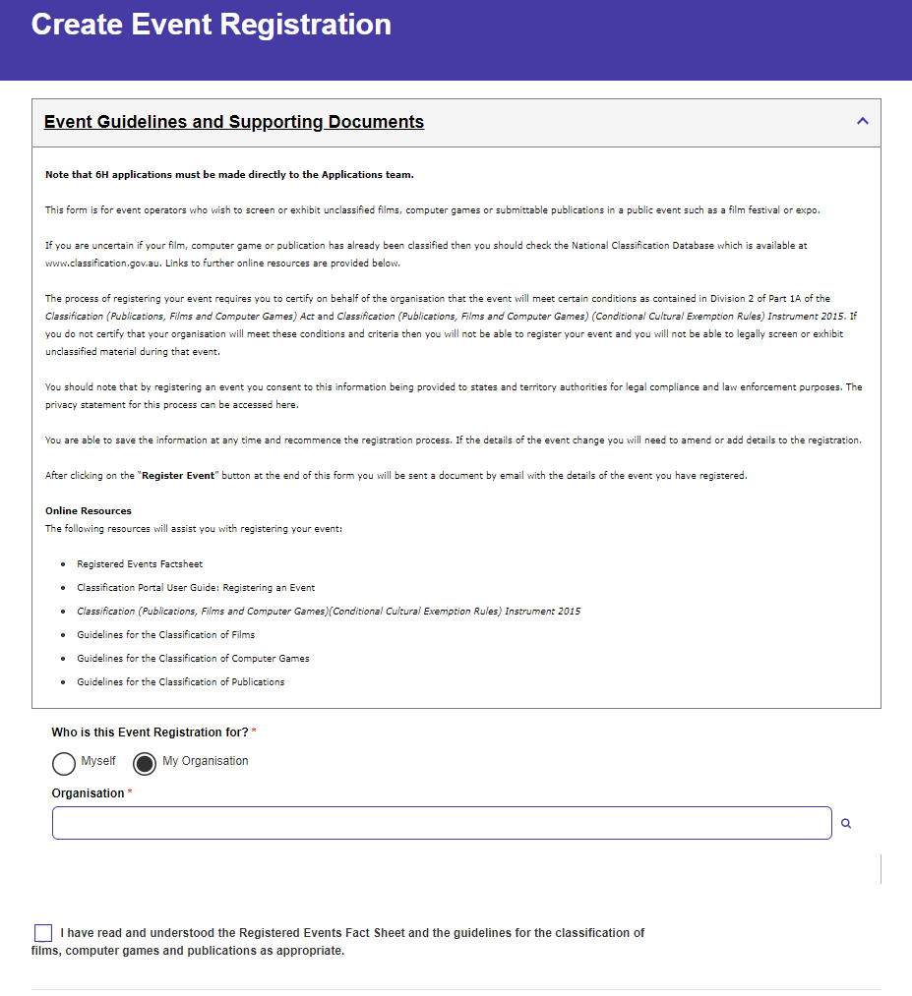
Enter details for: Event name, event type, description, event URL.
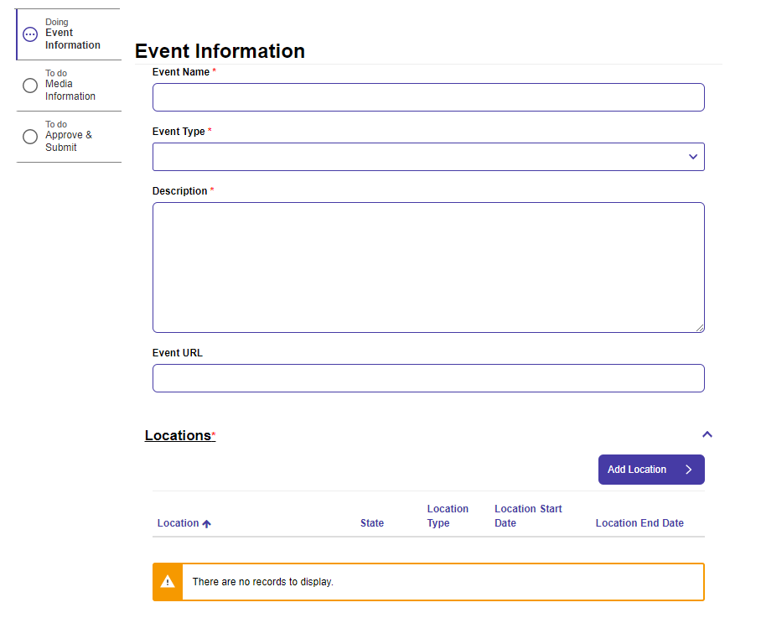
Event type is: Public Performance, Restricted Performance or Registered Charity Use.
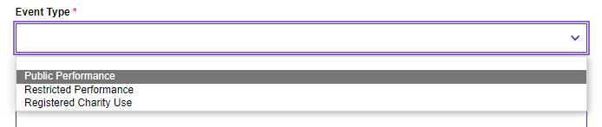

For Each location – location, location type (indoor or outdoor), State, location start date, location end date.
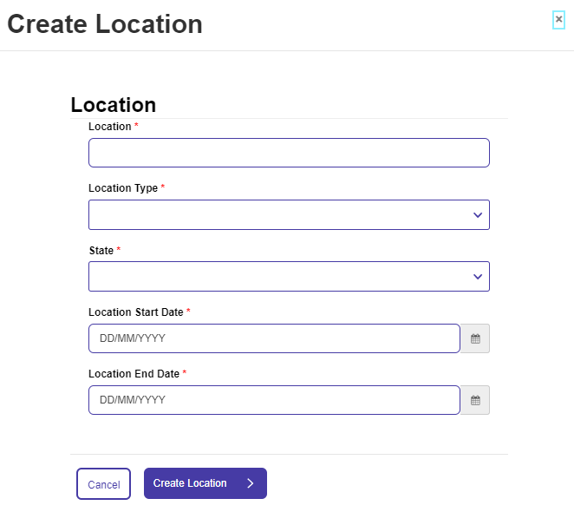
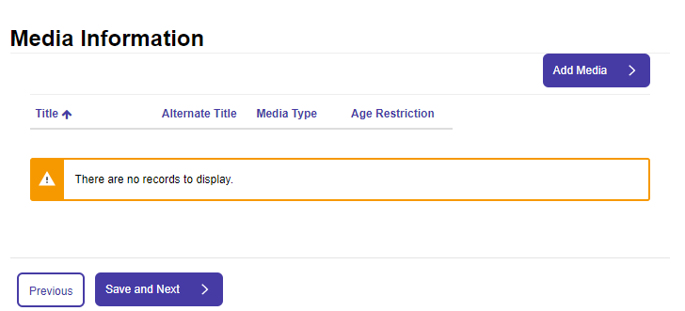

Add media information: title, alternate title, media type, age restriction, director, copyright year.

Reviews – Film, Games, Publications
Follow the create an application pathway and under each of Film, Games and Publications, you’ll be able to select “Request Review”

Select the previous application as per notes under Public Exhibition (Cinema).
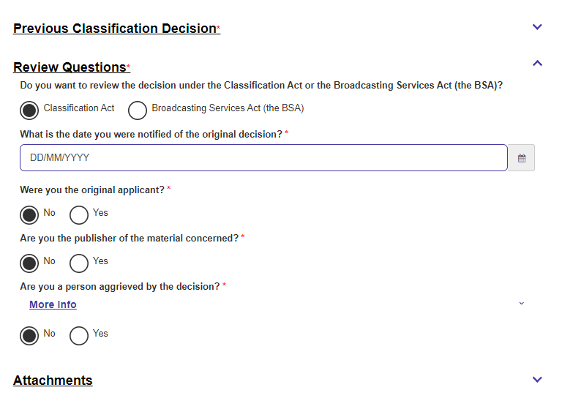
Questions asked are:

Do you want to review the decision under the Classification Act or the Broadcasting Services Act (the BSA)?
Do you want to review the decision under the Classification Act or the Broadcasting Services Act (the BSA)?
What is the date you were notified of the original decision?
Were you the original applicant?
Are you the publisher of the material concerned?
Are you a person aggrieved by the decision?
You can also upload documents to support your application:Flr
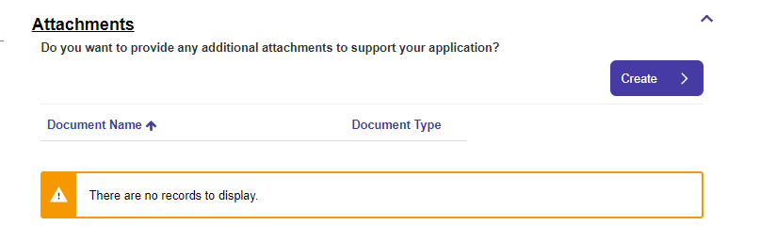
For each document, you must select a “Document Type” as provided. Click on the magnifying glass to the right of the “Document Type” field as shown below:
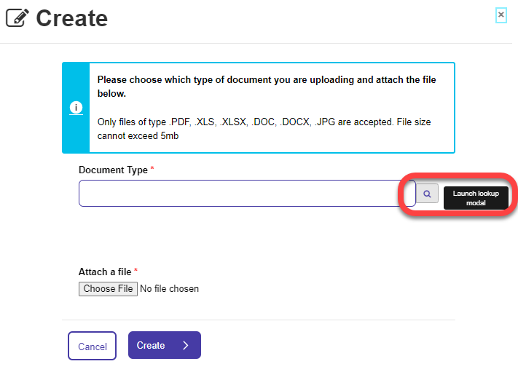
Options for Document type here are:
Other
Written Statement
Select a file from your operating system after clicking on “Choose File”.
Payment and declaration are next – no option to make this a priority application.

Advertising – Film and Games
Follow the create an application pathway and under each of Film, Games and Publications, you’ll be able to select “Advertising”
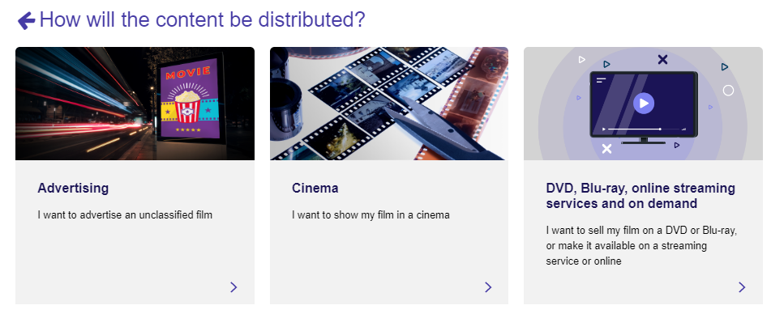

Film
Choose your organisation and you next fill in the “Basic Details” form:
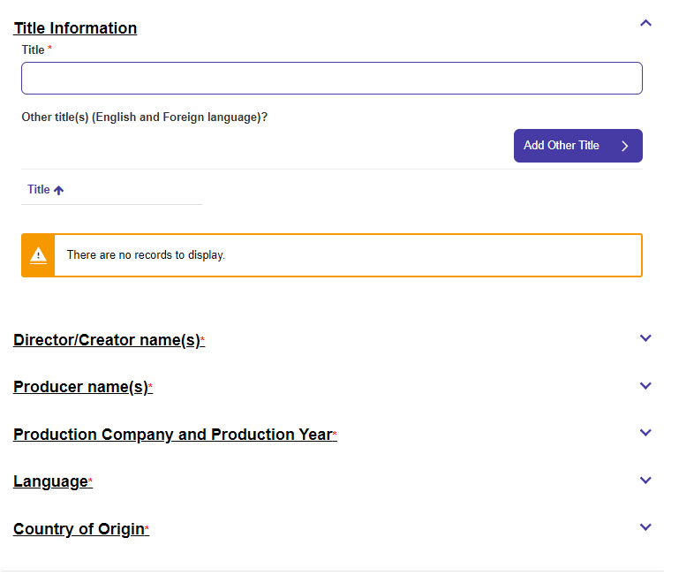
This form is exactly the same as per the Basic Details form in Public Exhibition (Cinema)
Title, Director/Creator names, Producer names, Production company and production year, language(s), country(ies) of origin.
Additional Information form for Film:
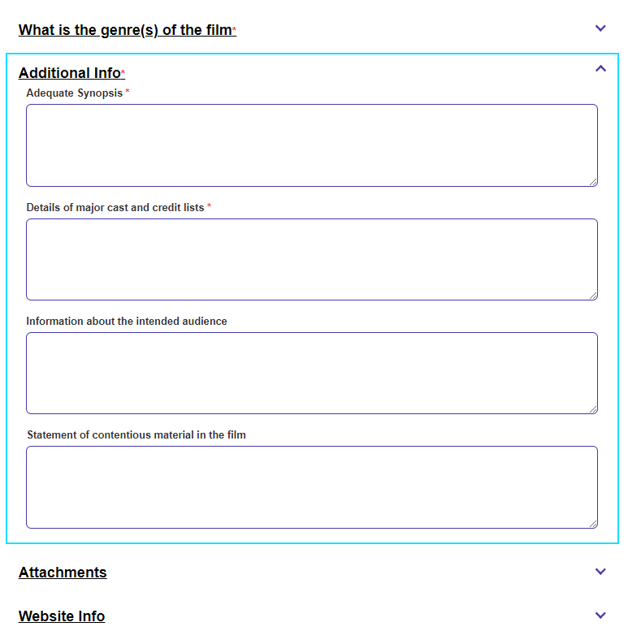
This form includes Genre(s), Attachments and Website info as we have seen before.
Additional info includes:
Adequate Synopsis
Details of major cast and credit lists
Information about the intended audience
Statement of contentious material in the film
Document types for Film include:
Available foreign advertising
Detailed production notes
Detailed reviews and media comment
Details of foreign classifications
Information from official websites
Media/press kit
Other
Posters and/or official images
Scripts and/or screenplay information
Payment and declaration- - change to Priority Application is available in this pathway.

Games
For games, click on the “Yes” panel for “This application is regarding advertising a game”
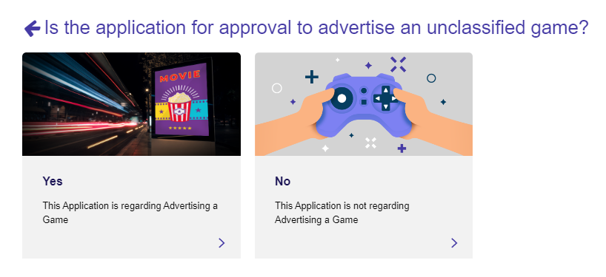
Select Organisation
Basic Information form asks for:
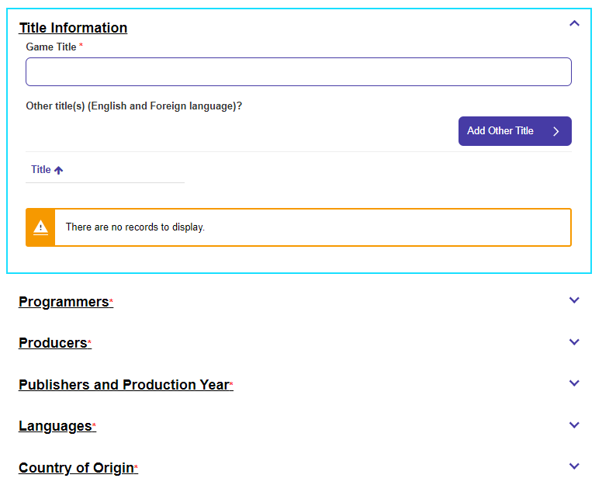
Title Information, Programmers, Producers, Publishers and Production year, Languages, County of Origin.
Additional Information form asks for:
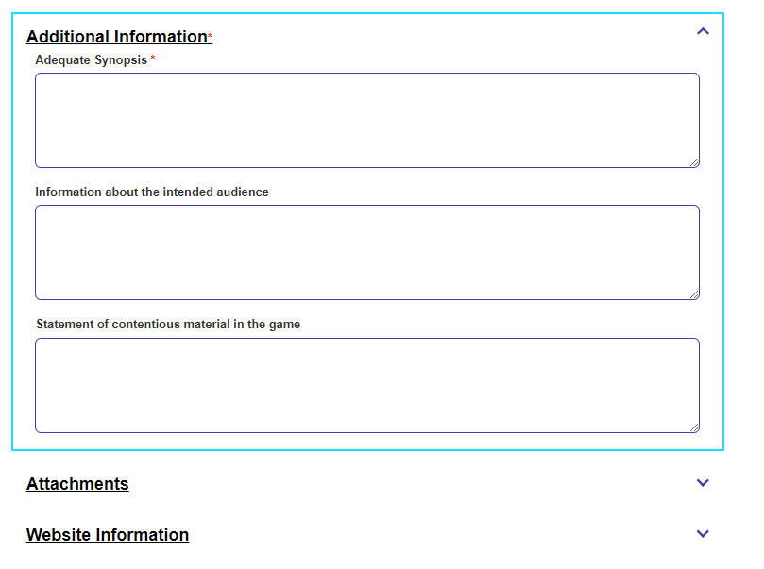
Adequate Synopsis
Information about the intended audience
Statement of contentious material in the game (text only field in this case)
Document types available are:
Available foreign advertising
Detailed production notes
Detailed reviews and media comment
Details of foreign classifications
Information from official websites
Other
Posters and/or official images
Scripts and/or screenplay information
Declaration and payment – Change to Priority Application is available in this pathway.

