


Applications Portal – User Guide
  - Classifiable Time Worksheet and Contentious Material
November 2022 (V1.0)

Contents
Introduction 1
CTW – Directly enter into the Portal 2
CTW – Use the provided spreadsheet 4
Contentious Material statement 6

Introduction
You can now create a full Classifiable Time Worksheet (CTW) via the Portal in two ways:
- Directly into the Portal
- For when you have lots of information, you can enter all details into a spreadsheet and then upload this into the Portal.
Context:
You are progressing an application and have indicated that your “application is for a new version of something that has been submitted before”.

CTW – Directly enter into the Portal

Step 1

- For each Classifiable Time Item you would like to enter directly into the Portal, click on the “Add Classifiable Time Item” button as shown below:
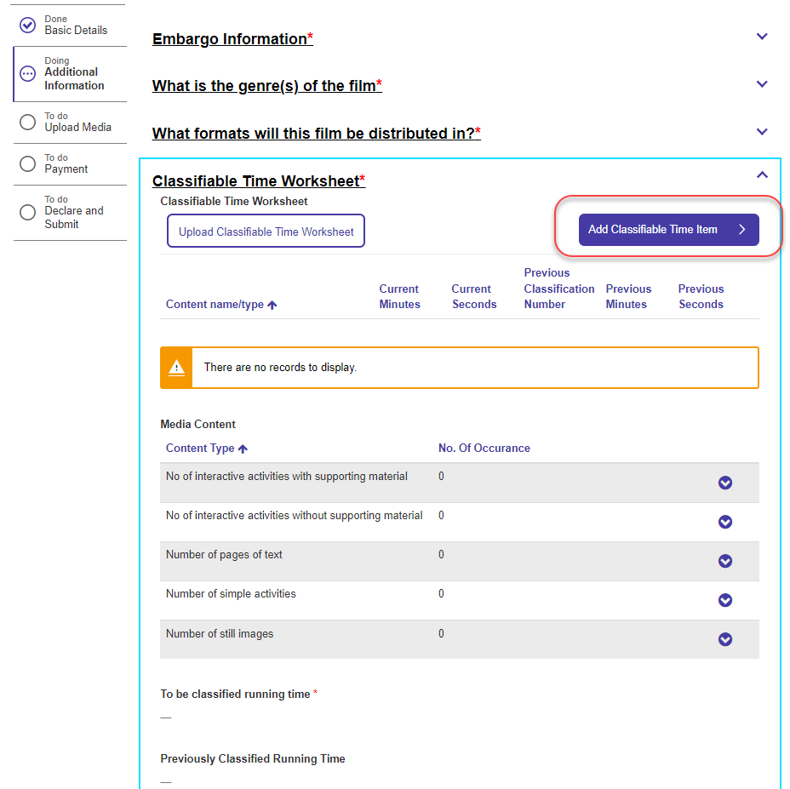

Step 2
Enter details for Content name/type, Running time and Previous Classification details as required:
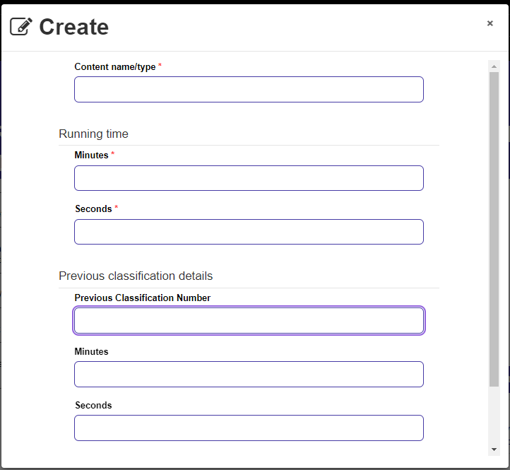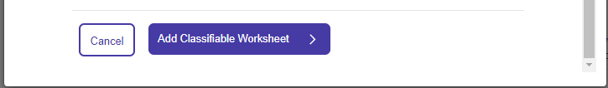

When finished, click on “Add Classifiable Worksheet”
You can keep adding additional Classifiable Time Items until all items are entered.
Step 3
You can also direct enter details for each of “Media Content types” – click on the downward facing chevron in the blue circle next to each Content type and choose “edit”:
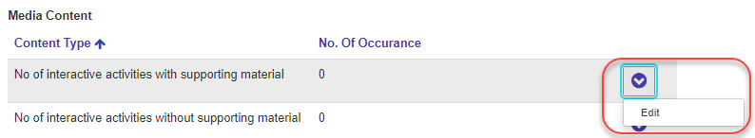

Fill in the “No of Occurrence” for your selected Media Content Type into the following edit screen and press “Update”:
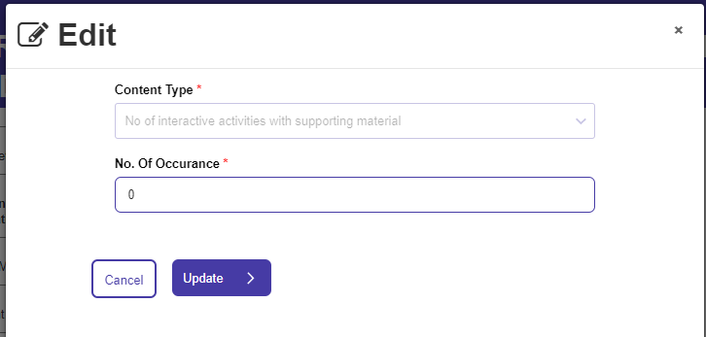

CTW – Use the provided spreadsheet

Step 1
Click on the “Upload Classifiable Time Worksheet” button”
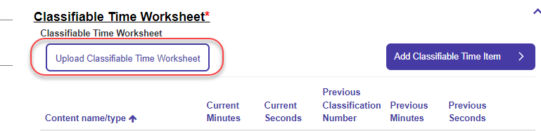
If you haven’t created a CTW worksheet before, click on “CTW Upload Template” text in the informational box:
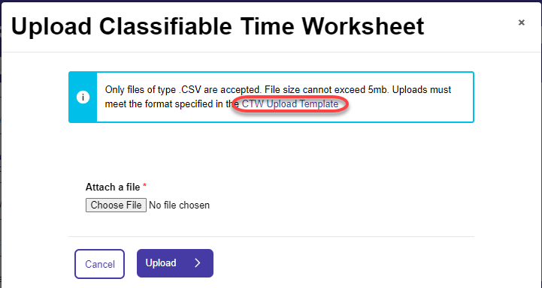

The “CTWTemplate.csv” file will be downloaded from within your browser. This comes pre-loaded with some dummy data and looks like this once opened in Excel:
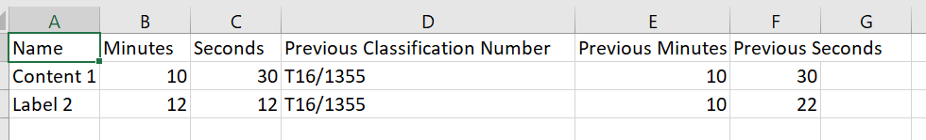

Fill in all of the details required:
- For “Previous Classification Number” please use the File Number (as shown) if possible.
If there are no previous classification details to enter – Leave “Previous Classification Number” blank and put 0’s (zeros) into Previous Minutes and Pervious Seconds. If you don’t do this, the upload will fail.
- It is a good idea to save the file with the title of the content you are submitting but this is not mandatory.
NOTE: Do not save the file as Excel format – it needs to remain in CSV file format.
Now press “Choose File” back in the browser and select the CTW file you just created.
Once Selected, press “Upload”.
The data you entered into the CTW template will appear in the Content area. Note that if you have previously directly entered a Classifiable Time Item, it will not be removed.
Once uploaded, you can still edit or remove individual Time items from the system – just choose the relevant option after pressing the downward facing blue chevron to the right of the time item details:

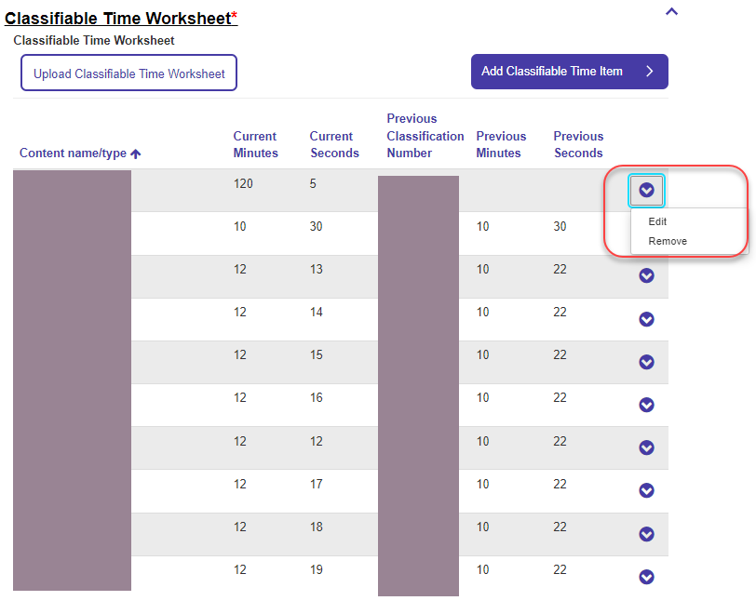

Contentious Material statement
If you have a Contentious Material statement to provide, you can enter a statement for any of the elements (Themes, Violence, Sex, Language, Drug use, Nudity).
Under the Contentious Material header, click on the “Yes” radio button, then “Add Contentious Materials”.
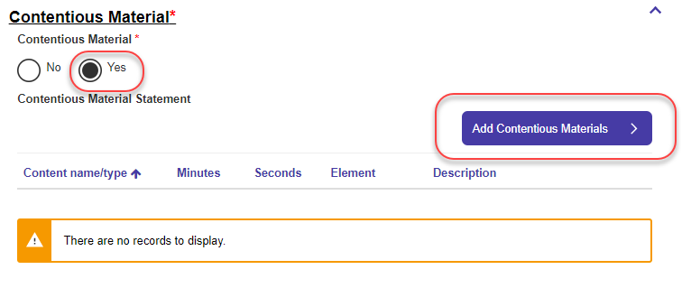

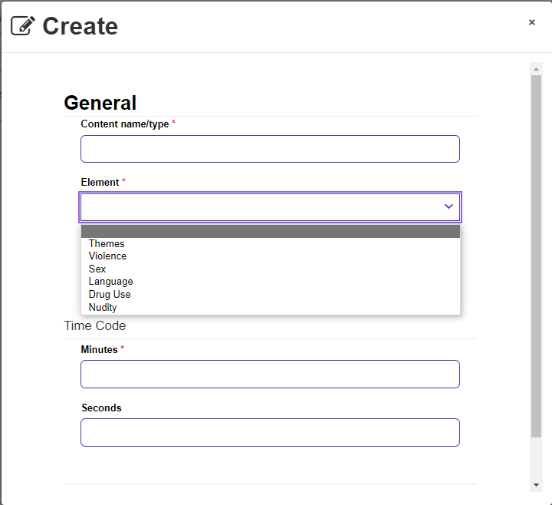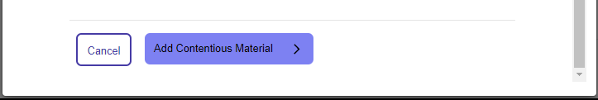

Enter the details as prompted and then press “Add Contentious Material”.

