


Applications Portal
  - FAQs
November 2022 (V1.0)
What’s new? 2
I am an existing user - how do I login for the first time to the new Portal? 2
How do I connect to an Organisation? 7
What if I don’t belong to an Organisation and/or I’m representing myself? 10
What are my responsibilities as an Organisational Administrator? 10
What do the roles of Standard User, Administrator and Finance along with Contact Types actually do? 11
I have selected an existing Organisation but nothing has happened – what do I do next? 12
The menu structure has changed – how do I create an ACA/ATSA, change a Title or request a review? 12
How do I get my Classification Certificate? 13
How do I get a previous Classification Certificate? 14
Can I request Certificate provided to another organisation? 14
I have done classification training online – when will I be able to submit an application? 14
I am an authorised assessor but haven’t been able to submit an application. 15
How do I see my account balance? 15
How do I get an account statement with past transactions? 16
I have paid my account twice – how do I get a refund? 17
How do I register a 6H event? 17
How do I register a non-6H event? 17
How do I submit an assessment report on behalf of the assessor and I haven’t done the necessary training? 18

What’s new?
The following features are new in the Applications Portal as of the release of Nov 2022 :
- An easier user interface which reduces the amount of time it takes to submit an application.
- The ability to manage finances including visibility of up to date organisational balances, recent transactions and receipts.
- An updated way of managing users that have access to an organisation.
- Increased self-service functionality with an updated set of email notifications and on-system updates – including automated generation and retrieval of Classification Certificates.
- Improved integration with Box with a simpler content upload facility.
- Updated Terms and Conditions to reflect management of privacy issues.

I am an existing user - how do I login for the first time to the new Portal?
What you need:
You will need your mobile number and mobile phone to login into the new Portal.
Key tip:
As an existing user, your old password will not be known to the system.
You must choose “Forgot Password” the first time you try and login.

Recommended browsers
The recommended browsers to use when accessing the portal are: Chrome, Firefox or Microsoft Edge. Internet Explorer and Safari are not recommended.
Steps:
Note again: this process only works if you are an existing user.
Step 1:
Goto https://www.classification.gov.au in your browser.
Click on “Portal Login” on the right-hand side of the screen.

Your existing system account, including the organisation(s) you represent has been migrated to our new system. To re-establish access to your account, go to the Classification Portal and click on Forgot password link.
Note again: If you did not have a previous account in, you will need to sign up as a new user – choose the “sign up now” option from the first screen.
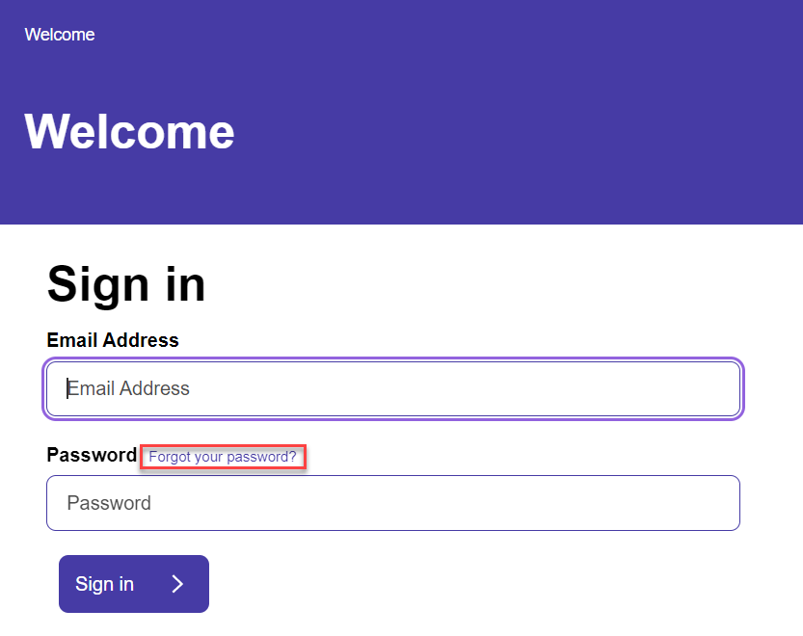

Step 2:
Verify your email address by typing the same email address that you have used previously in the Email Address field. Then click on the Send verification code button.
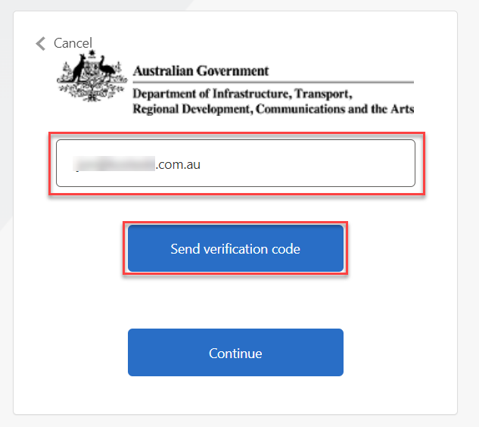

Step 3:
A 6-digit verification code will be emailed to the email address you provided. Type the verification code into the Verification Code field and click on the Verify code button.
Note: The verification code will expire after 10 minutes. However, you can click on the Send new code button to get another. If the verification code is slow to arrive, please check your junk/spam folder.
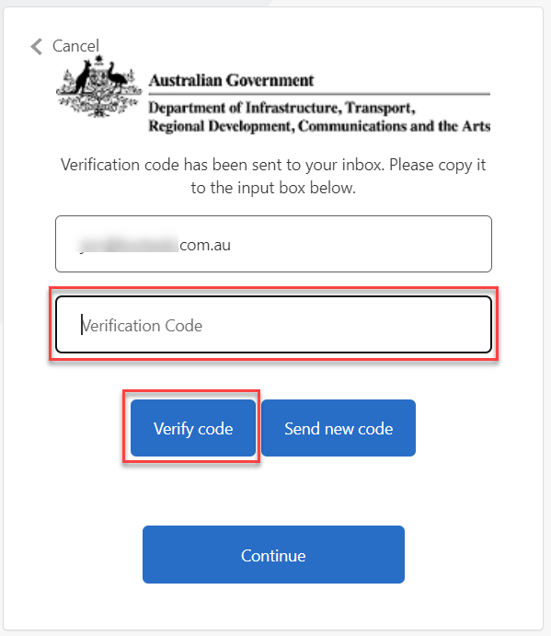

Step 4:
In the New Password and Confirm New Password fields, type in the password you would like to use to access your portal account. It should be between 10 and 30 characters long.
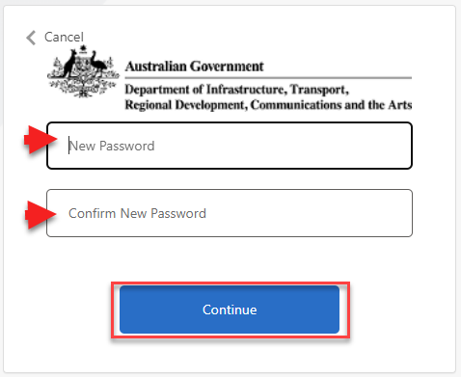

Step 5:
Now you will need to set up SMS authentication. Select your country from the Country Code drop down menu. Then type your mobile phone number in the Phone number field and click on the Send Code button. A 6-digit code will be sent to your mobile via SMS.
Note: If you are based outside Australia you can set up SMS authentication using an international mobile phone number.
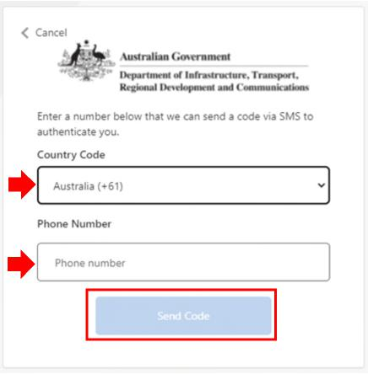
Step 6:
Check your mobile phone for an SMS. The SMS will include a 6-digit code that you need to enter into the Enter your verification code below field and then click on the Verify Code button.
Note: The code will expire after 10 minutes. You can click on the send a new code link to get another code.
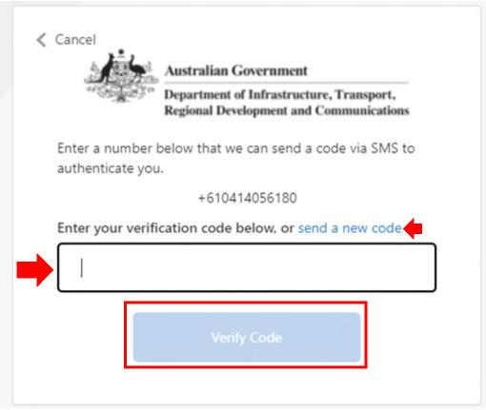
Step 7:
You have now successfully created a Classification portal account!
You will now be redirected to the portal login page where you can login with your new password.
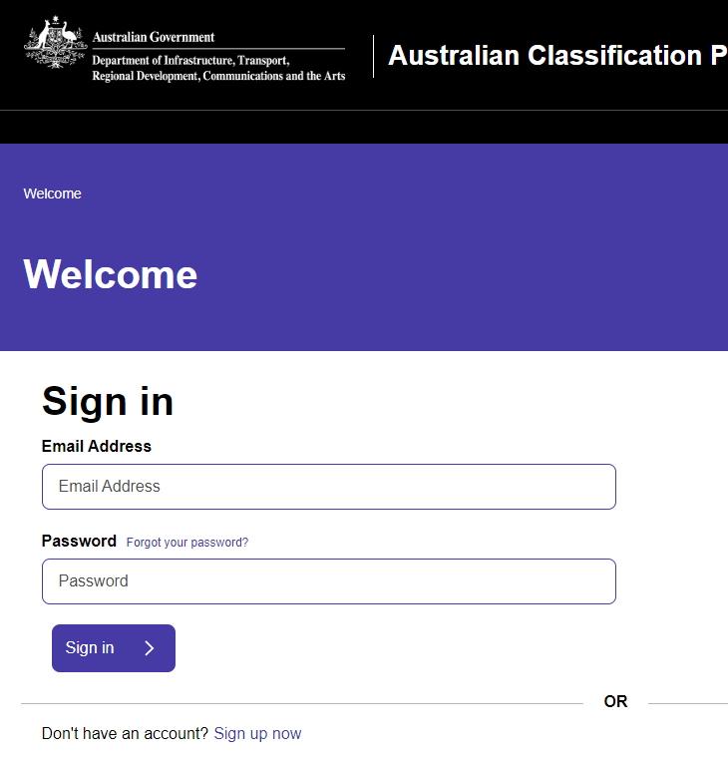

How do I connect to an Organisation?
In the new Portal, you generally have to provide an Organisation name when submitting applications.
If you don’t have an existing Organisation linked to your account, you must either:
- Find the Organisation as already in the Portal and request access to submit applications on behalf of the Organisation; or
- Create a new Organisation.

Here are the steps to find an existing Organisation:
Step 1:
Choose “Organisation Management” from the main dashboard:
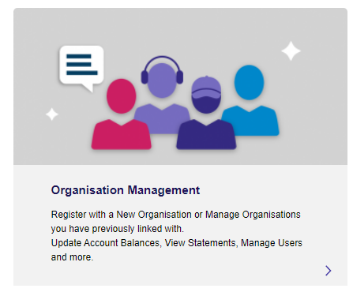

Step 2:
Click on “Add Another Organisation”:
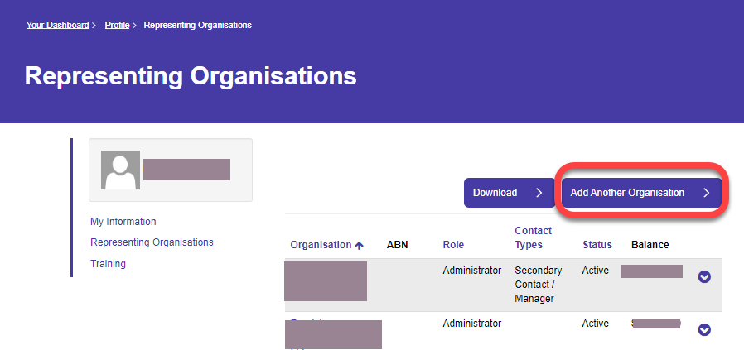

Step 3:
If you know the ABN, enter this into the ABN field. If you don’t know the ABN, enter some text that you would expect to see in the Organisation name.
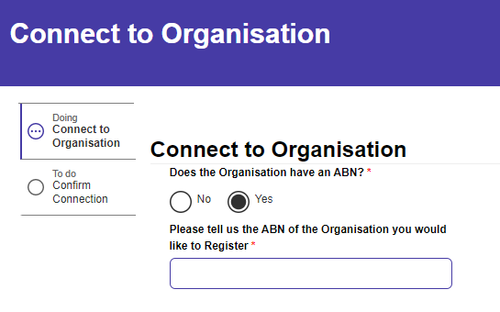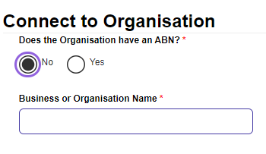

If the text or ABN you’ve entered match an existing Organisation, you will see this in the results list as follows:
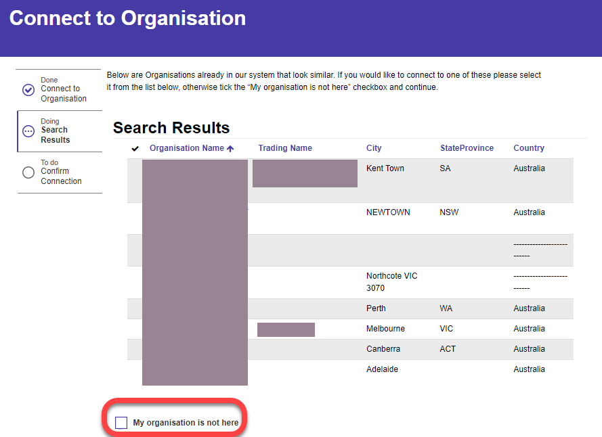

Step 4:
If your Organisation is in the list, click on the Organisation name and press “Next”. Goto step 5.

If your Organisation is not in the list, either press “Previous” and try again or click the box for “My Organisation is not here” and then press “Next”.

Step 4a – If you entering a new Organisation.
Fill in necessary details for your Organisation and press “Next”. If you are representing yourself, just enter your personal details.
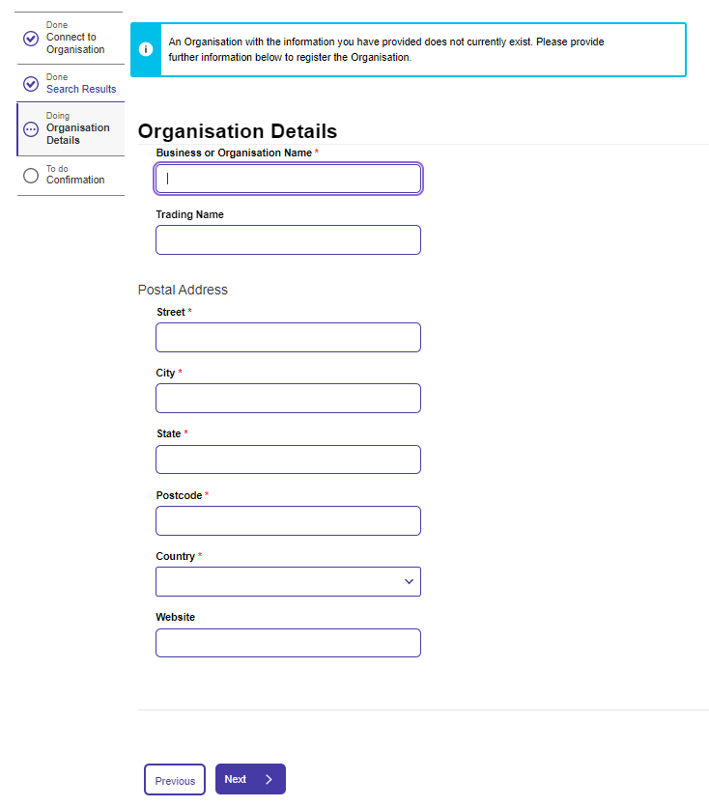

Step 5:
You will be asked to check the details provided, acknowledge some declaration text and then press “Submit”.
IMPORTANT: You must read and acknowledge the updated Terms and Conditions.

What if I don’t belong to an Organisation and/or I’m representing myself?
If you are representing yourself, just create a new Organisation with a unique name of your choice and no ABN. Follow the steps to create a new organisation as per noted above in “How do I connect to an Organisation”.

What are my responsibilities as an Organisational Administrator?
The following details are included in the Terms and Conditions which all users must agree in order to be able to use the Portal:

4 Role and responsibilities of organisational administrators
4.1 If you are the organisational administrator of the Classification Portal for your organisation:
a. you agree to comply with any requirements imposed on organisational administrators of the Classification Portal by your organisation,
b. you acknowledge and agree that you and any user granted access to the Classification Portal on behalf of your organisation will be able to view [and amend] any applications and registrations, including draft applications and registrations, submitted by other users on behalf of your organisation, which may include confidential information or information that is personal information for the purposes of the Privacy Act 1988,
c. you agree to take all reasonable steps to ensure that access arrangements to the Classification Portal on behalf of your organisation are appropriate and that users accessing the Classification Portal on behalf of your organisation meet any requirements imposed by the organisation for use of the Classification Portal, and
d. you agree to take all reasonable steps to revoke a person’s access to the Classification Portal as soon as practicable after the person ceases to act on behalf of your organisation or ceases to have the authority of your organisation to access the Classification Portal on its behalf.

What do the roles of Standard User, Administrator and Finance along with Contact Types actually do?
As an administrator, when approving another user to access your organisation, you must select appropriate roles. These are:
Standard Account – Given by default when a person requests access to an organisation – this allows the user to view applications submitted by their organisation and to submit applications on behalf of their organisation.
Finance - This role gives a user access to the ‘Finance & Accounting’ area of the organisation on the portal and allows them to view and download transactions.
Administrator- This role allows a user to manage requests for access to their organisation and manage existing users access levels. This role also is able to submit applications and access the ‘Finance & Accounting’ area.

Note: All access levels are able to add funds to an organisation.
Contact Types:
These are simply an attribute of a contact and they provides no additional functionality. They serve purely as a way to reference who the best contact person is in an organisation.
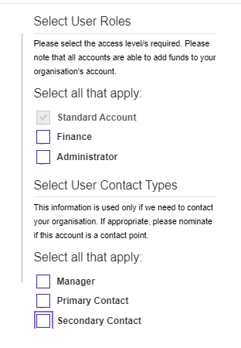

I have selected an existing Organisation but nothing has happened – what do I do next?
If the Organisation you have selected has an existing administrator, they will receive a notification that you have requested access and will process your request.
We are aware of cases where the allocated Administrator is no longer an active user or there is actually no existing administrator for an Organisation.
If you haven’t heard anything back within a day from submitting your request (or earlier if your application is urgent), please contact the Classification Team and we will help.

The menu structure has changed – how do I create an ACA/ATSA, change a Title or request a review?
The new menu structure is based around content type (Films, Home Entertainment (Games) or Publications) and you’ll find ACAs, ATSAs, title changes and reviews under each relevant content type.
So - start by selecting “Application Management” from the main dashboard:
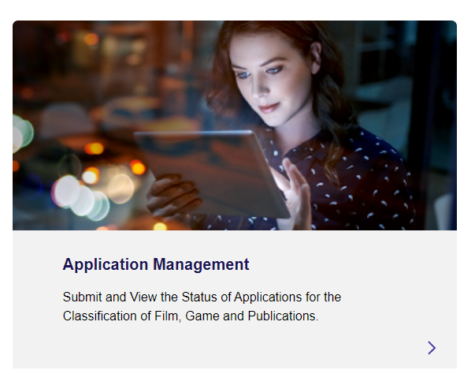

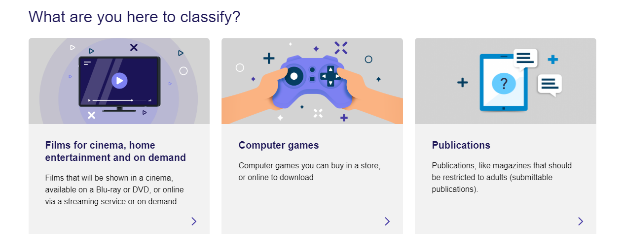
The answers you provide to questions along the way will determine if the application is an ACA or ATSA.
So – for ACAs and ATSAs, start by selecting “Application Management”, “Create new Application”, “Films for Cinema, home entertainment and on demand”.
Just answer the questions along the way and the correct application type will be determined by the answers you provide.
Refer to the full Reference Guide for Applications for all details on different application types and pathways.

How do I get my Classification Certificate?
Certificates are now automatically provided to you via the Portal and you can download them from there.
When your application has been finalised, you will be notified via email that you have a notification in the Portal.
Log into the Portal and open Application Management.
In your list of applications, you will see your application with the status of “Finalised”. To download the Certificate, click on the downward facing chevron to the right and select “Download Classification Certificate”.
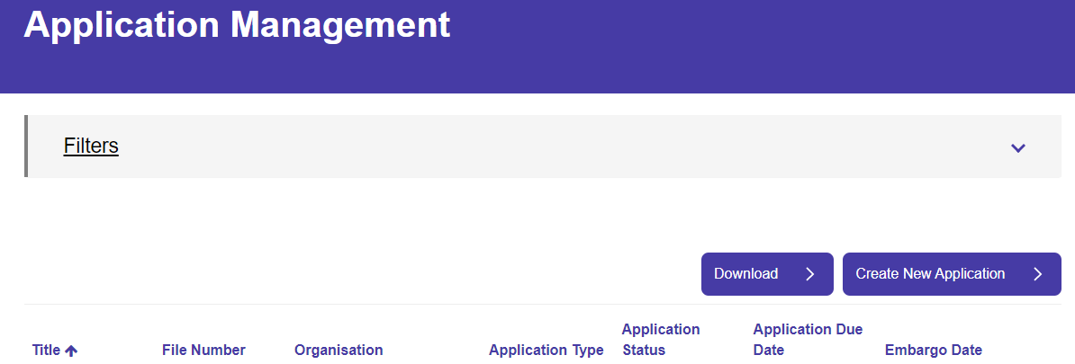
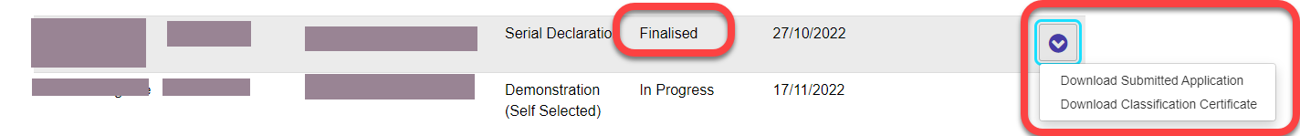

How do I get a previous Classification Certificate?
For recent applications, Certificates will be available as per details under “How do I get my Classification Certificate?”.
If the application does not appear in your list, please contact the Classification team.

Can I request Certificate provided to another organisation?
You need to contact the Applications team to request a Certificate provided to another organisation.

I have done classification training online – when will I be able to submit an application?
Your training records will be loaded into the system in an overnight processing run. Once loaded, you can check on your training records under your profile, Training menu as per the below.

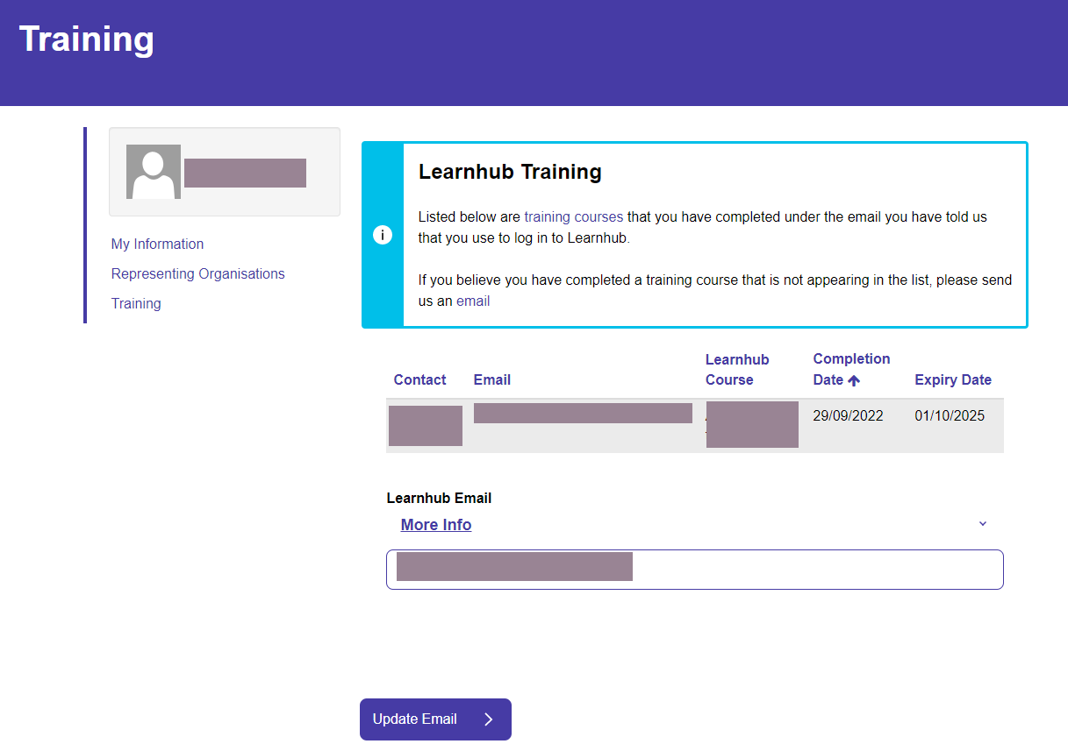

I am an authorised assessor but haven’t been able to submit an application.
It could be that your training record hasn’t been loaded properly – please check your Training details as per details above and contact the Classification team if necessary.

How do I see my account balance?
Just navigate to Organisation Management from the main dashboard.
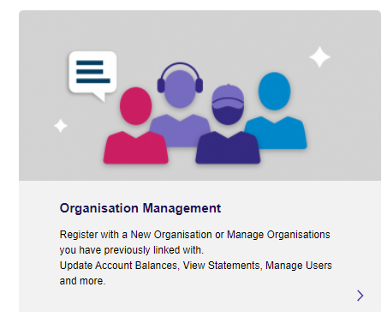
Balances are displayed on the following page.

How do I get an account statement with past transactions?
From the main dashboard, Choose “Organisation Management”
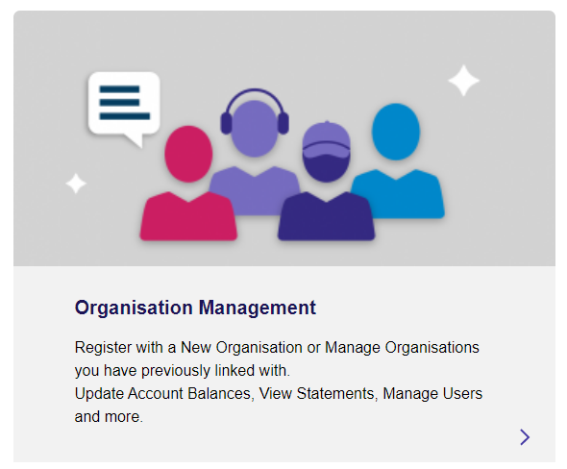

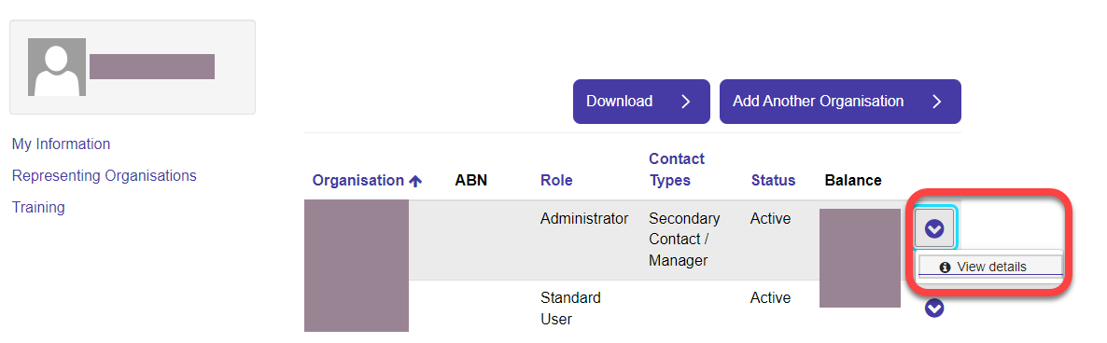
Find your organisation of interest in the list of organisations, press the downward facing chevron to the right and choose “View Details”:
From the resulting screen, choose, “Finance and Accounting” and you can now view and download your transaction history.

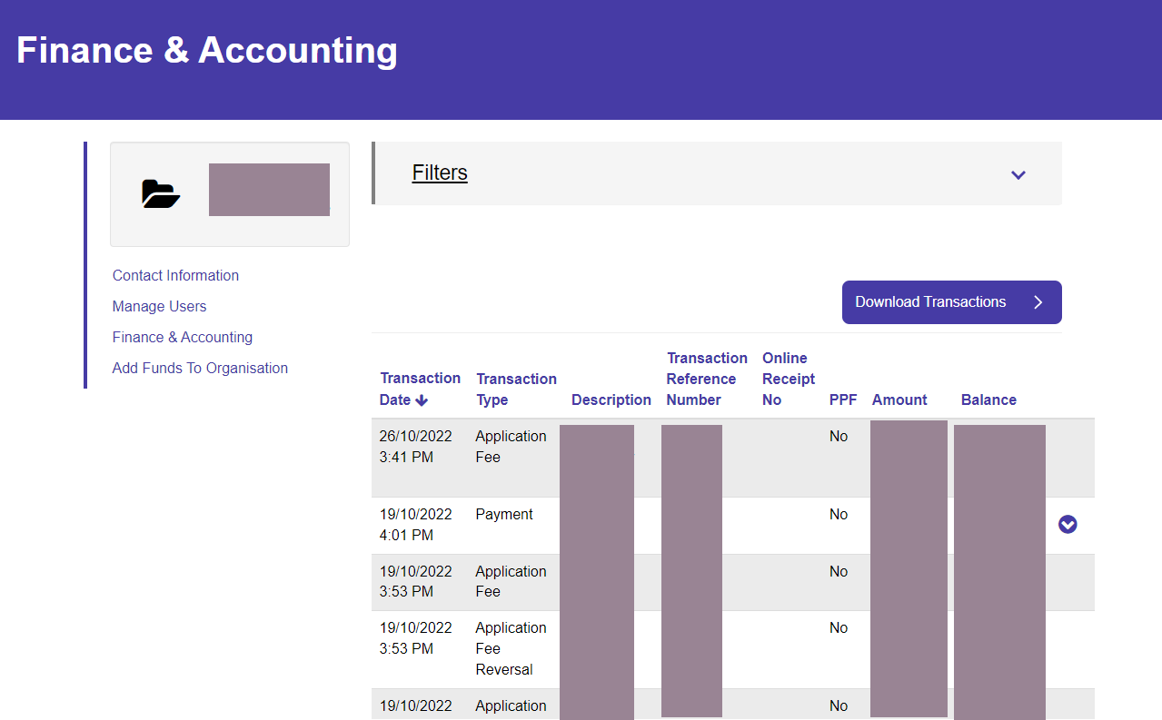
If you have lots of transactions, you can drop down the “Filters” option and filter by Transaction type and/or date range.

I have paid my account twice – how do I get a refund?
For any account issues such as overpaid accounts, please contact the Classification team.

How do I register a 6H event?
For 6H events, please contact the Applications team.

How do I register a non-6H event?
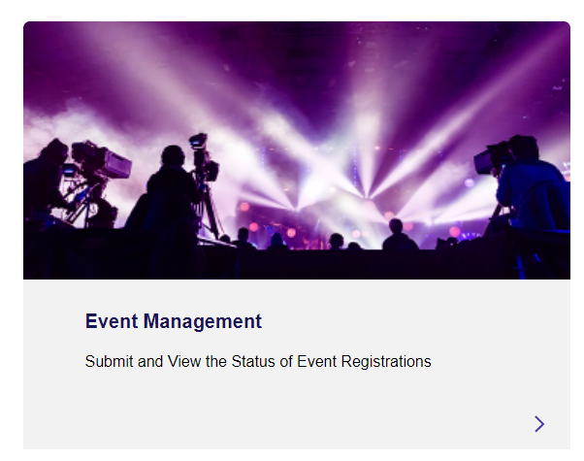
All non-6H Events can be registered directly in the system – simply choose “Event Management” from the main dashboard and follow the prompts.

How do I submit an assessment report on behalf of the assessor and I haven’t done the necessary training?
If you are entering assessment report details on behalf of an assessor who isn’t registered on the Portal, just let the Classification Team know.
The Classification Team will setup your account so that you can submit the application.
The assessor will need to sign a declaration form and this will be provided by the Classification team.

