


Applications Portal
  - Financial and Organisational Management
November 2022 (V1.0)
Contents
Introduction 1
Viewing Financial Transactions 2
Filtering Transactions 4
Managing Users 4

Introduction
New Features are now available in relation to managing access to Organisational records and financial transactions.
As an Administrator for an Organisation, you can now view and download:
- Previous transactions; and
- Current Account Balance,

You can also:
- Apply advanced filters to transactions – by Transaction and within a date range; and
- Manage users and their access to organisational information.

Viewing Financial Transactions
Step 1

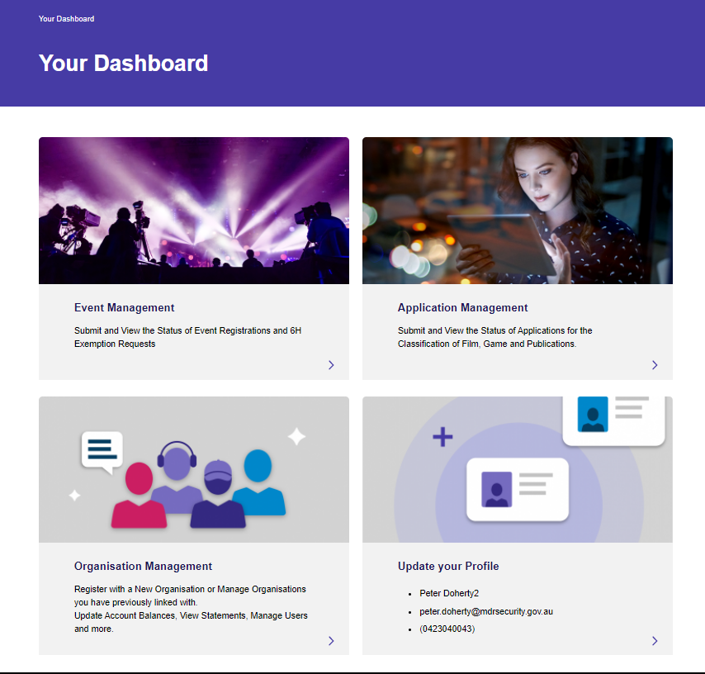
- Navigate to “Organisation Management on the lower left of the main Dashboard:

Step 2

Click on the name of the Organisation you wish to view details for:
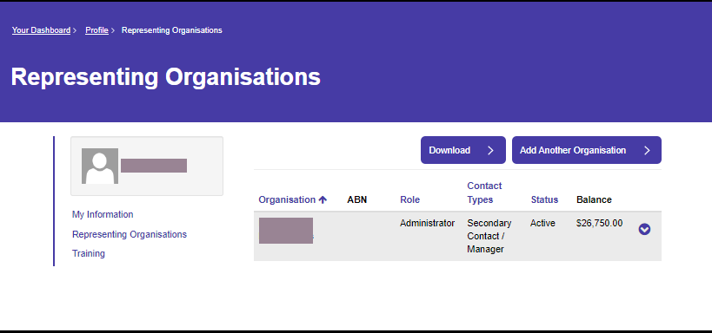

Click on “Finance and Accounting” from the list on the left:
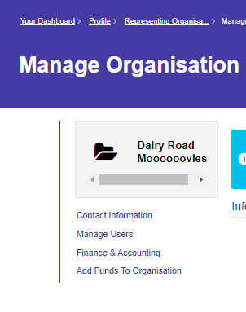

Step 3

That’s it! You now can see a list of transactions for the selected Organisation.
From here, you can also use advanced Filters to view specific transactions

Filtering Transactions
Click on the downward facing chevron to the upper right of the transaction list and across from the word “Filters”.
Select a transaction type from the list if needed and/or enter a date range as shown below. You can edit the Date Range field directly.
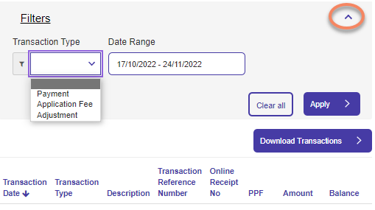

Managing Users
Step 1
Choose “Manage Users” from the Managing Organisation page:

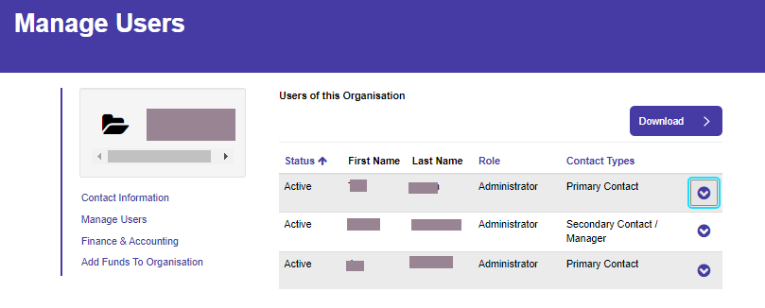

If you want to update user details, press on the downward facing chevron to the right of the user’s name and you’ll be able to add or remove access via the subsequent screen:
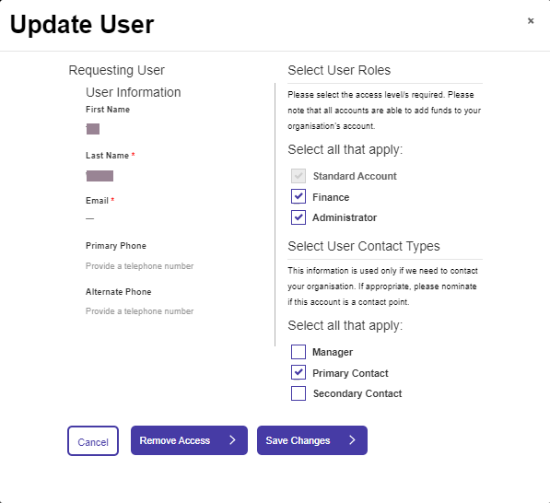
As an administrator, when approving another user to access your organisation, you must select appropriate roles. These are:
Standard Account – Given by default when a person requests access to an organisation – this allows the user to view applications submitted by their organisation and to submit applications on behalf of their organisation.
Finance - This role gives a user access to the ‘Finance & Accounting’ area of the organisation on the portal and allows them to view and download transactions.
Administrator- This role allows a user to manage requests for access to their organisation and manage existing users access levels. This role also is able to submit applications and access the ‘Finance & Accounting’ area.

Note: All access levels are able to add funds to an organisation.
Contact Types:
These are simply an attribute of a contact and they provides no additional functionality. They serve purely as a way to reference who the best contact person is in an organisation.

