

Publications—Classification Factsheet

Classification of publications
- Publications can be broadly defined as any written or pictorial matter, which can include: books, magazines, graphic novels and manga.
- Unlike films and computer games, not all publications require classification before being made available for sale or distribution.
- Only ‘submittable publications’ are required to be classified.
- Classification decisions for publications are made using the
- Classification (Publications, Films and Computer Games) Act 1995
- National Classification Code 2005
- Guidelines for the Classification of Publications 2005.
- Publications can only be classified by the Australian Classification Board (the Board).

What is a ‘submittable publication?’
- The Classification (Publications, Films and Computer Games) Act 1995 defines a ‘submittable publication’ as “an unclassified publication that…. contains depictions or descriptions that:
- are likely to cause the publication to be classified RC (Refused Classification); or
- are likely to cause offence to a reasonable adult to the extent that the publication should not be sold or displayed as an unrestricted publication; or
- are unsuitable for a minor to see or read.”
- In practice this means only publications which are likely to be Refused Classification or are likely to be classified Category 1 Restricted or Category 2 Restricted are required to be submitted for classification.
- As such, the threshold for a publication to be submitted for classification is high.
- Publications with covers that are not suitable for display in public are considered ‘submittable publications,’ as the impact of any descriptions, depictions and references on covers should be low. This includes publications with content that may not meet the threshold of a ‘submittable publication.’

The Classification categories
Classifications | National Classification Code 2005
Refused Classification (RC)  (Illegal to import or sell in Australia) | Publications that:  - describe, depict, express or otherwise deal with matters of sex, drug misuse or addiction, crime, cruelty, violence or revolting or abhorrent phenomena in such a way that they offend against the standards of morality, decency and propriety generally accepted by reasonable adults to the extent that they should not be classified; or  - describe or depict in a way that is likely to cause offence to a reasonable adult, a person who is, or appears to be, a child under 18 (whether the person is engaged in sexual activity or not); or  - promote, incite or instruct in matters of crime or violence.
Category 2 – Restricted  (Restricted to 18+, not to be sold in Queensland) | Publications (except RC publications) that:  - explicitly depict sexual or sexually related activity between consenting adults in a way that is likely to cause offence to a reasonable adult; or  - depict, describe or express revolting or abhorrent phenomena in a way that is likely to cause offence to a reasonable adult and are unsuitable for a minor to see or read.
Category 1 – Restricted  (Restricted to 18+, not to be sold in Queensland) | Publications (except RC publications and Category 2 restricted publications) that:  - explicitly depict nudity, or describe or impliedly depict sexual or sexually related activity between consenting adults, in a way that is likely to cause offence to a reasonable adult; or  - describe or express in detail violence or sexual activity between consenting adults in a way that is likely to cause offence to a reasonable adult; or are unsuitable for a minor to see or read.
Unrestricted | All other publications.  The ‘Unrestricted’ classification encompasses a wide range of material. It is not likely to include material that offends a reasonable adult to the extent that it should be restricted.

Who is responsible for submitting a publication for Classification?
- While there are no restrictions on who can submit a publication for classification, the onus falls on anyone who has the intention of selling, advertising or importing a submittable publication.
- This may include: publishers (national and international), distributors or library vendors.
- The Director of the Board also has the power to call in publications for classification where there are reasonable grounds to believe that a publication is a ‘submittable publication.’

Classification process
- By applications as either:
- Standard – classification decisions made within 20 days; or
- Priority – classification decisions made within 5 days.
- Full details of the classification process including the documents required and associated fees can be found online
https://www.classification.gov.au/for-industry/apply-for-classification/classify-publication.

How to find out if a publication has been classified?
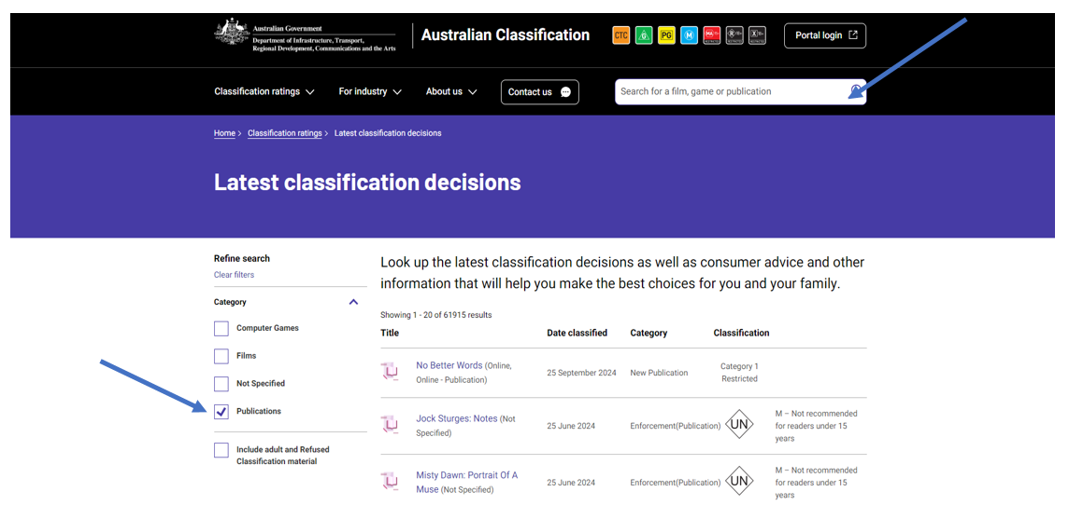
- Classification decisions for publications can be on found on the classification website at www.classification.gov.au by searching for the title of the publication.
- Go to ‘Latest Classification Decisions’ and tick the publications box, before searching the title.
- Be aware when searching for a publication that the title on the website may not match the title of the publication in the library, as the Board may have put it under a different title e.g. Smiths vs The Smiths. This may happen where there are duplicate publications.
- If you cannot find the title contact us using the contact us form.

Display and markings
- Once a publication has been classified there are rules about packaging that the publication must be contained in, as well as the display of classification markings.
- As with submitting publications for classification, it is the responsibility of anyone who has the intention of selling or advertising a classified publication for ensuring the publication is in the correct packaging and displays the appropriate classification markings. This includes the publisher, distributor, retailer or library.
- In accordance with State and Territory enforcement legislation, all publications that are classified must be appropriately labelled with an official label showing the classification category and relevant consumer advice. Full details of the relevant state and territory legislation can be found here https://www.classification.gov.au/about-us/legislation.
- The Board may also impose additional requirements on the packaging of the publication. The Board makes these decisions based on the classification of the publication, the content within the publication and the cover of the publication.

Displays
- Category 2 – Restricted
- May not be publicly displayed and may only be displayed in premises that are restricted to adults.
- Must be sold or delivered in packaging with an official label showing the classification category positioned on the front cover of the publication itself as well as on any packaging.
- Category 1 – Restricted
- Must be distributed in a sealed wrapper
- Covers must be suitable for public display. If the Board determines that covers are not suitable for public display, it may stipulate that the publication must be sealed in plain opaque wrapping.
- Must display the classification category on the front cover of the publication itself as well as on any packaging.
- Unrestricted
- The Board may also impose a condition on publications that it classifies ‘unrestricted’ that it must be in a sealed package when it is sold, displayed for sale or delivered.
- Covers must be suitable for display in public. The impact of any descriptions, depictions and references on covers should be low.
- Publications with covers which are not suitable for public display will not be permitted in the ‘Unrestricted’ category.
- The Board may require an unrestricted publication to carry the label with the consumer advice of ‘M – not recommended for readers under 15 years.’ This must be displayed on the front cover of the publication itself as well as on any packaging.

Markings
- The marking may be increased or reduced in size and scale with the rest of the material included in the advertisement; however, it must remain in proportion with the publication’s front cover.
- Publications must be in the format in Schedule 2 of the Classification (Publications, Films and Computer Games) (Markings and Consumer Advice) Determination 2014 https://www.legislation.gov.au/F2014L01758/latest/text.

Other resources
Additional information | Legislation
- Publications Overview Attachment  - Application process | Australian Classification  - Sell a publication | Australian Classification  Advertise a publication | Australian Classification  - Display classification markings | Australian Classification | - Classification (Publications, Films and Computer Games) Act 1995  - National Classification Code 2005  - Guidelines for the Classification of Publications 2005  - Classification Serial Publications Principles 2005

Publications Guidelines define reasonable adult as an individual “…possessing common sense and open mind, and able to balance personal opinion with generally accepted community standards.”
The Act defines minor to mean “a person under 18.”

