



Classification - Create an account and MFA
  - Classification User guide
March 2026

This guide shows you what you need to do before you begin using the Classification Portal, including how to create your account and set up Microsoft Authenticator as the multi-factor authentication method.
Please ensure you have downloaded the free Microsoft Authenticator app on a compatible device from the
Apple App Store or Google Play Store before you begin. Microsoft Authenticator app will work on:
• iPhones and iPads running iOS 16 or later
• Android phones and tablets running Android 8 or later.

Recommended browsers (latest version of): Chrome, Firefox, Safari or Microsoft Edge.

Create an account
To create a Classification Portal account, navigate to the Homepage | Australian Classification and complete the following steps.
- Select the Portal login button
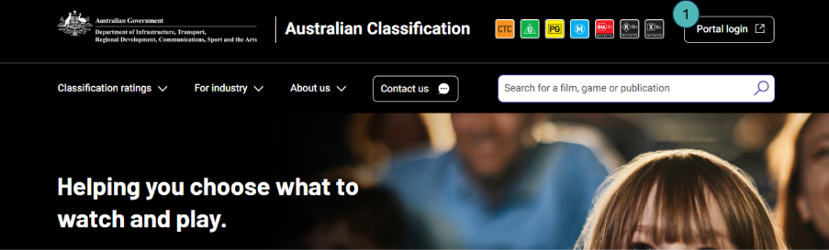
- Select the Sign up now link.
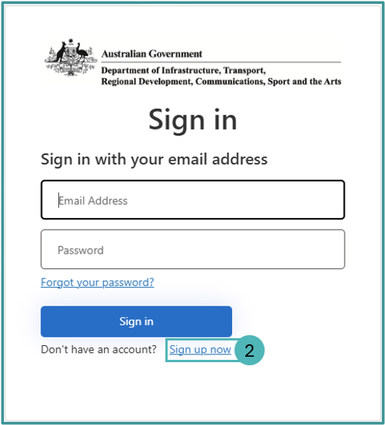
- Enter the Email Address that you want linked to your Classification Portal account.
- Enter the characters displayed under CAPTCHA to confirm you are a person.
- Select the Send verification code button to receive a 6-digit verification code to the email address you entered in step 3.
If the email does not appear in your inbox, you may need to check your junk or spam folder.
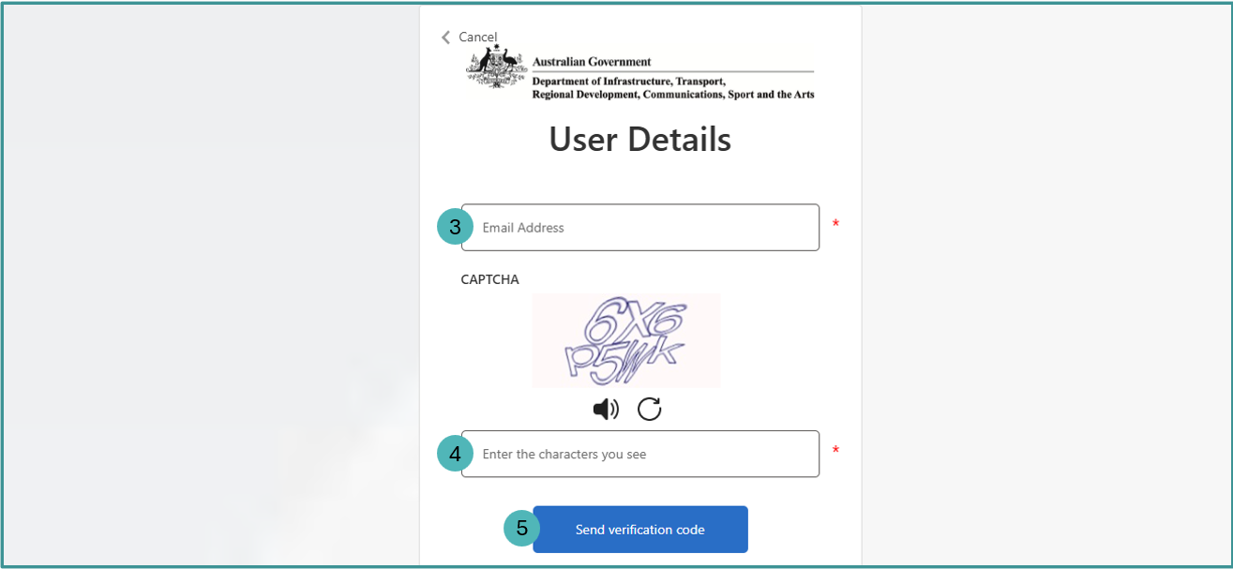
- Enter the 6-digit Verification Code from the email.
- Select the Verify code button to verify your email address.
  - The verification code will expire after 10 minutes. If you don't enter the code in time, select the Send new code button to receive a new 6-digit code via email. Then, return to the previous step (6) and try again.
- Enter a New Password to access your account. Your password must be between 8 and 64 characters, and have at least 3 of the following:
  - a lowercase letter
  - an uppercase letter
  - a digit
  - a symbol.
- Enter the same password into the Confirm New Password field.
- Enter your Given Name.
- Enter your Surname.
- Enter your Primary Phone.
- Enter your Alternate Phone (Optional).
- Read the Privacy Notice and select the checkbox to acknowledge you have read and understood the Privacy Notice.
- Select the Create button.
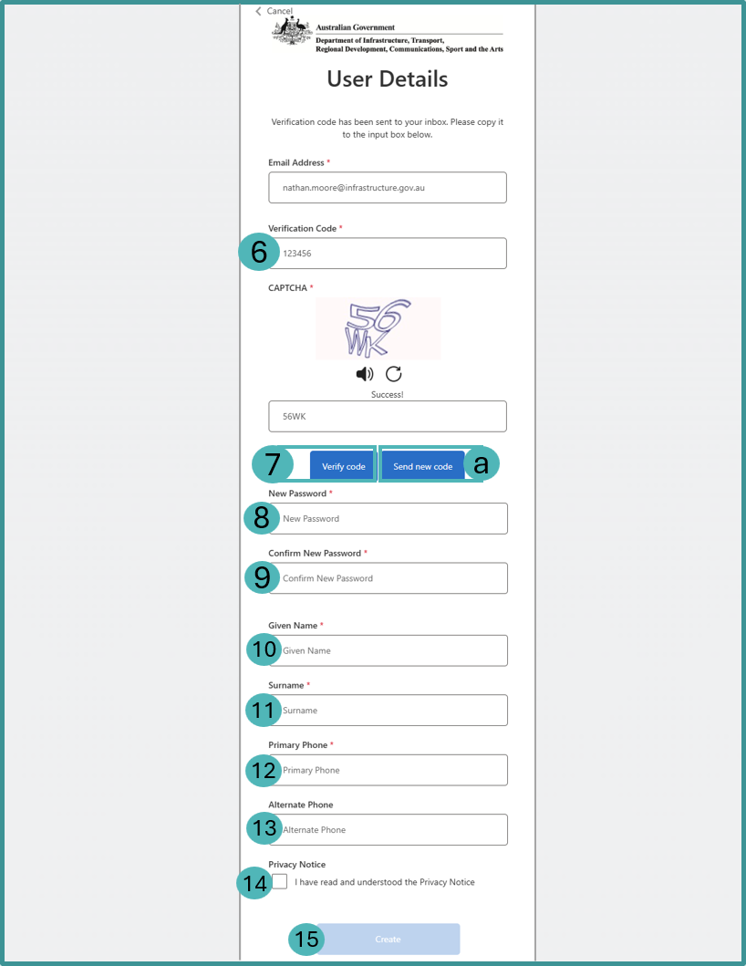
You have successfully created a Classification Portal account and will now need to set up multi-factor authentication. Multi-factor authentication will help keep your Classification Portal account secure.

Set up multi-factor authentication with Microsoft Authenticator
To set up multi-factor authentication first download the Microsoft Authenticator app (Apple App Store or Google Play Store) and complete the following steps on the Classification Portal and within the app.
- Open the Microsoft Authenticator app on your device and add a new authentication using one of the following methods:
  - If you already use the app to verify your sign in to other sites, select the plus button.
  - If not, select the Add account button.
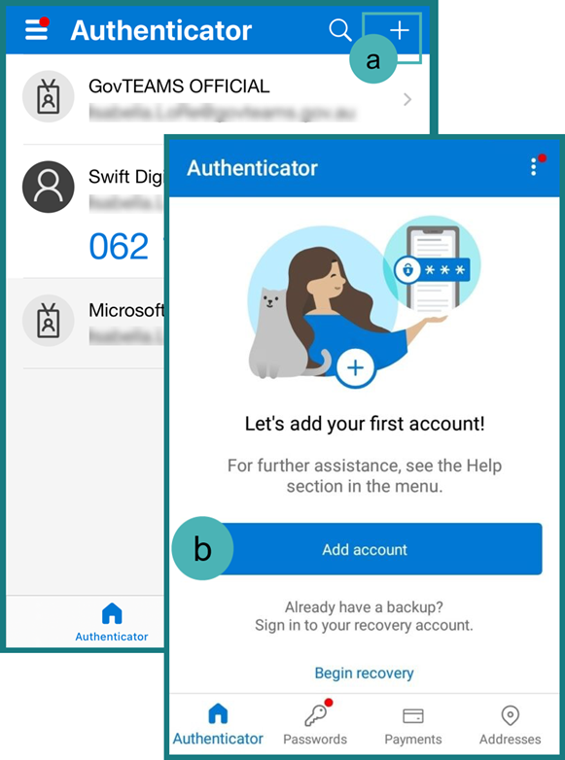
- Select Other (Google, Facebook, etc), do not select Work or School Account or manually add personal Microsoft accounts, as these generate 8-digit codes that will not work with Classification MFA.
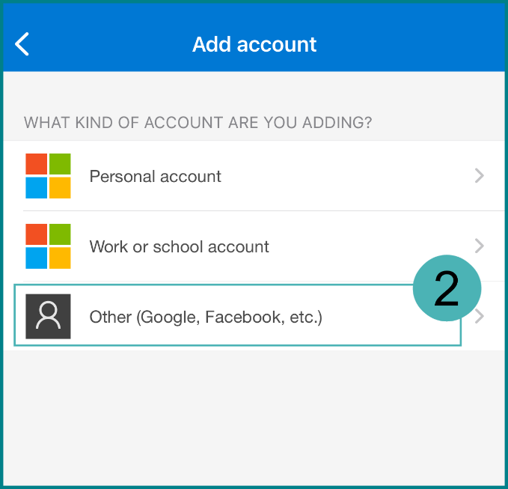
- Add the authentication using one of the following methods:
  - Using the app, scan the QR code with your device.
  - Select the Still having trouble? link underneath the QR code to reveal an account name and secret key. Then, select the Enter code manually button in your app, enter Account name and Secret Key into the free text fields and select the Finish button.
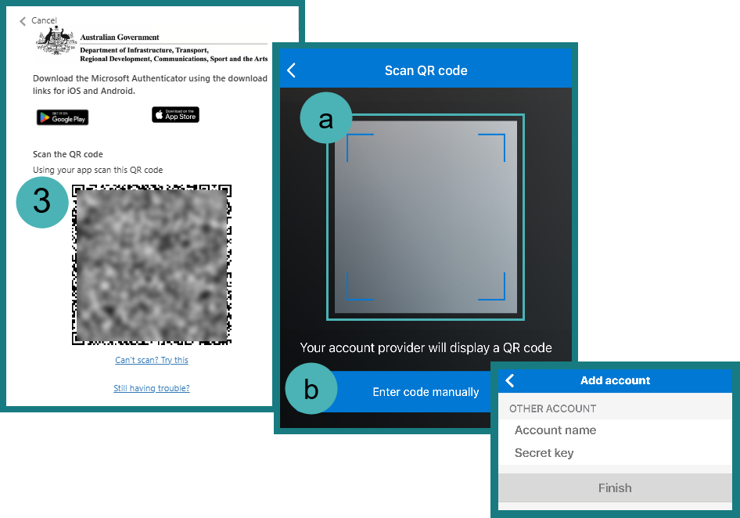
- Select the Verify button in the Classification Portal.
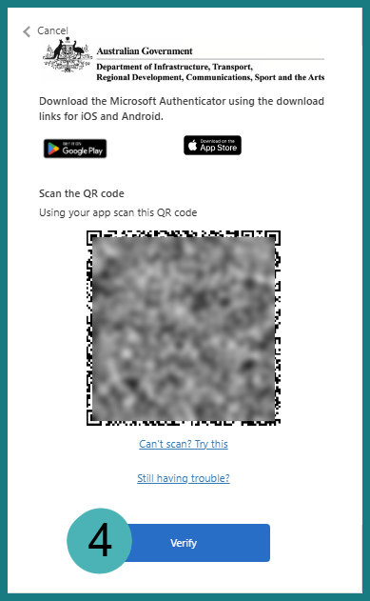
- Select your authenticator account from the list in the Microsoft Authenticator app on your device.
- Enter the 6-digit code from the Microsoft Authenticator app into the Enter your code field in the Classification Portal.
- Select the Verify button.
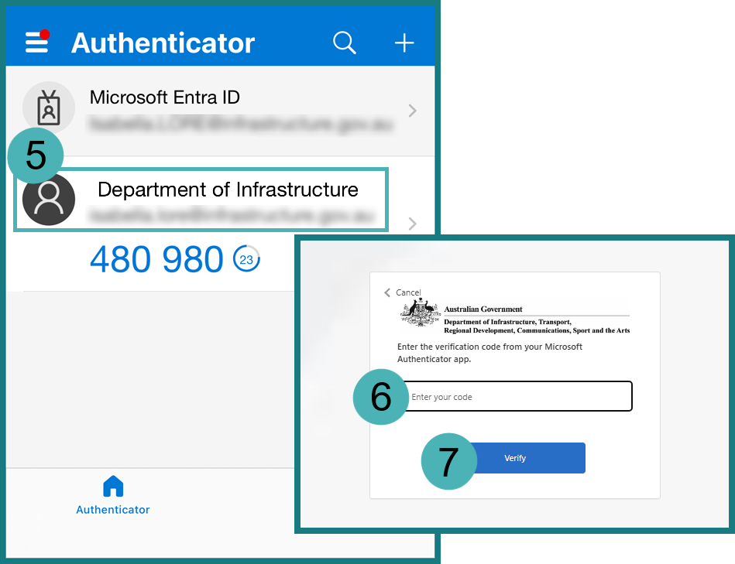

You have successfully set up multi-factor authentication for your Classification Portal account.

