



Set up Microsoft Authenticator as an existing user
  - Classification User guide
March 2026

This guide will take you through the steps on how to set up Microsoft Authenticator as the
multi-factor authentication method for your existing Classification Portal account.
Please ensure you have downloaded the free Microsoft Authenticator app on a compatible device from the
Apple App Store or Google Play Store before you begin. Microsoft Authenticator app will work on:
• iPhones and iPads running iOS 16 or later
• Android phones and tablets running Android 8 or later.

Recommended browsers (latest version of): Chrome, Firefox Safari or Microsoft Edge.

Set up multi-factor authentication with Microsoft Authenticator
To set up multi-factor authentication first download the Microsoft Authenticator app (Apple App Store or Google Play Store) and complete the following steps on the Classification Portal and within the app.
- Sign in to your existing account by navigating to the Australian Classification site and selecting the Portal login button.

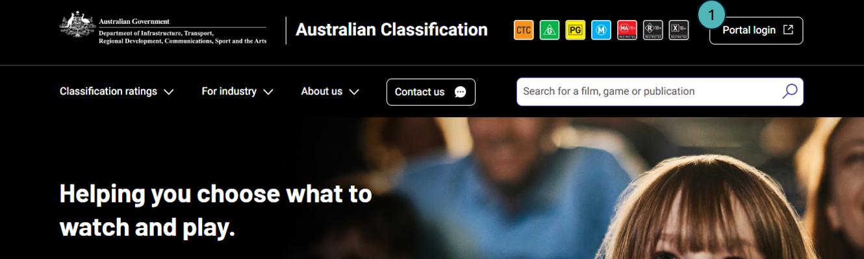

- Enter your Email address.
- Enter your Password.
- Select the Sign in button.
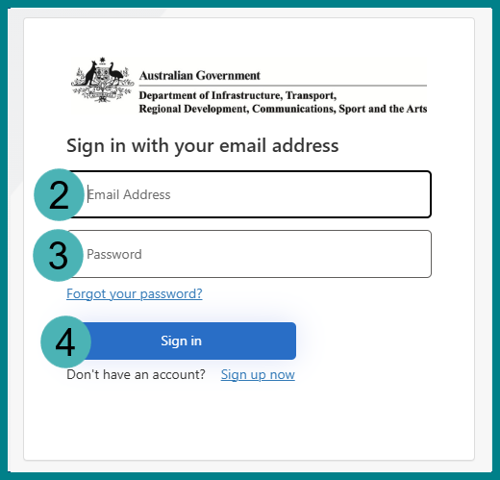
- Open the Microsoft Authenticator app on your device and add a new authentication using one of the following methods:
  - If you already use the app to verify your sign in to other sites, select the plus button.
  - If not, select the Add account button.

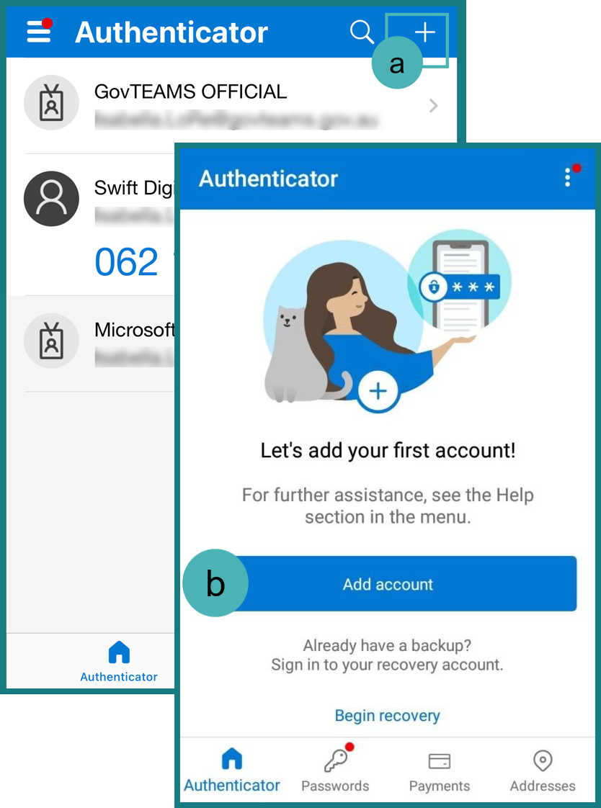

- Select Other (Google, Facebook, etc), do not select Work or School Account or manually add personal Microsoft accounts, as these generate 8-digit codes that will not work with Classification MFA.
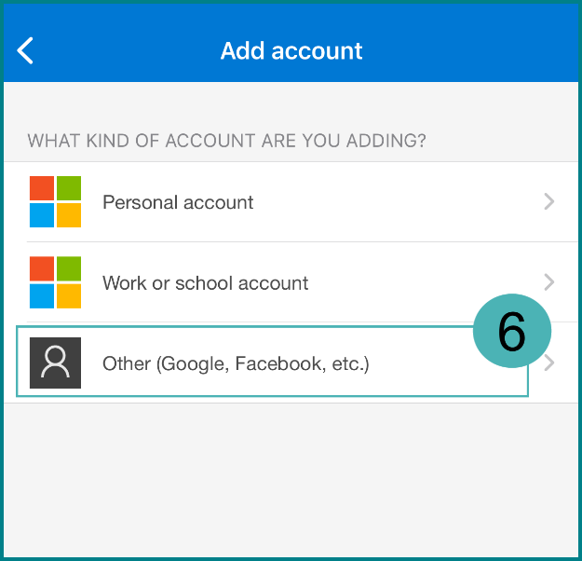
- Add the authentication using one of the following methods:
  - Using the app, scan the QR code displayed on the Classification Portal with your device.
  - Select the Still having trouble? link underneath the QR code to reveal an account name and secret key. Then, select the Enter code manually button in your app, enter Account name and Secret Key into the free text fields and select the Finish button.

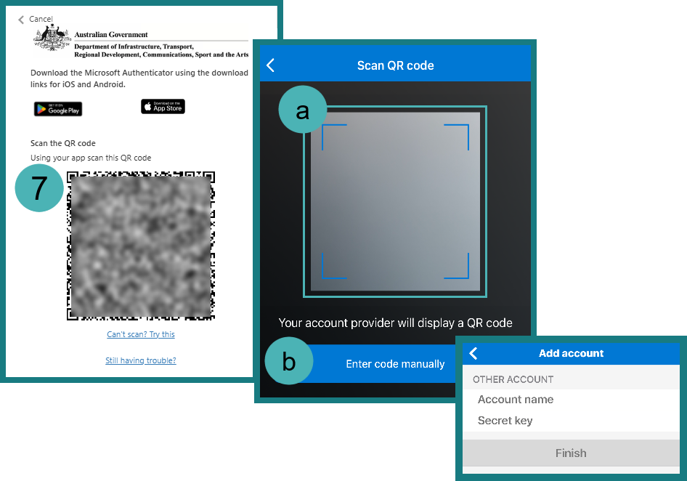
- Select the Verify button in the Classification Portal.
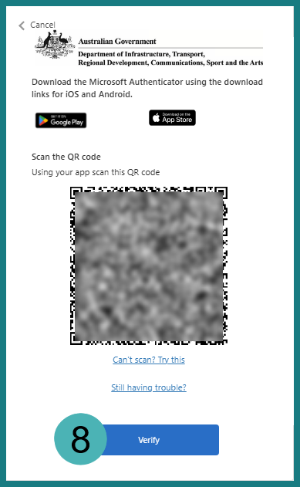
- Select your authenticator account from the list in the Microsoft Authenticator app on your device.
- Enter the 6-digit code from the Microsoft Authenticator app into the Enter your code field on the Classification Portal.
- Select the Verify button.

