


User Guide
  - Submitting a Notice of Classification in the Classification Portal
September 2024

Introduction
This user guide is for submitting a Notice of Classification (notice) as per section 6HA of the Classification (Publications, Films and Computer Games) Act 1995 (Classification Act) in the Classification Portal (Portal) at classificationportal.classification.gov.au.
To learn more about deeming, go to classification.gov.au/for-industry/deeming-classifications.

Before you start
Before you start, you must:
- have a Portal account
- be approved by your organisation/client(s) to submit notices on their behalf. You can learn how to link to organisations in the Portal FAQ user guide. This is available for download at classification.gov.au/for-industry/frequently-asked-questions-and-guides.
- have the required information about the film or television (TV) series you are publishing in another format:
  - the title
  - any other titles (e.g. alternate, foreign language or episode titles), if relevant
  - duration/running time (in minutes)
  - the broadcaster that most recently classified this title
  - the broadcaster classification (rating)
  - the broadcaster consumer advice, if relevant.

Submitting a notice
For TV series
It is your organisation/client’s choice whether to submit a notice for each episode in a TV series, or submit one notice for a batch of episodes, a whole season, multiple seasons or the whole series.

- Log in to the Portal and select Submission management.


- Select Create New Submission.
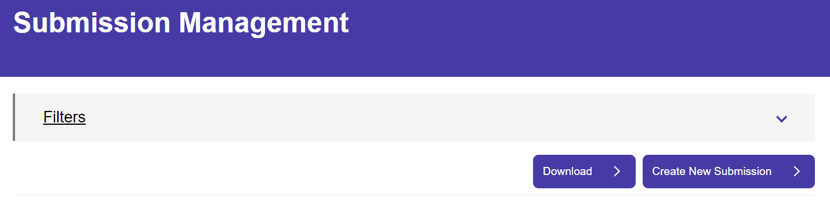

- Select Films for cinema, home entertainment and on demand.
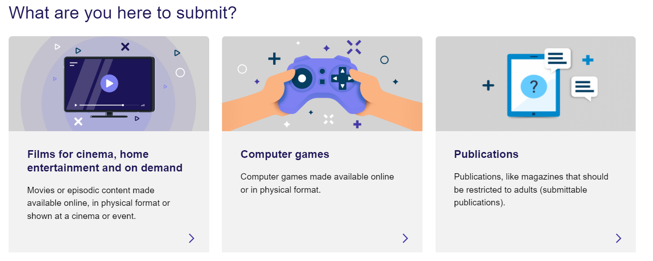

- Select Classification.
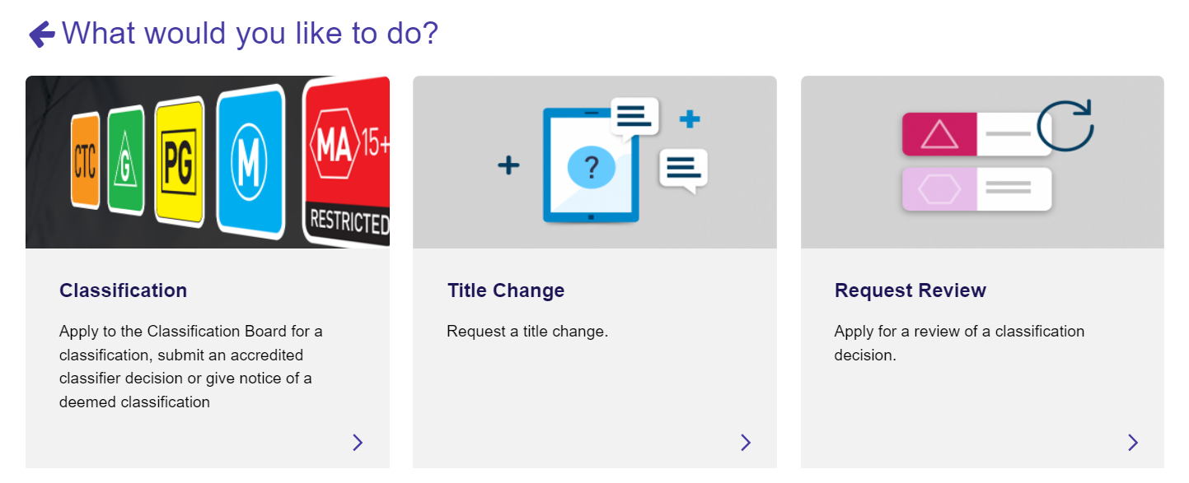

- Select Submit a Notice of Classification.
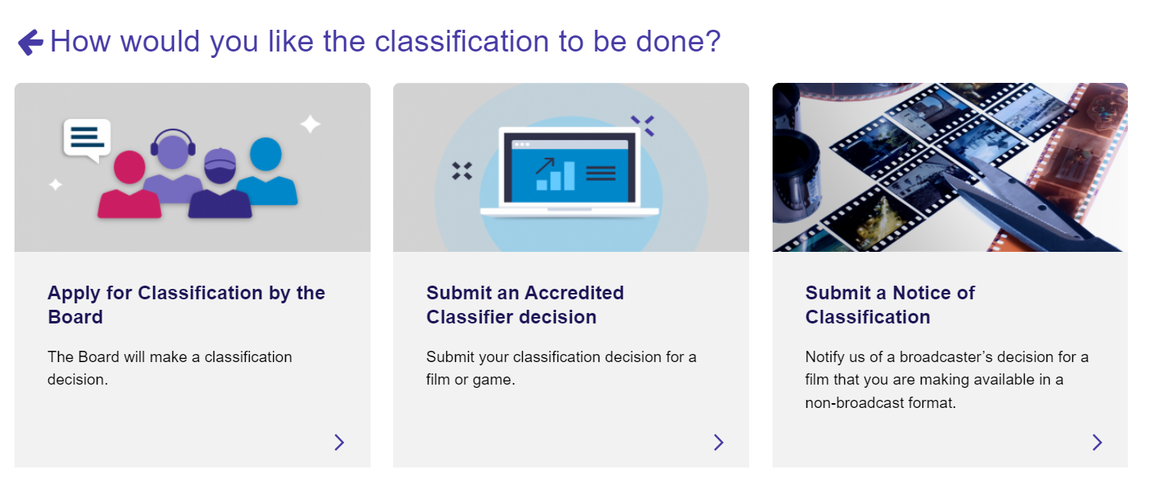

- Select your organisation/client from the drop-down list and then select Start Submission.
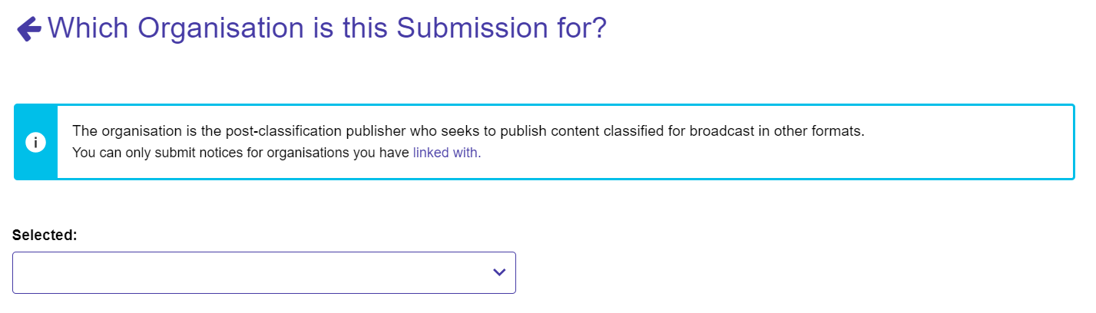

- Select each of the toggle buttons on the right-hand side of the page to expand these 4 sections:
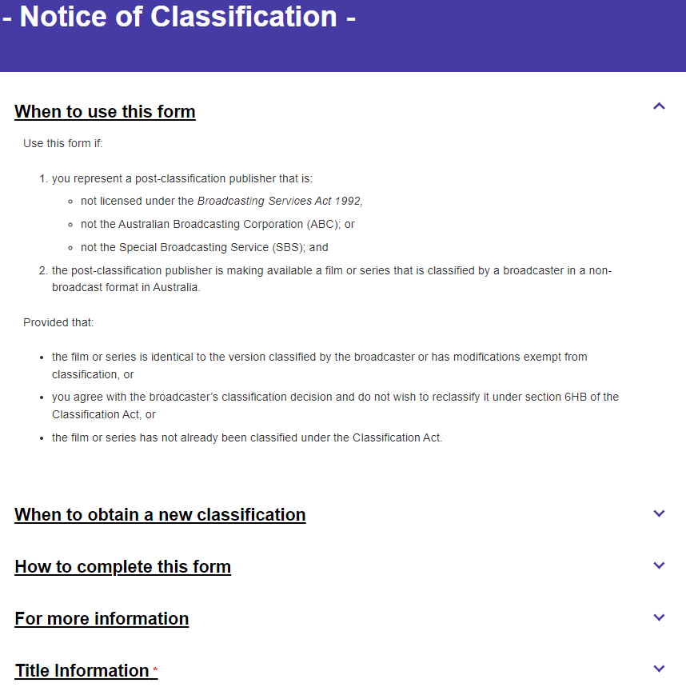

- Expand the Title information section and enter the title of the film or TV series in the Title field.
Please refer to the help text for guidance on titles.
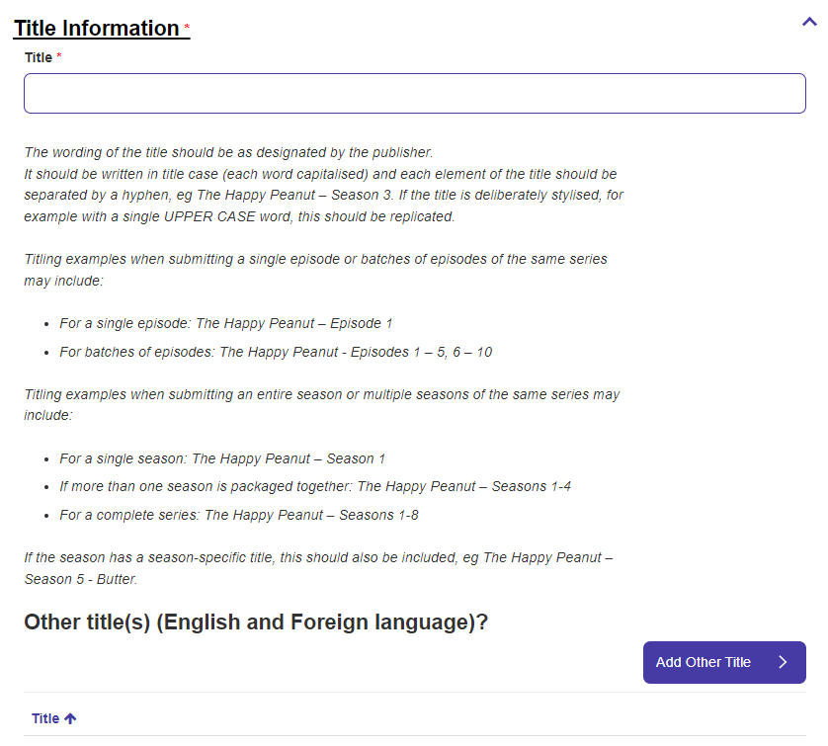
- Select Add Other Title to add any other title(s), as relevant. Then select Save and Next to go to the next page. Other title(s) may include:
  - Alternative title(s)
  - Foreign language title(s)
  - Episode titles.
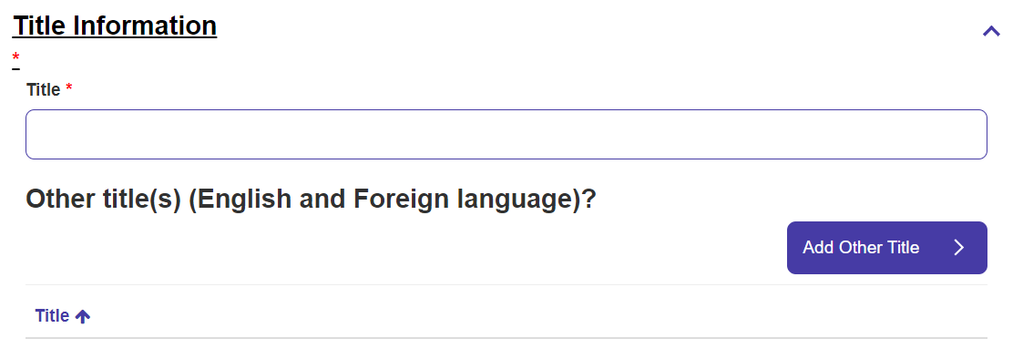
0

- Enter the duration / running time in minutes (to the nearest whole minute). For series, season or batches of episodes, this is the total duration of all episodes combined.
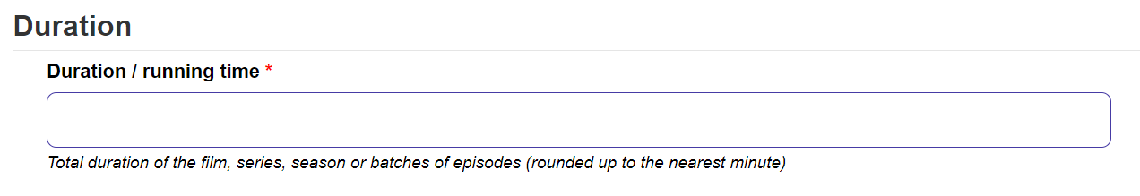

- Select the most recent broadcaster classification being used. Select Save and Next to go to the next page.
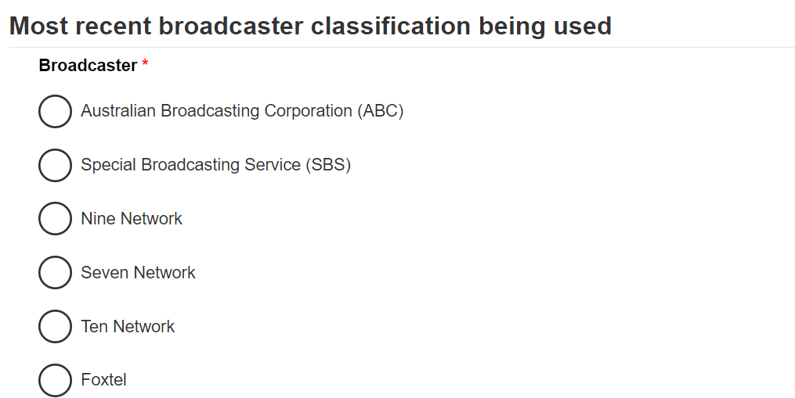

- Enter the broadcaster classification (rating) from the drop-down menu.
  - If the broadcaster used these ratings, please apply the relevant rating under the Classification Act:
    - P (pre-school children) becomes G
    - C (school-aged children) becomes PG.
  - If you are submitting multiple episodes, select the highest episode rating. For example, in a series with 2 episodes rated MA 15+ and 3 episodes rated M, select MA 15+. This is to ensure that Australian consumers receive information about the most impactful content in the series.
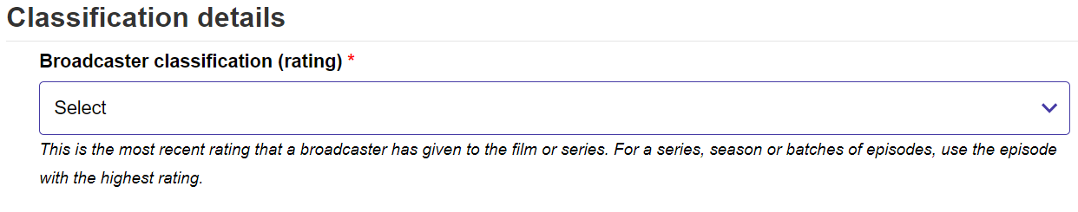

- Enter the broadcaster consumer advice, and then select Save and Next to go to the next page.
  - exactly as used by the broadcaster
OR
  - if you are submitting multiple episodes or seasons, use the consumer advice for the episode(s) with the highest rating. Using the example in the above step, if the 2 episodes rated MA 15+ have consumer advice of ‘Strong themes and coarse language’, use this and disregard the consumer advice for the 3 episodes rated M.
OR
  - if the broadcaster did not use consumer advice, leave this field blank.
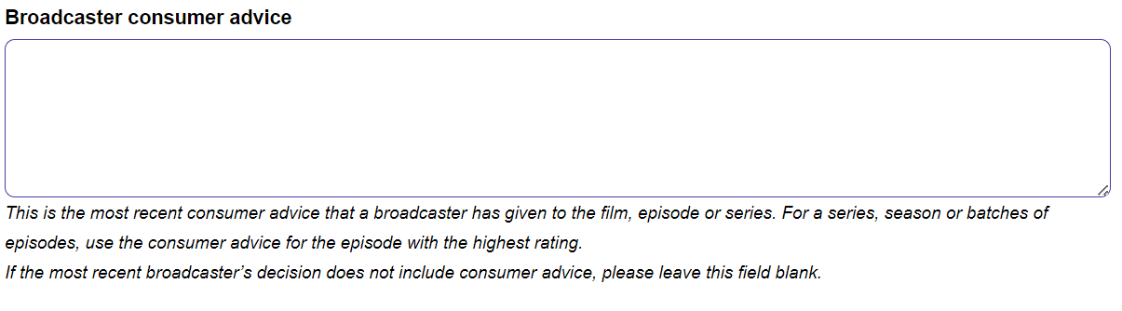

- If you would like to download a summary of the notice for your records, select Download summary.
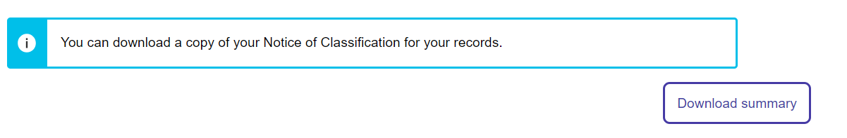
0

- Review the ‘Declare and submit’ section, select each tick box to agree, and select Submit.
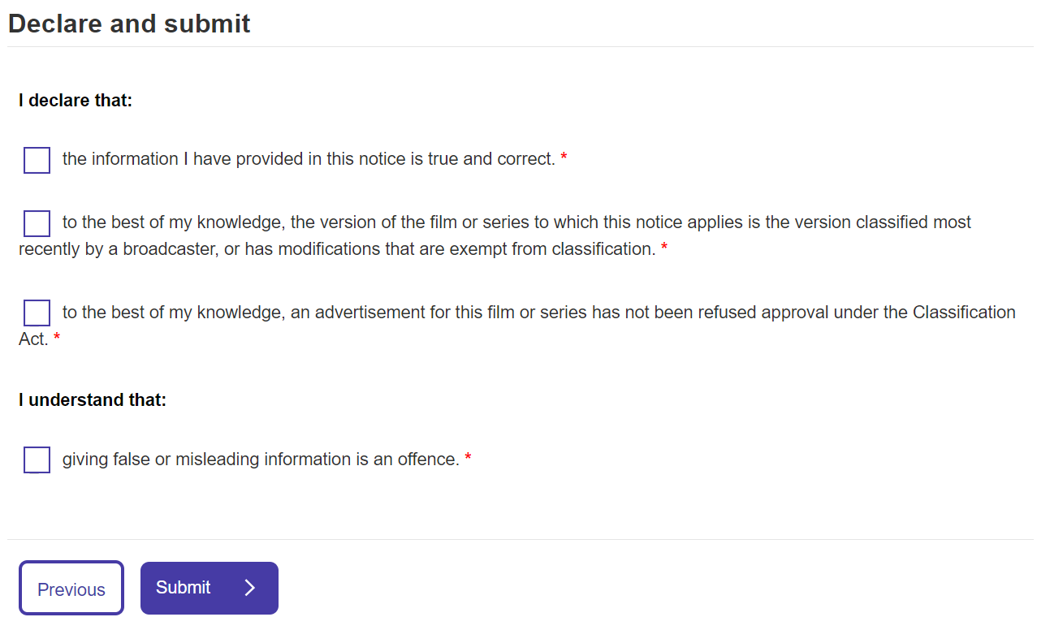
0

Once the notice is submitted
The classification decision takes effect under the Classification Act when you submit the notice. The decision will be published to the National Classification Database at classification.gov.au.
If you wish to submit an Additional Content Assessor (ACA) application for the bonus material only, please wait until the next day to submit the ACA application. Your Notice is registered in our system overnight and is not available for linking on the day the Notice is submitted.
If you have made an error in the notice, please email operationalpolicy@communications.gov.au. The department will notify you of the next steps.

