


User Guide
  - Submitting an accredited classifier decision for a film
November 2024

Introduction
This user guide is for submitting a classification decision (decision) for the purposes of section 22K(2) of the Classification (Publications, Films and Computer Games) Act 1995 (Classification Act) in the Classification Portal (Portal) at classificationportal.classification.gov.au.
To learn more about accredited classifiers, go to classification.gov.au/for-industry/accredited-classifiers.

Before you start
Before you start, you must:
- have a Portal account.
- be an accredited classifier (AC).
- have the ‘accredited classifier’ role assigned to you for the organisation for which you are submitting the decision on behalf of.
- have the following information for the classification decision:
  - the organisation name
  - the title or file number of any previous decision for the film, if relevant
  - the title
  - any other titles (English and Foreign language)
  - director/creator names
  - producer names
  - duration/running time
  - embargo information
  - synopsis
  - release date
  - IMDB URL
  - publisher authorisation date
  - date the content was viewed
  - impact level of each classifiable element (themes, violence, language, nudity, drug use, sex)
  - consumer advice as per the list issued under section 12A of the Classification Act
  - a brief explanation why you gave the classification (rating) and consumer advice to the film, focusing on the classifiable element(s) that are most impactful
  - anything else you wish to tell us about the content in the film, such as material that may be contentious or sensitive.
You can learn how to link organisations in the Portal FAQ and how to request the ‘accredited classifier’ role in the Management of accredited classifiers user guide at classification.gov.au/for-industry/frequently-asked-questions-and-guides.

Submitting an AC decision for a film

Initial navigation
- Log in to the Portal, select Submission Management.

- Select Create New Submission.
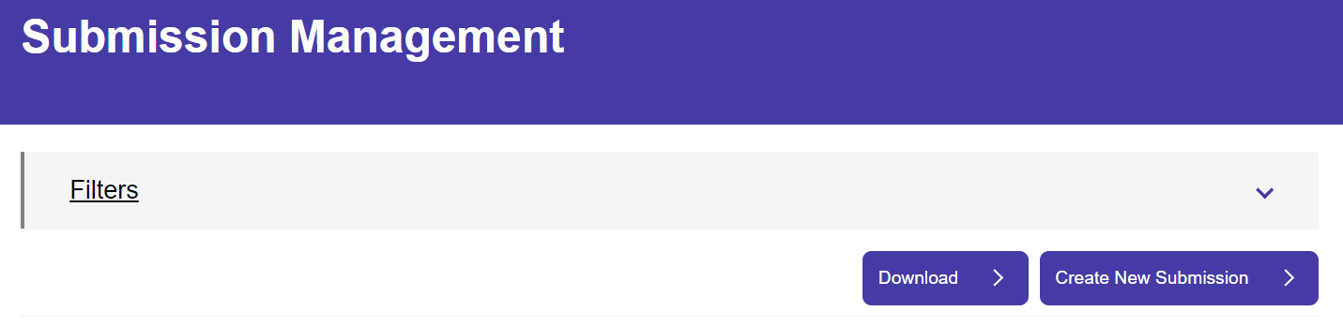

- Select Films for cinema, home entertainment and on demand.
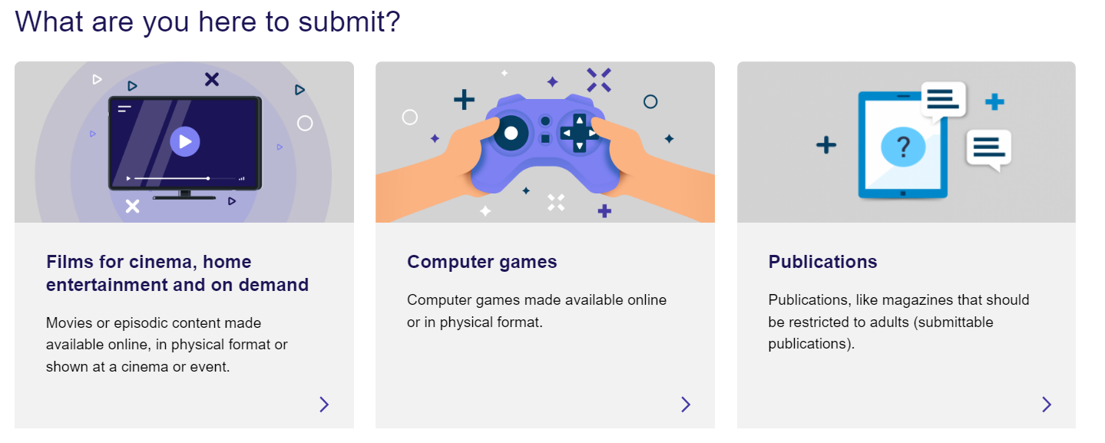
- Select Classification.
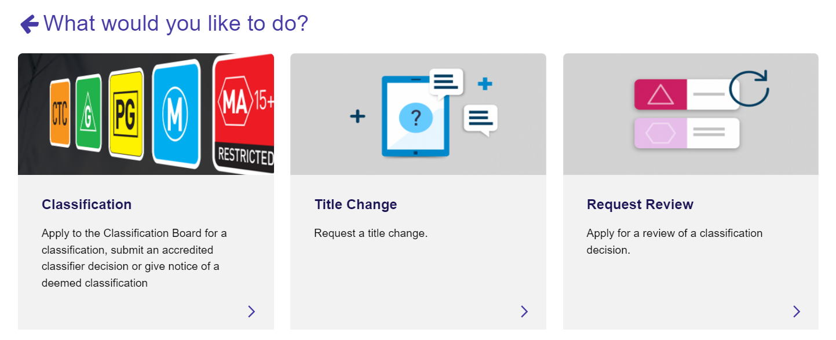
- Select Submit an Accredited Classifier decision.
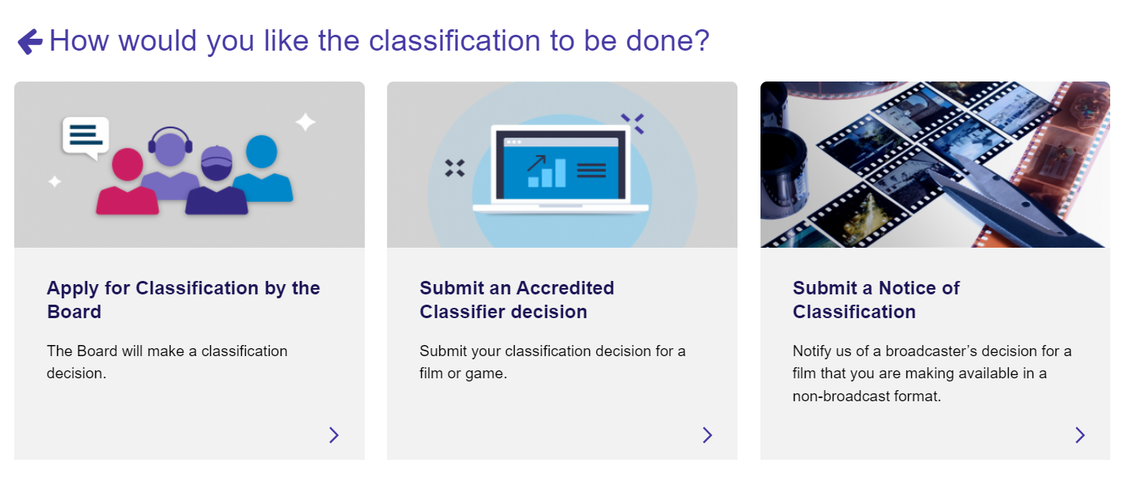

- Select your organisation from the drop-down list, then Next.
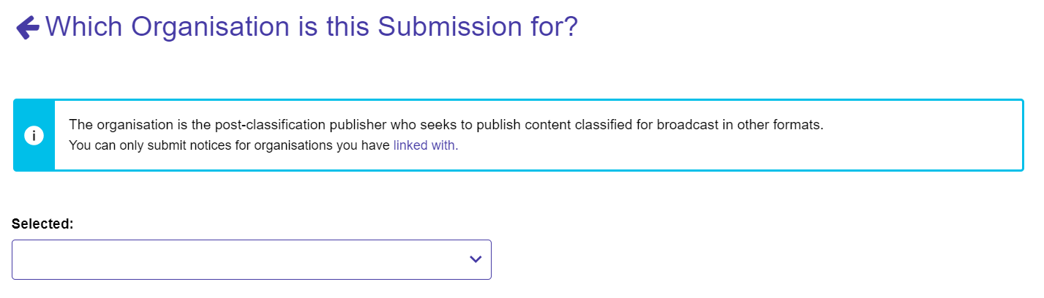
- Select the relevant tile for ‘Is this submission related to a previous decision’:
  - If you select No, go to step 9.
  - If you select Yes, go to step 8.
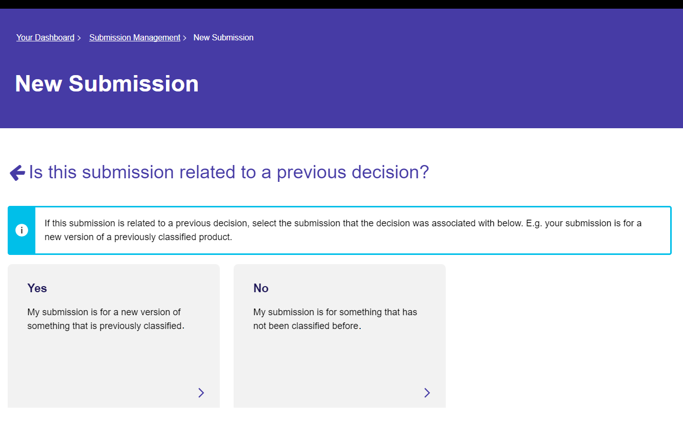
- If the submission is for a film that has been classified previously:
  - Select Select to Search, this opens up a search screen.
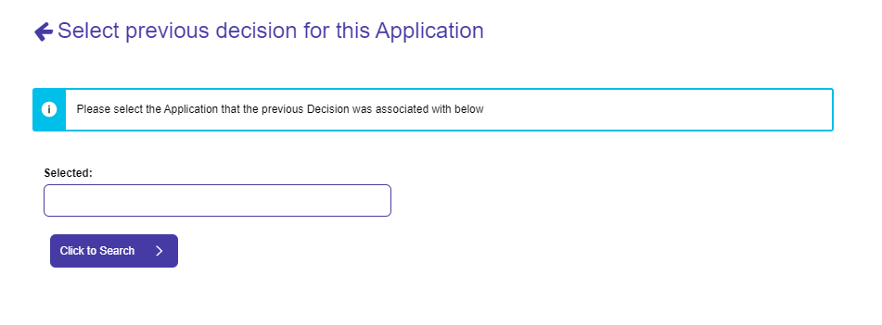
  - You can search by: File number, Title (exact title yes/no) or keywords, then select Search.
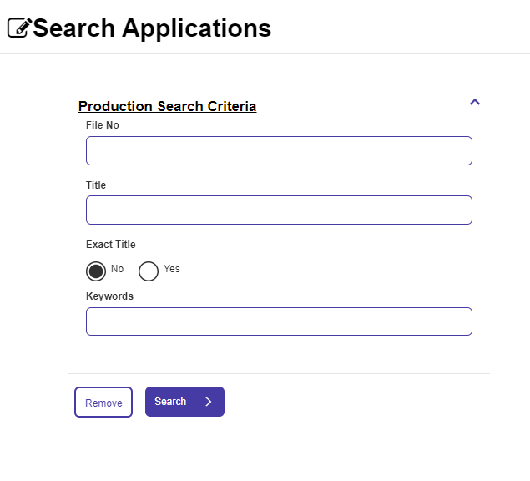
  - To get to the ‘Select’ button, you may need to use the scroll bar on the right-hand side and drag it down. Once it appears, choose Select then Start Submission.
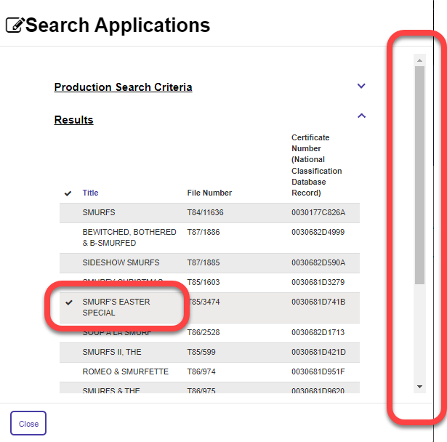
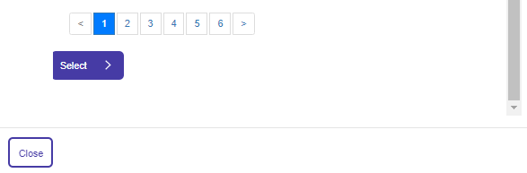

Basic details
- Use the toggles to expand the sections on this page. Mandatory fields are marked with *.
  - If you completed step 8, the information from the original decision will appear.
Keep any information that still applies, and edit any that has changed for this version.
  - Input all the relevant fields and then select Save and Next.
    - For Director/Creator name(s), Producer name(s) and Production Company, select Add and then enter each name one at a time. If there are multiple names, you must repeat this step for each one.
    - For Production Year, enter a four-digit number (e.g. 2022).
    - For Language, use the look up function to search for a language. Select a language and/or subtitle language, then select Add Language. If there are multiple languages, you must repeat this step for each one.
Language is set to English by default, you may delete if required.
    - For Country of Origin, use the look up function to search for a country. Select a country then select Add Country. If there are multiple countries, you must repeat this step for each one.
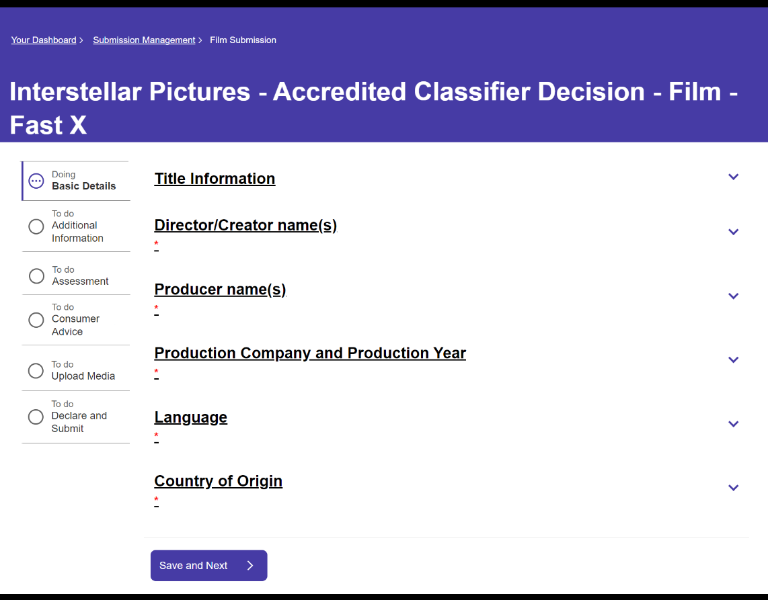

Additional information
- Use the toggles to expand the sections on this page. Input relevant fields and then select Save and Next. Mandatory fields are marked with *.
  - For Embargo information, enter the information as relevant
  - For Synopsis, duration, release date and IMDB URL:
    - add a synopsis, if relevant
    - input the run time in minutes (to the nearest whole minute)
    - input a release date (DD/MM/YYYY)
    - input the IMDB URL, if available.
  - For Publisher details:
    - the company will auto-populate based on the organisation you selected at Step 6
    - select the authorisation date as per the date the organisation authorised you to classify the film
    - select the date you viewed the film. This date must be on or after the publisher authorisation date

Rating
- Enter a value for each classifiable element (element). Select the chevron and select Edit, select the rating from the drop-down list, and select Submit. If the element is not present in the content, select ‘None’. Repeat for each element.
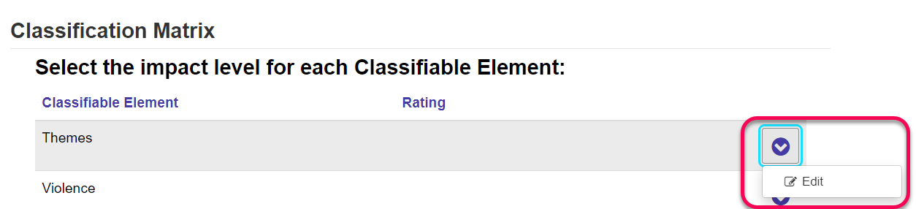
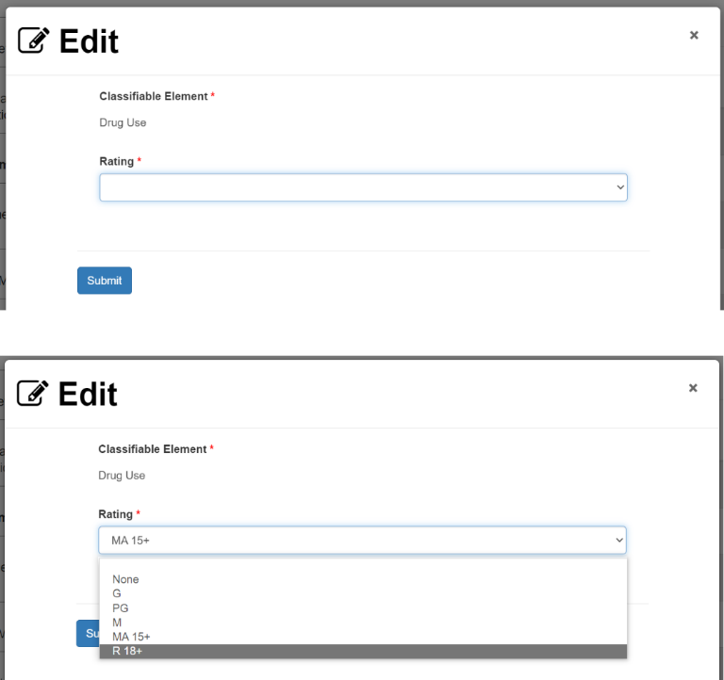
- After you have selected a rating for each element, select Display Rating to generate the overall rating. The overall rating corresponds with the highest rated element(s).
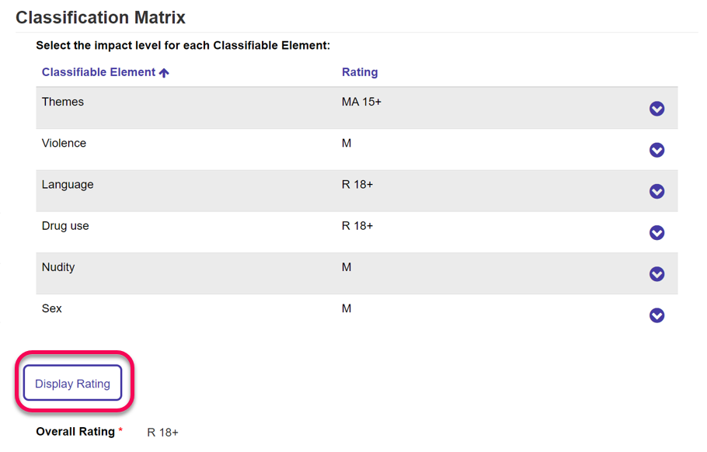
- In Reason(s) for decision, input text for both questions. Then select Save and next.
  - Please input brief details or examples of the classifiable element(s) you identified with the highest impact within the film. You can provide timestamps, as relevant.
Example: The film contains a breakdown of a familial relationship as well as adolescent behaviour related to risk-taking and questioning sexuality. At 22min, a child is depicted witnessing a verbally abusive argument between their parents. The film contains use of the word ‘f**k’ throughout.
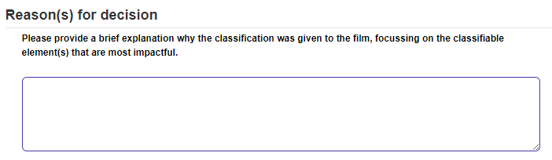
  - Please input brief details or examples of any issues of community concern present in the film, if any.
Example: At 43min, a teenager references that their father is violent towards their mother.
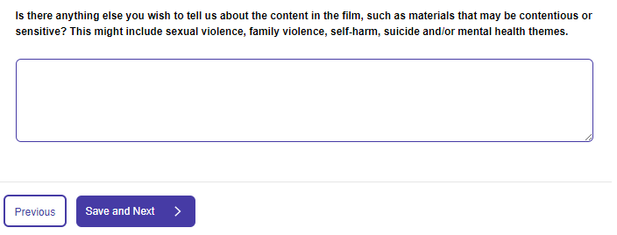

Consumer advice
The consumer advice (CA) section of the submission uses logic based on the ratings for each element you selected at Step 12. The form will only display the elements and consumer advice terms that may be applicable at the overall rating of the film, or one lower for any issues of community concern.
If an element or consumer advice term does not appear on the list, it is because it does not meet the logic for inclusion in the consumer advice or the term is not on the current consumer advice list issued under section 12A of the Classification (Publications, Films and Computer Games) Act 1995.
- Select Add/Remove CA Terms to add consumer advice terms for each classifiable element, select the applicable terms using the tick boxes, and then select Add CA terms. There may be a scroll bar on the right-hand side. Use the scroll bar to view additional consumer advice terms and the Add CA Terms button.
  - Consumer advice terms are mandatory for elements corresponding with the overall rating.
  - Consumer advice terms are optional for elements that are one rating lower than the overall rating.
If relevant, input only the issues of community concern present in the film at one rating lower.
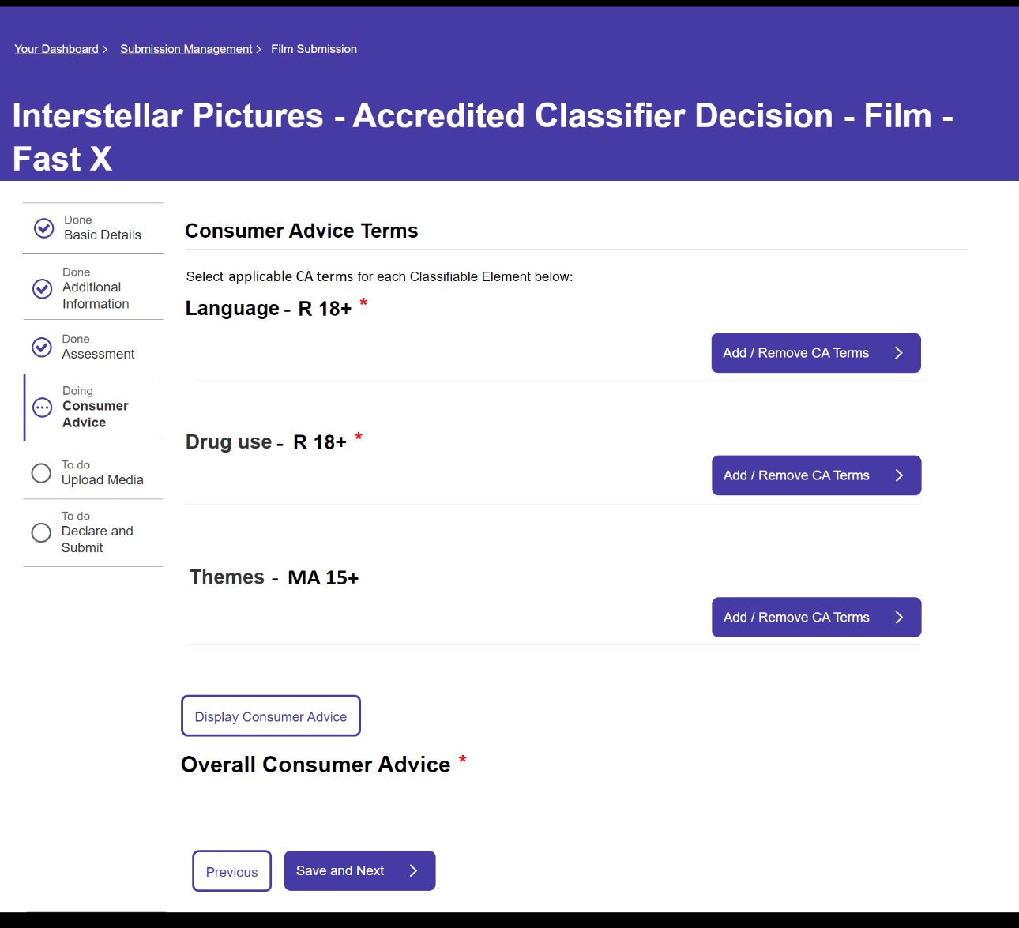

- After selecting the consumer advice terms you need, select Display Consumer Advice. The system will then generate the Overall consumer advice.
  - If the overall consumer advice reflects your classification decision, select Save and Next.
  - If the overall consumer advice does not reflect your classification decision, please select the correct consumer advice terms in the relevant classifiable elements and if needed, go to the previous page and change the classification matrix.
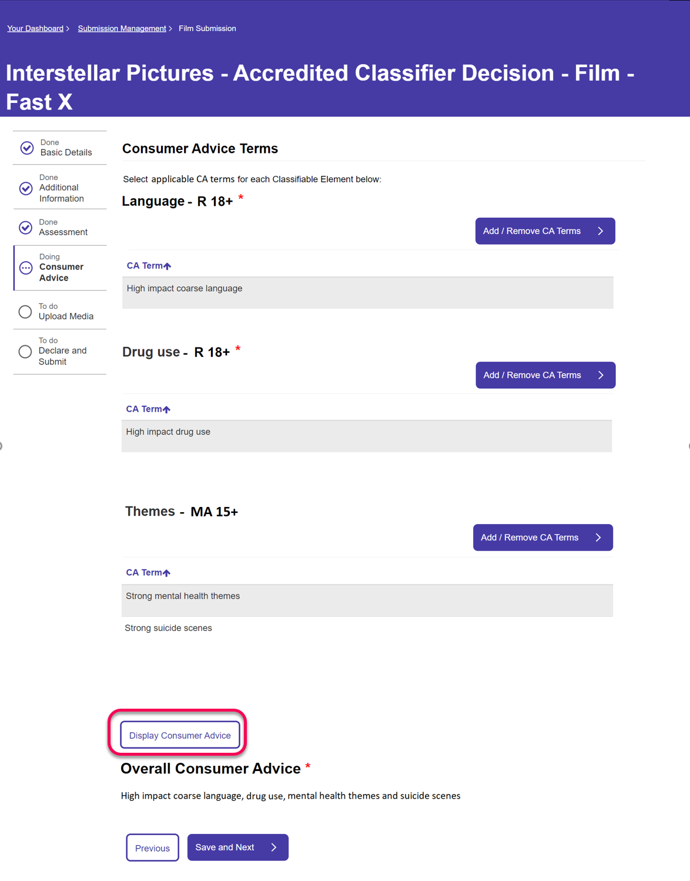

Upload media
- You can upload or provide links to media, and then select Save and Next.
These options are available to you:
- online via Box – upload media files directly to Box (file size limited to 3GB).
- online via another method – enter the location or file path, including relevant access code or password in the text box. Please advise if the link is only available for a specified period.
- a physical copy of the content – if you are posting a DCP drive or other physical media via a courier.
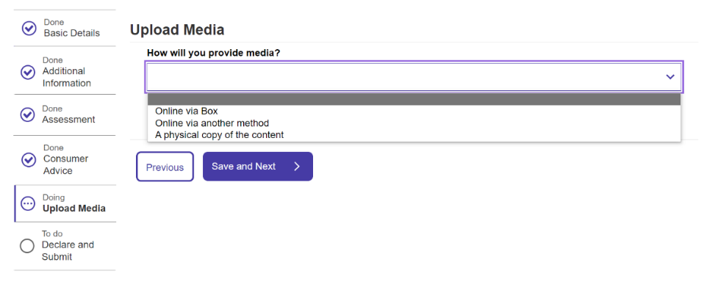

Declare and submit
- Select Download Summary if you would like to download a copy of the submission.
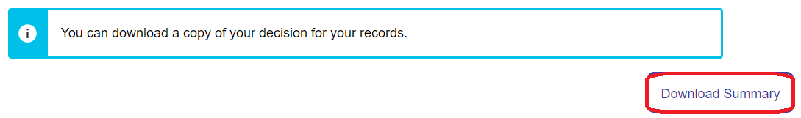
- Review the “Your classification decision” section to check that the overall rating and consumer advice reflects your classification decision.
If it does not correctly reflect your decision, please use the ‘Previous’ button at the bottom of the page to return to previous pages.
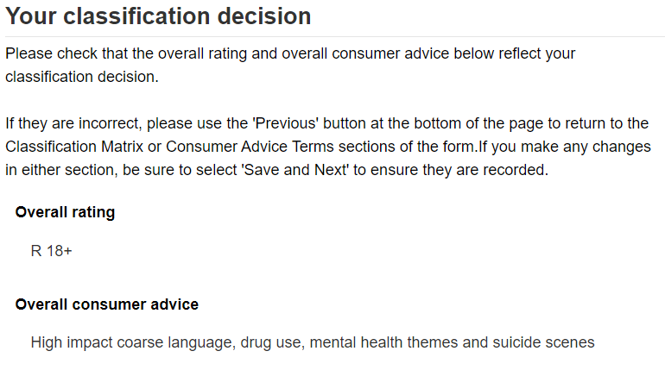
- Review the declaration, select the tick boxes to agree, then select Submit.
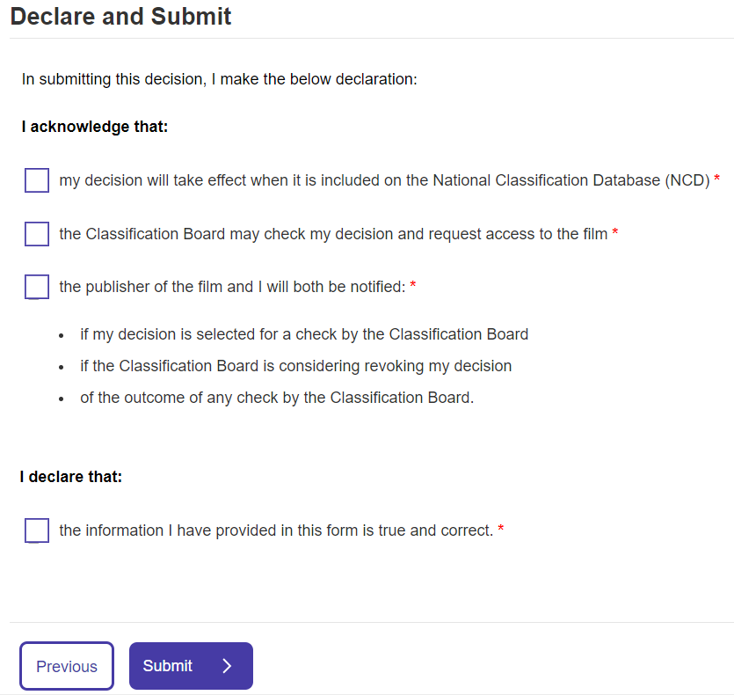

After submission
The classification decision takes effect under the Classification Act when it is published on the National Classification Database at classification.gov.au.
If you have made an error in the submission, please email accreditedclassifier@infrastructure.gov.au. The department will notify you of the next steps.

